Category 3

1. Bank of india: 2018, 2.8k, 0.71, look handsome in 7y, had set back in covid ,but recovering well and mostly beating index ( not as previous corno but atleast beating ) 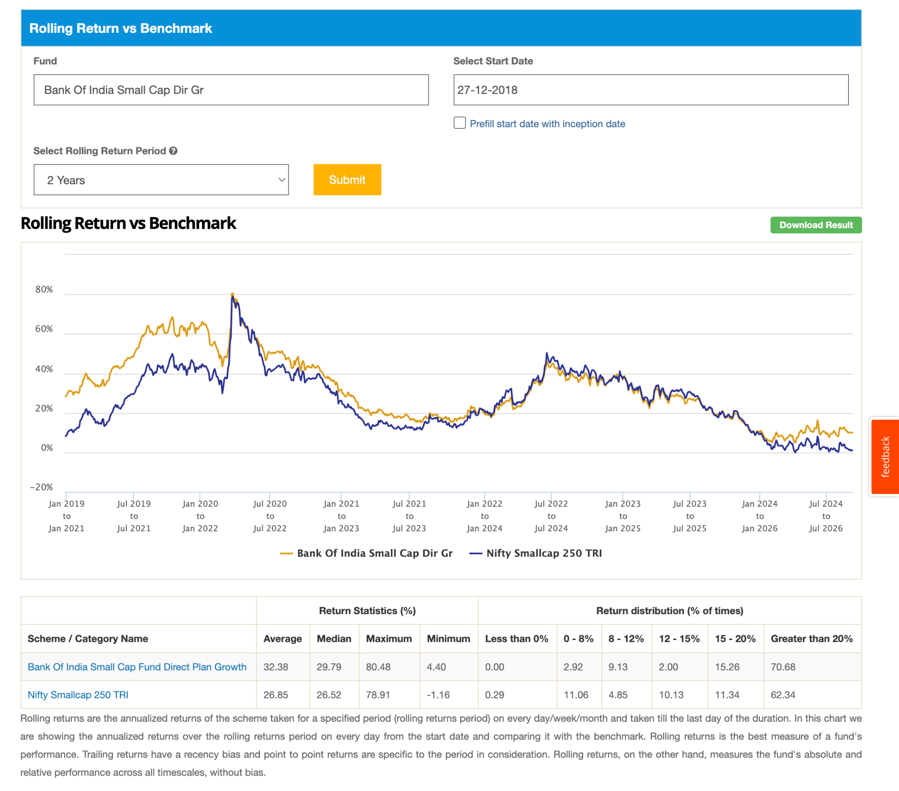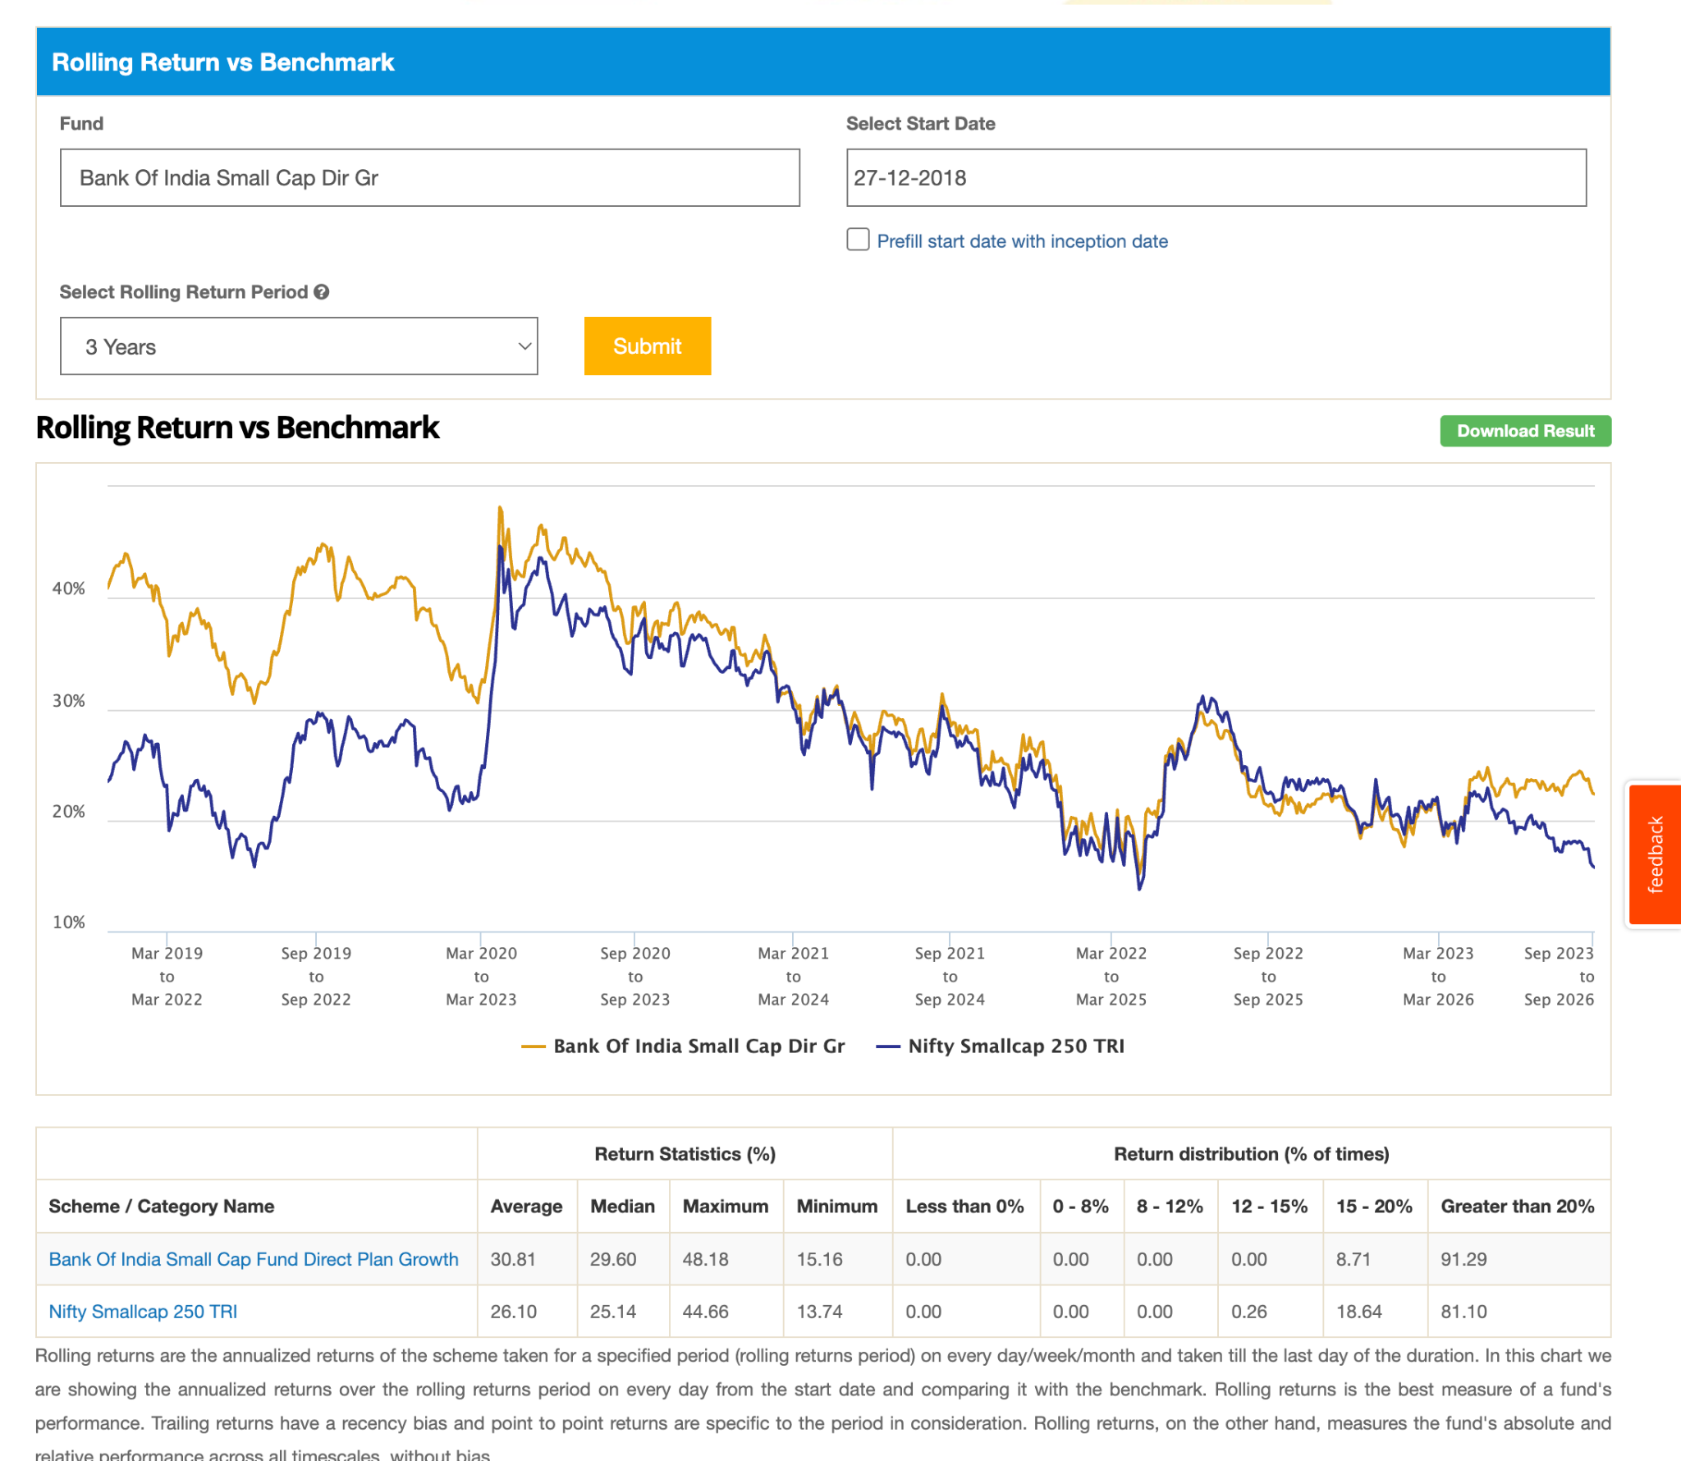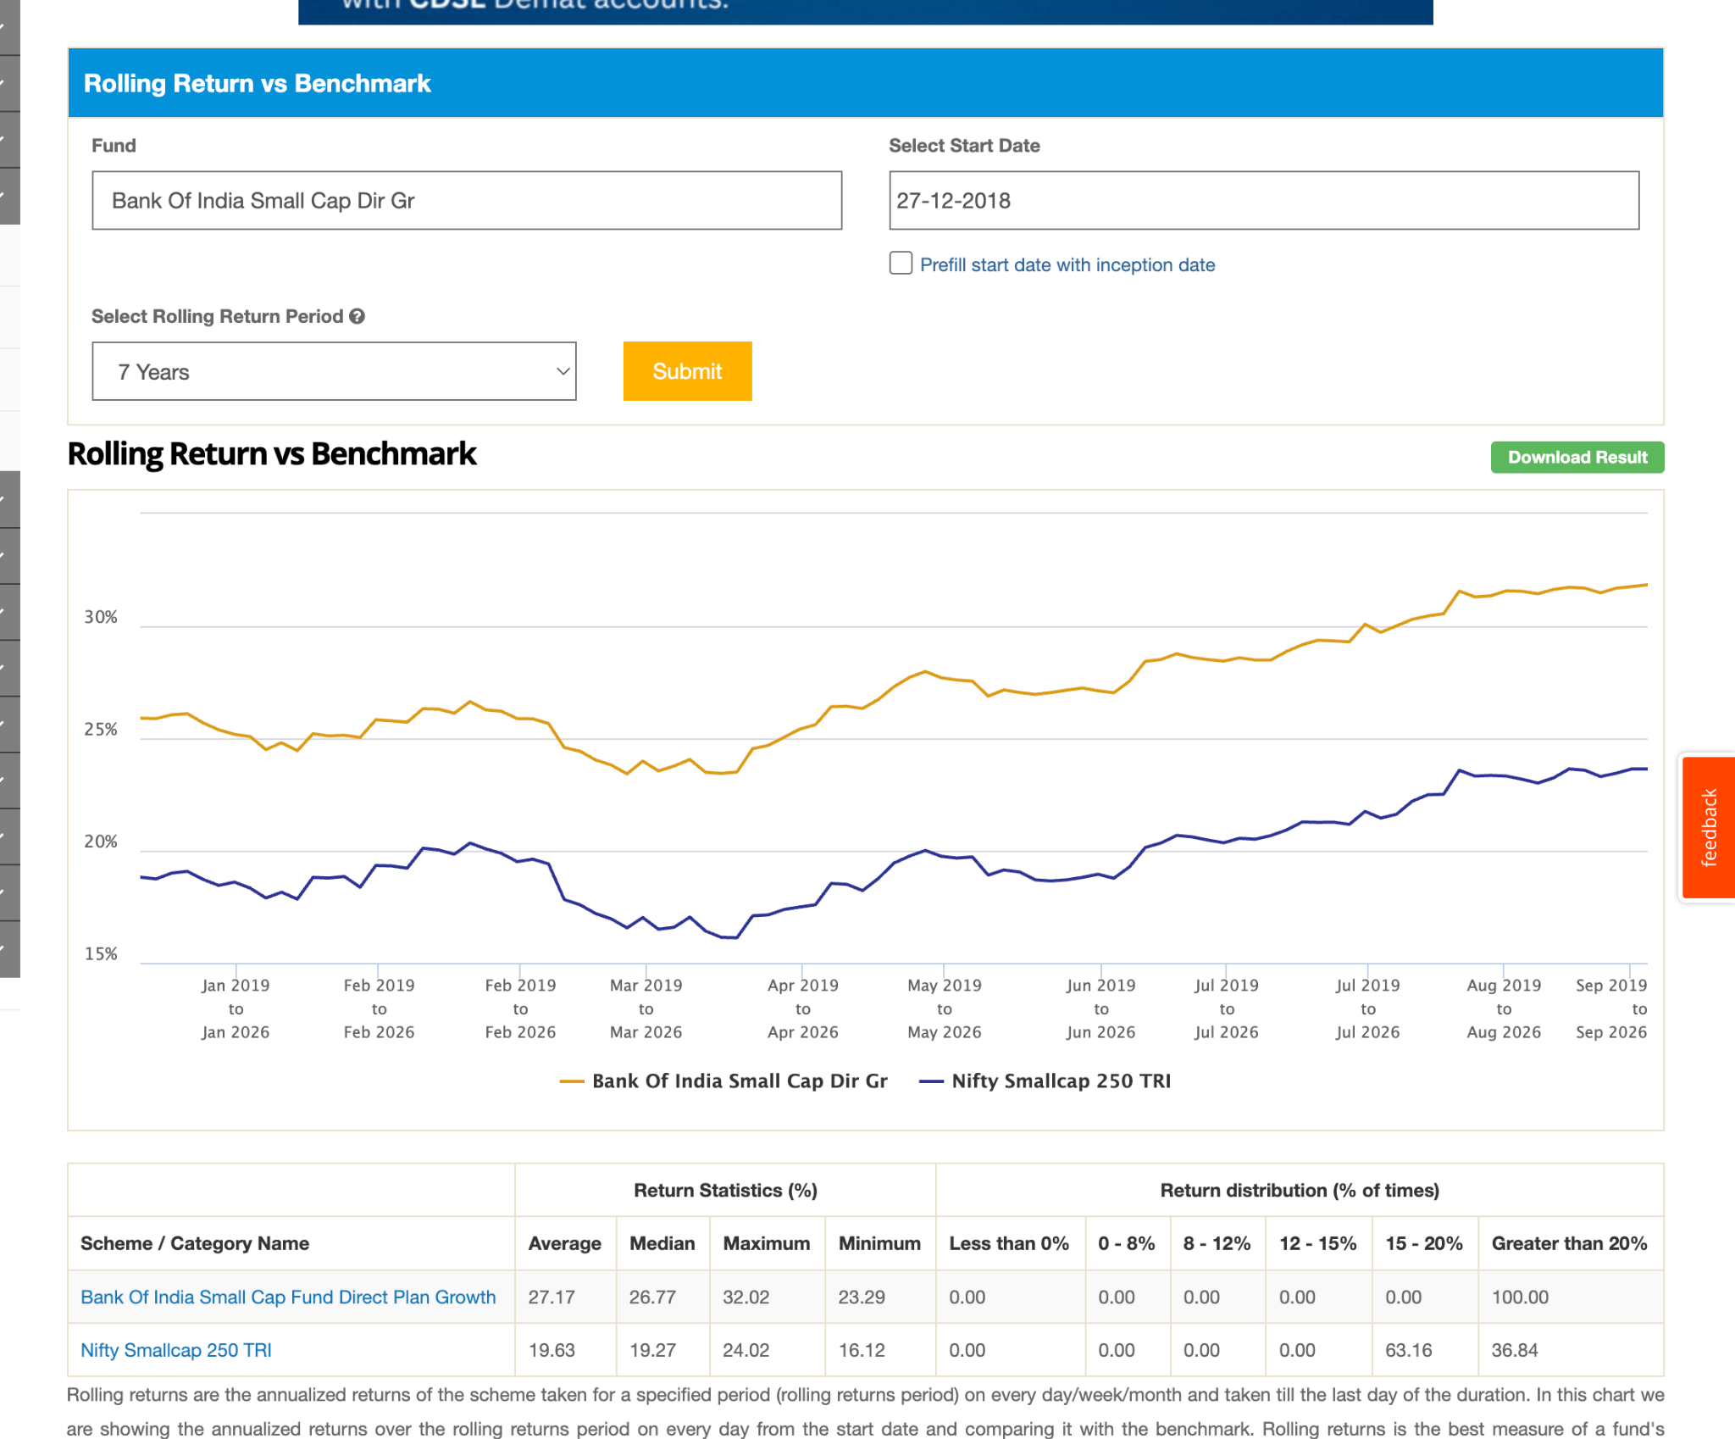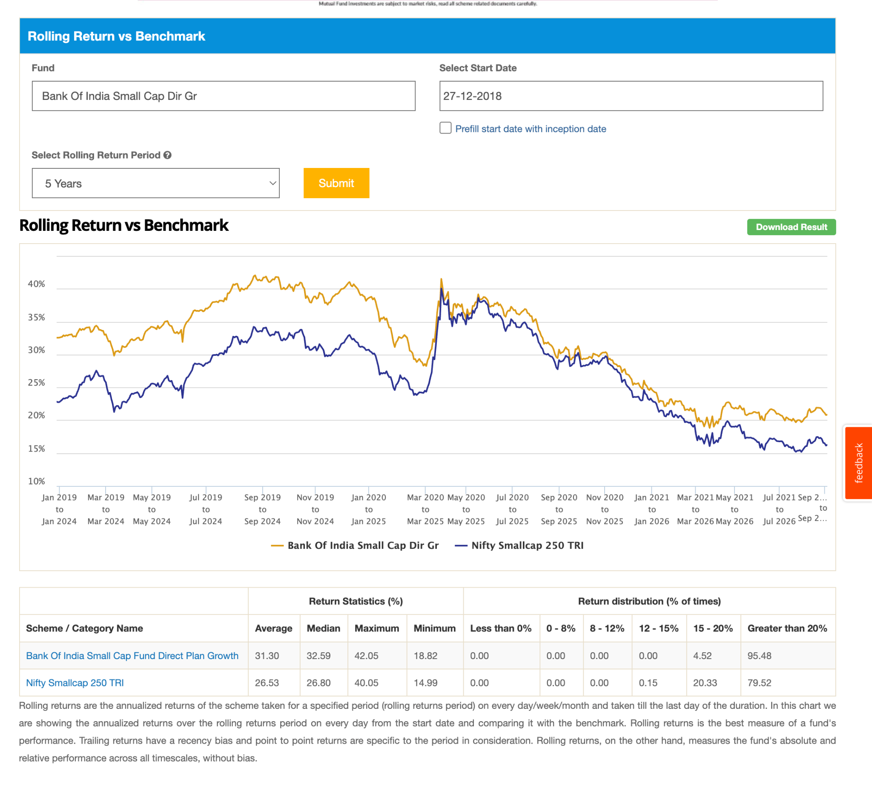

2. Edelweiss: 6.8k, 2019, 0.66 , consider this looks good, -35.87, also git at corono recovering just touching and beating .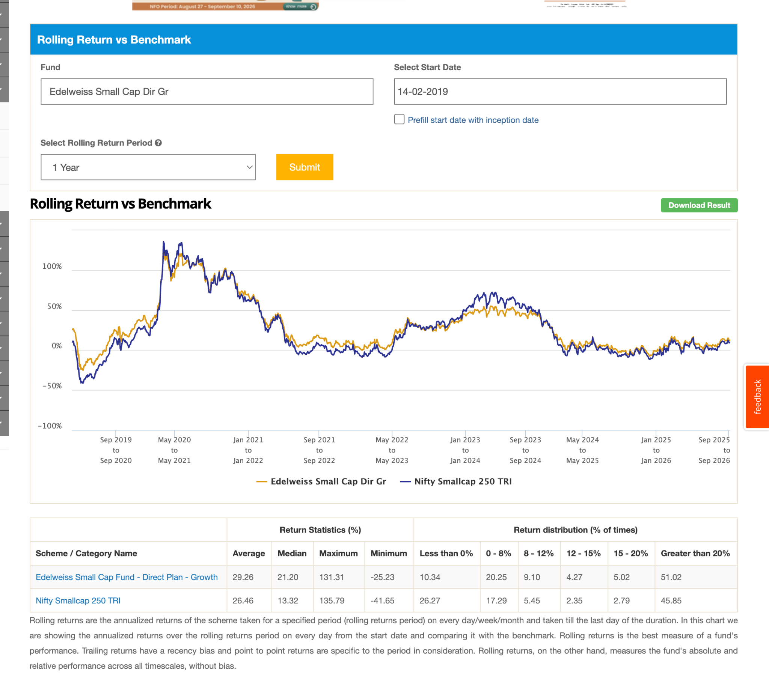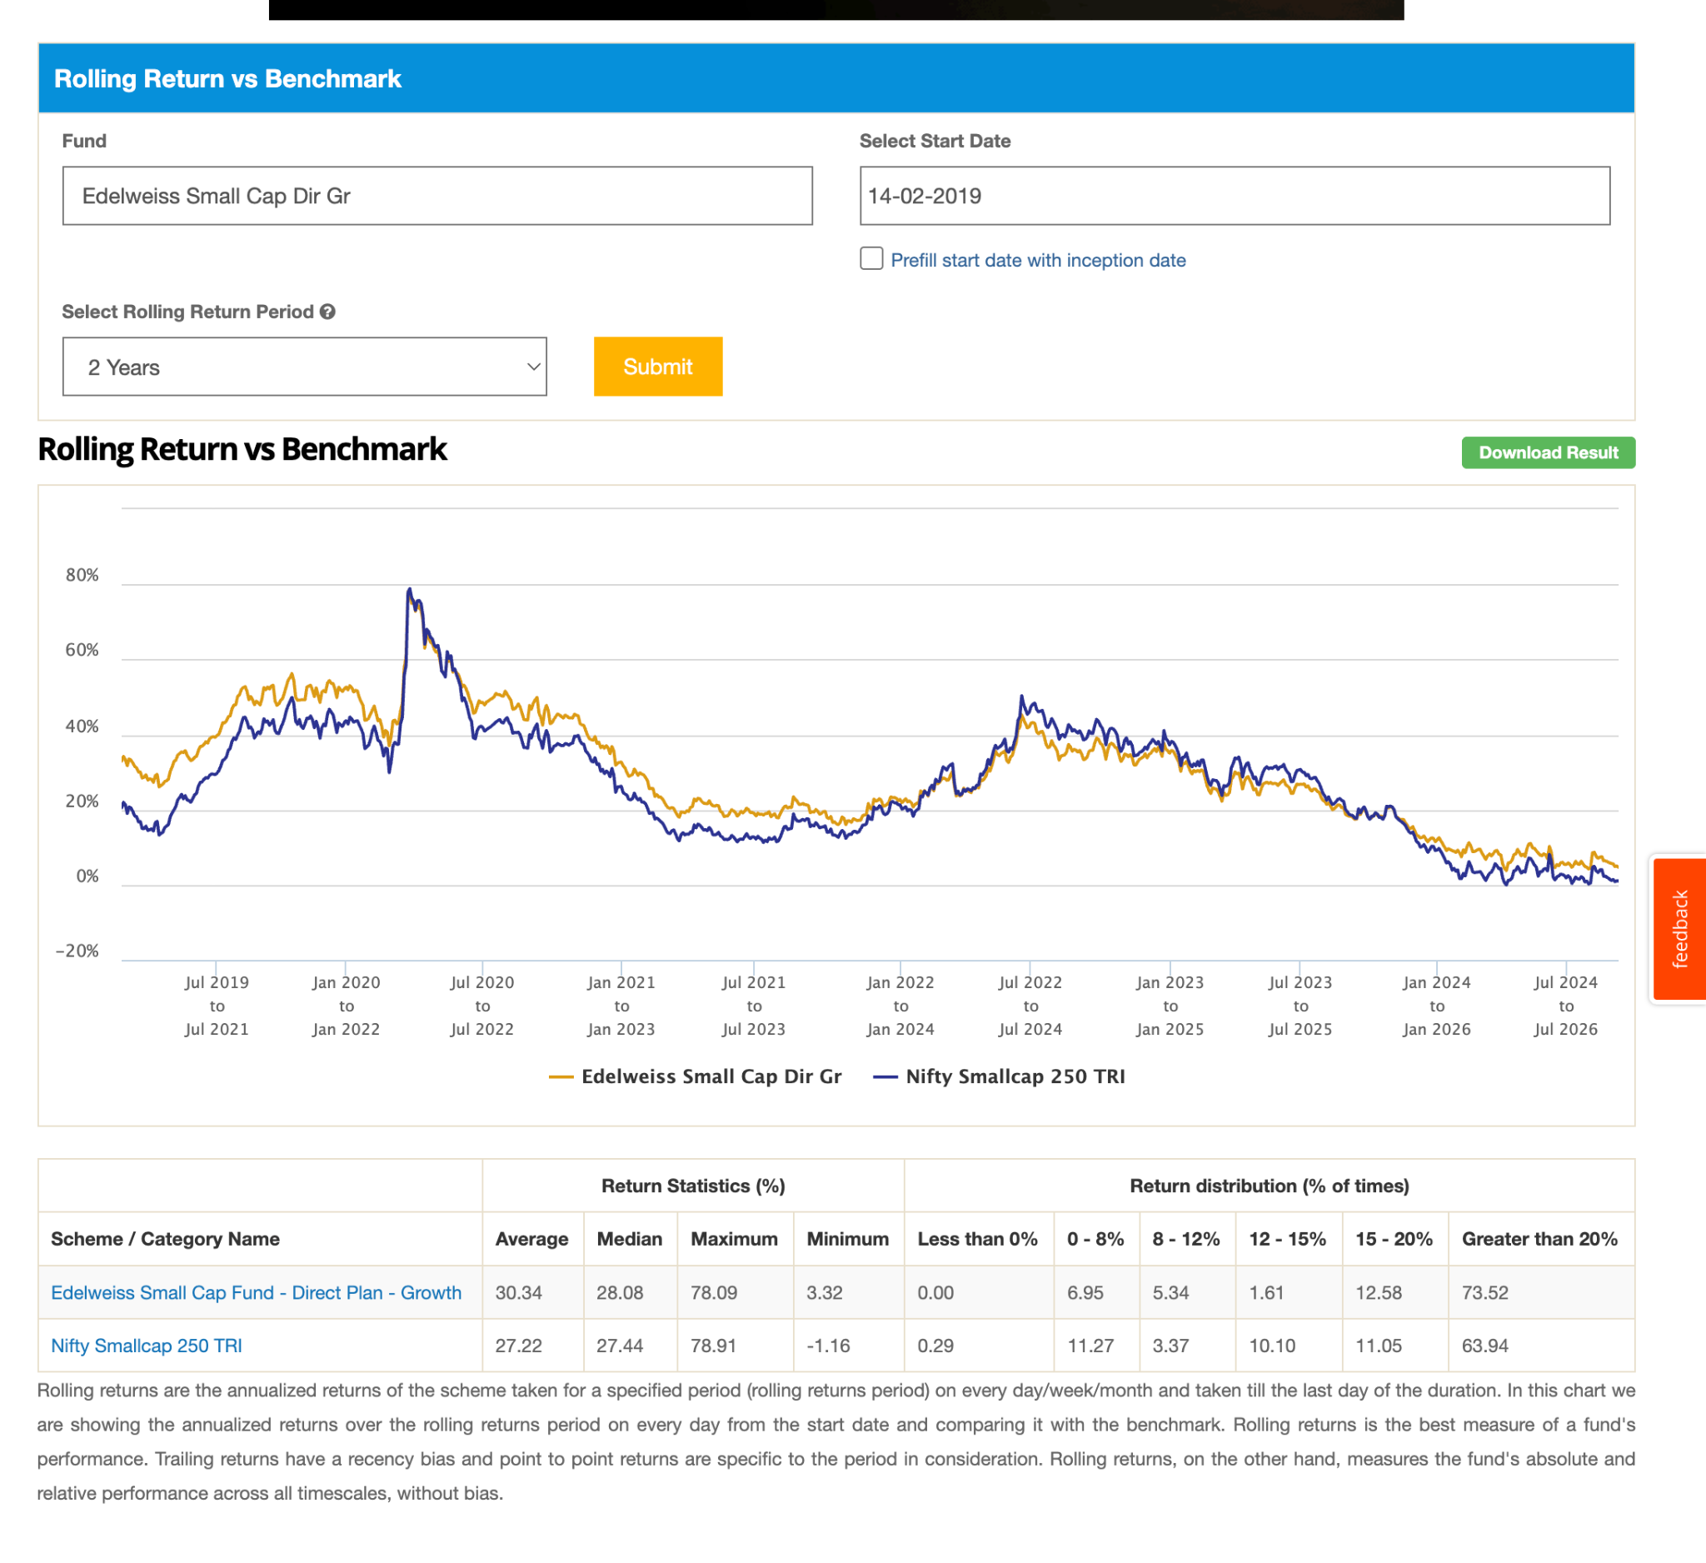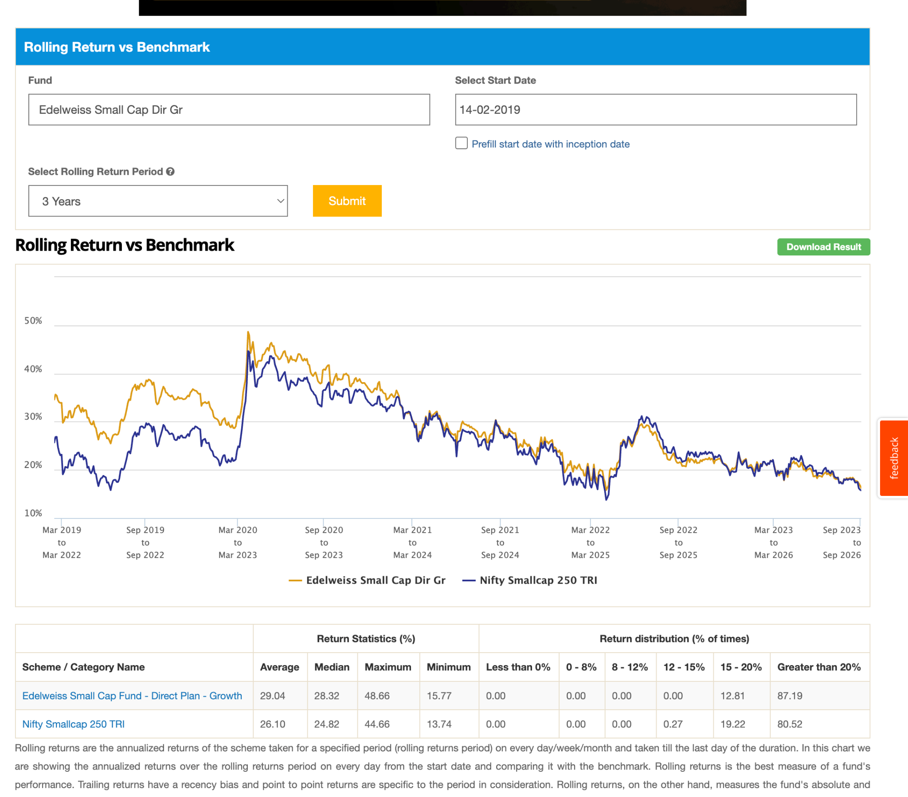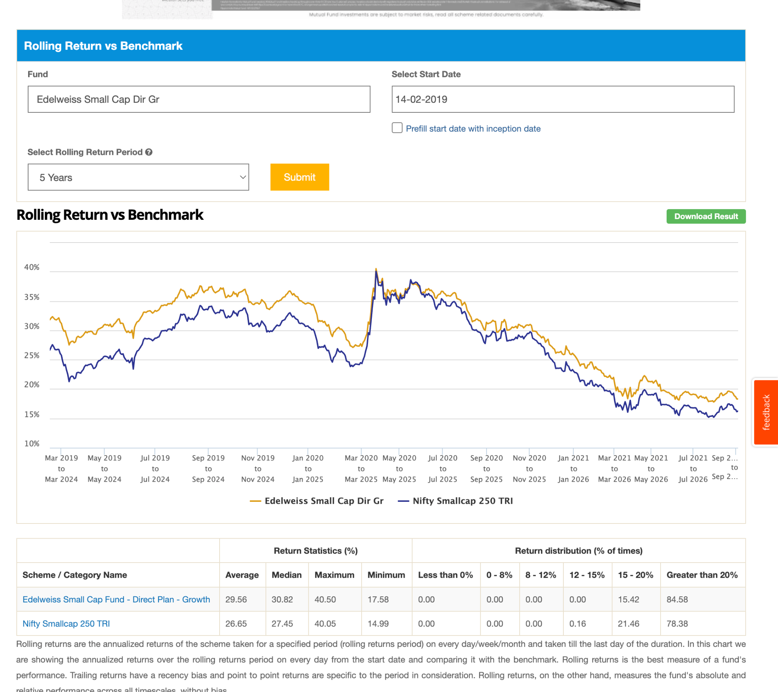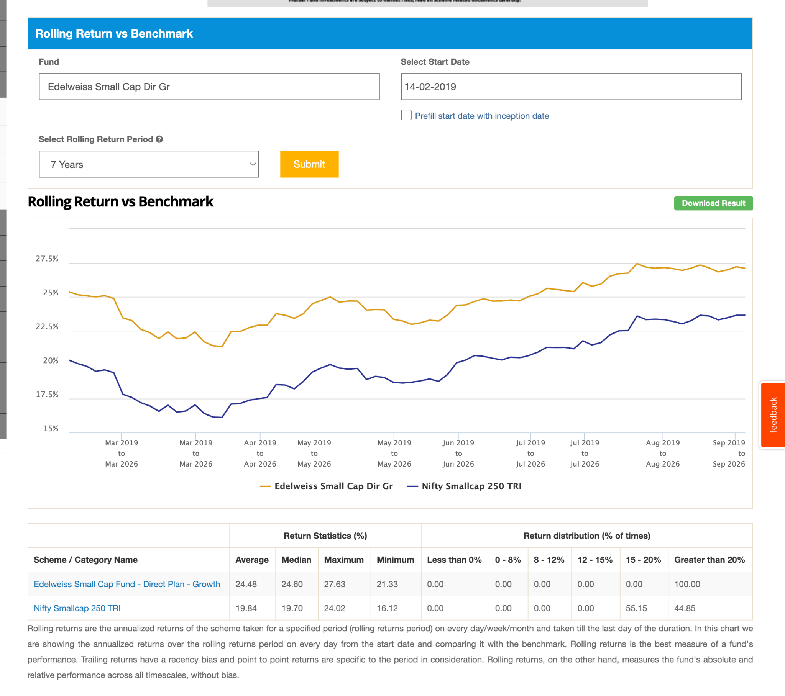
3. Invesco: 14.5k , 0.63, 2018 7y handome, 5y handomlyy survied cornoa, -36.75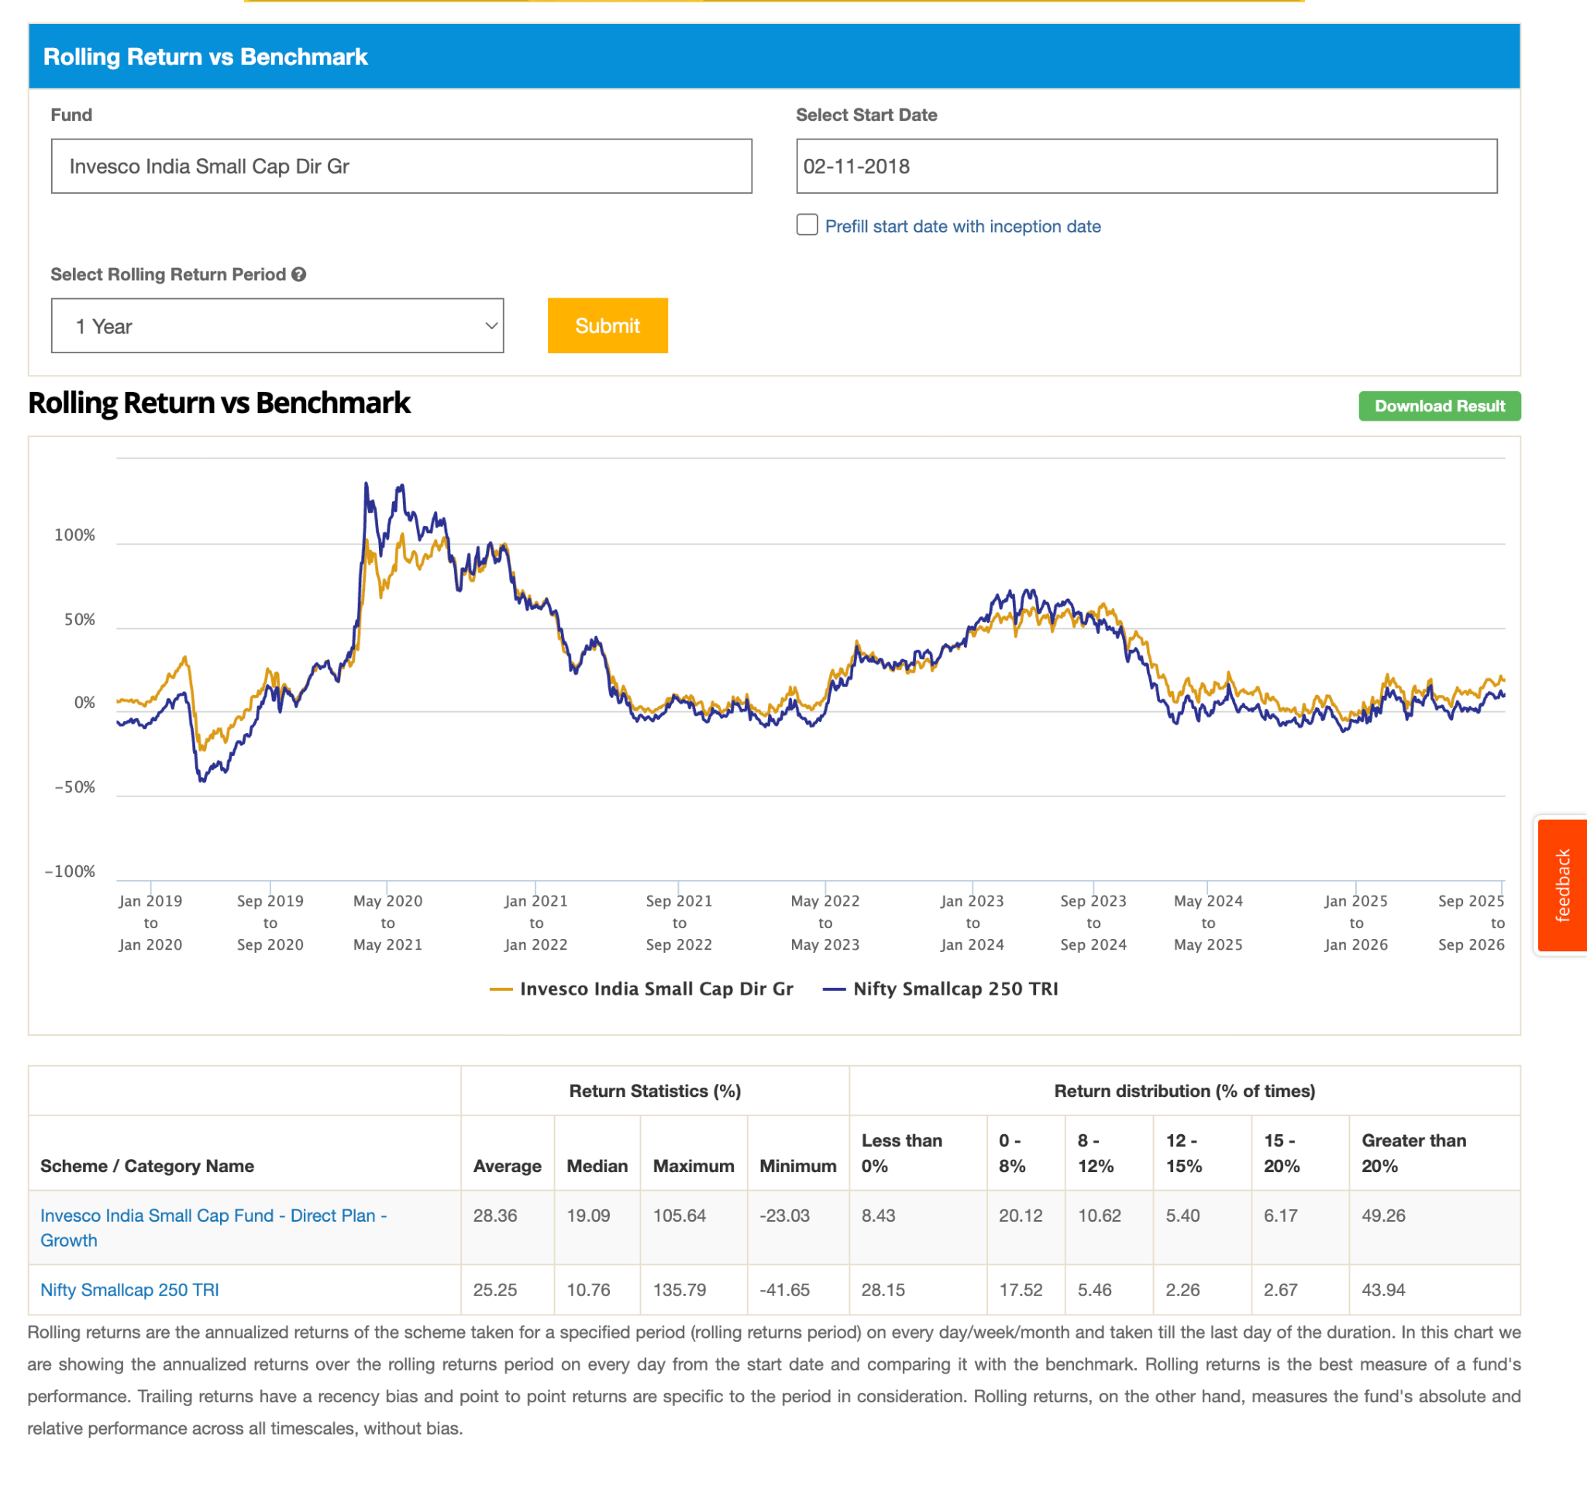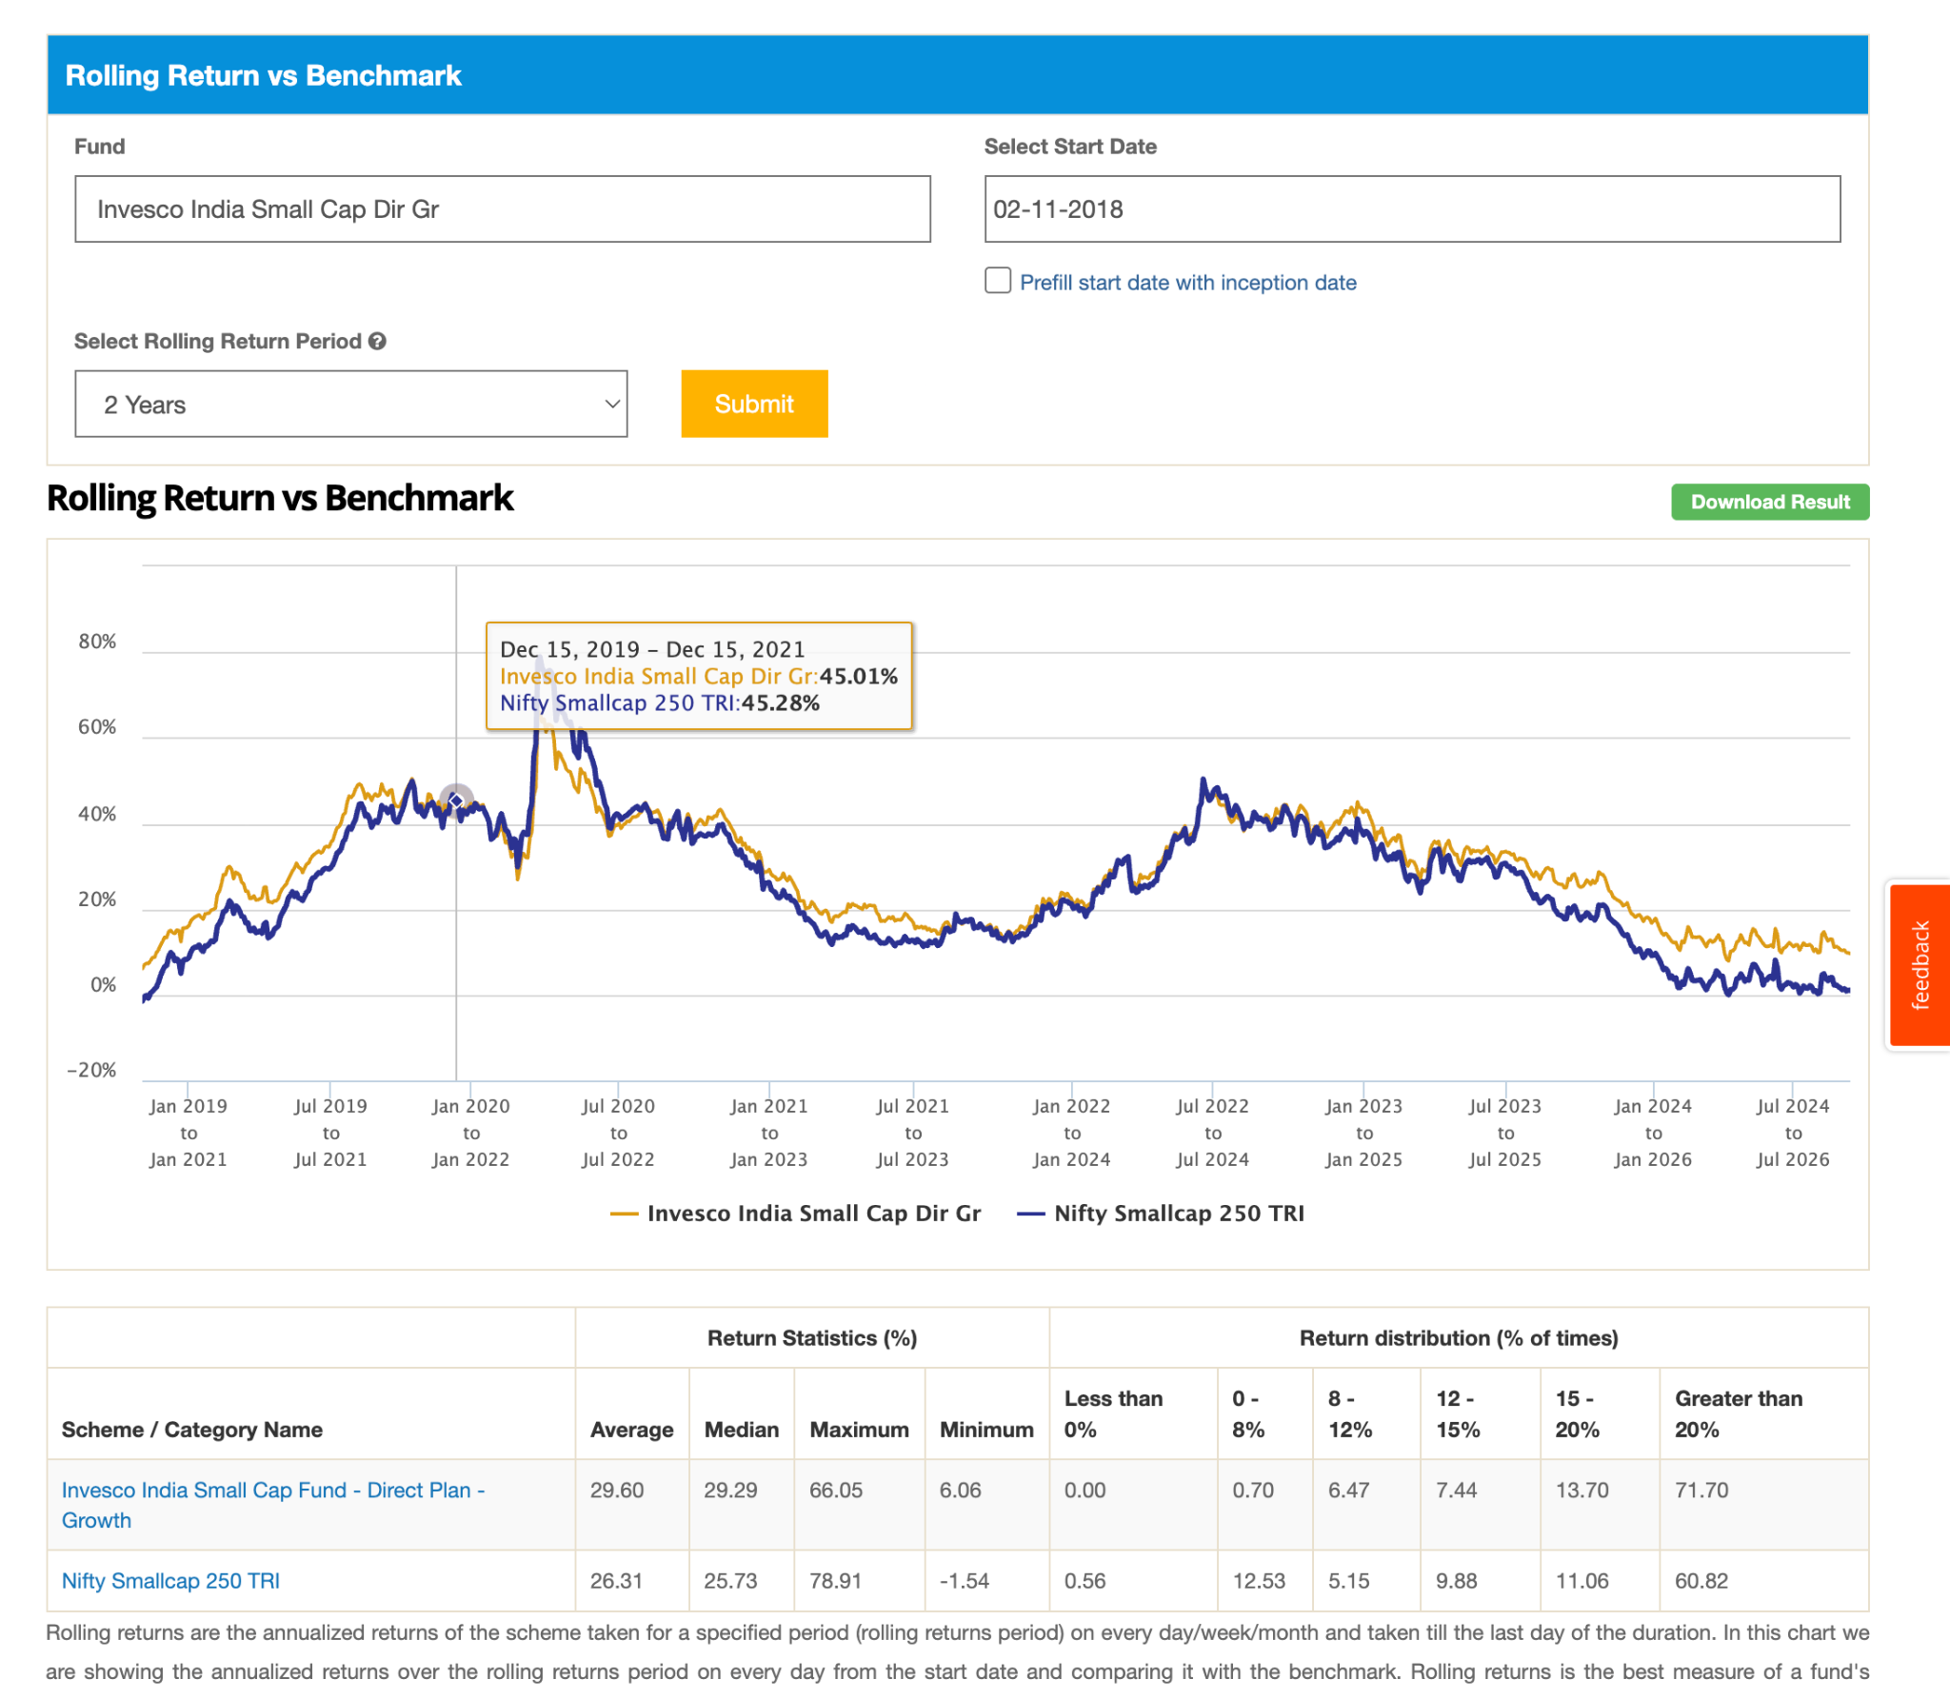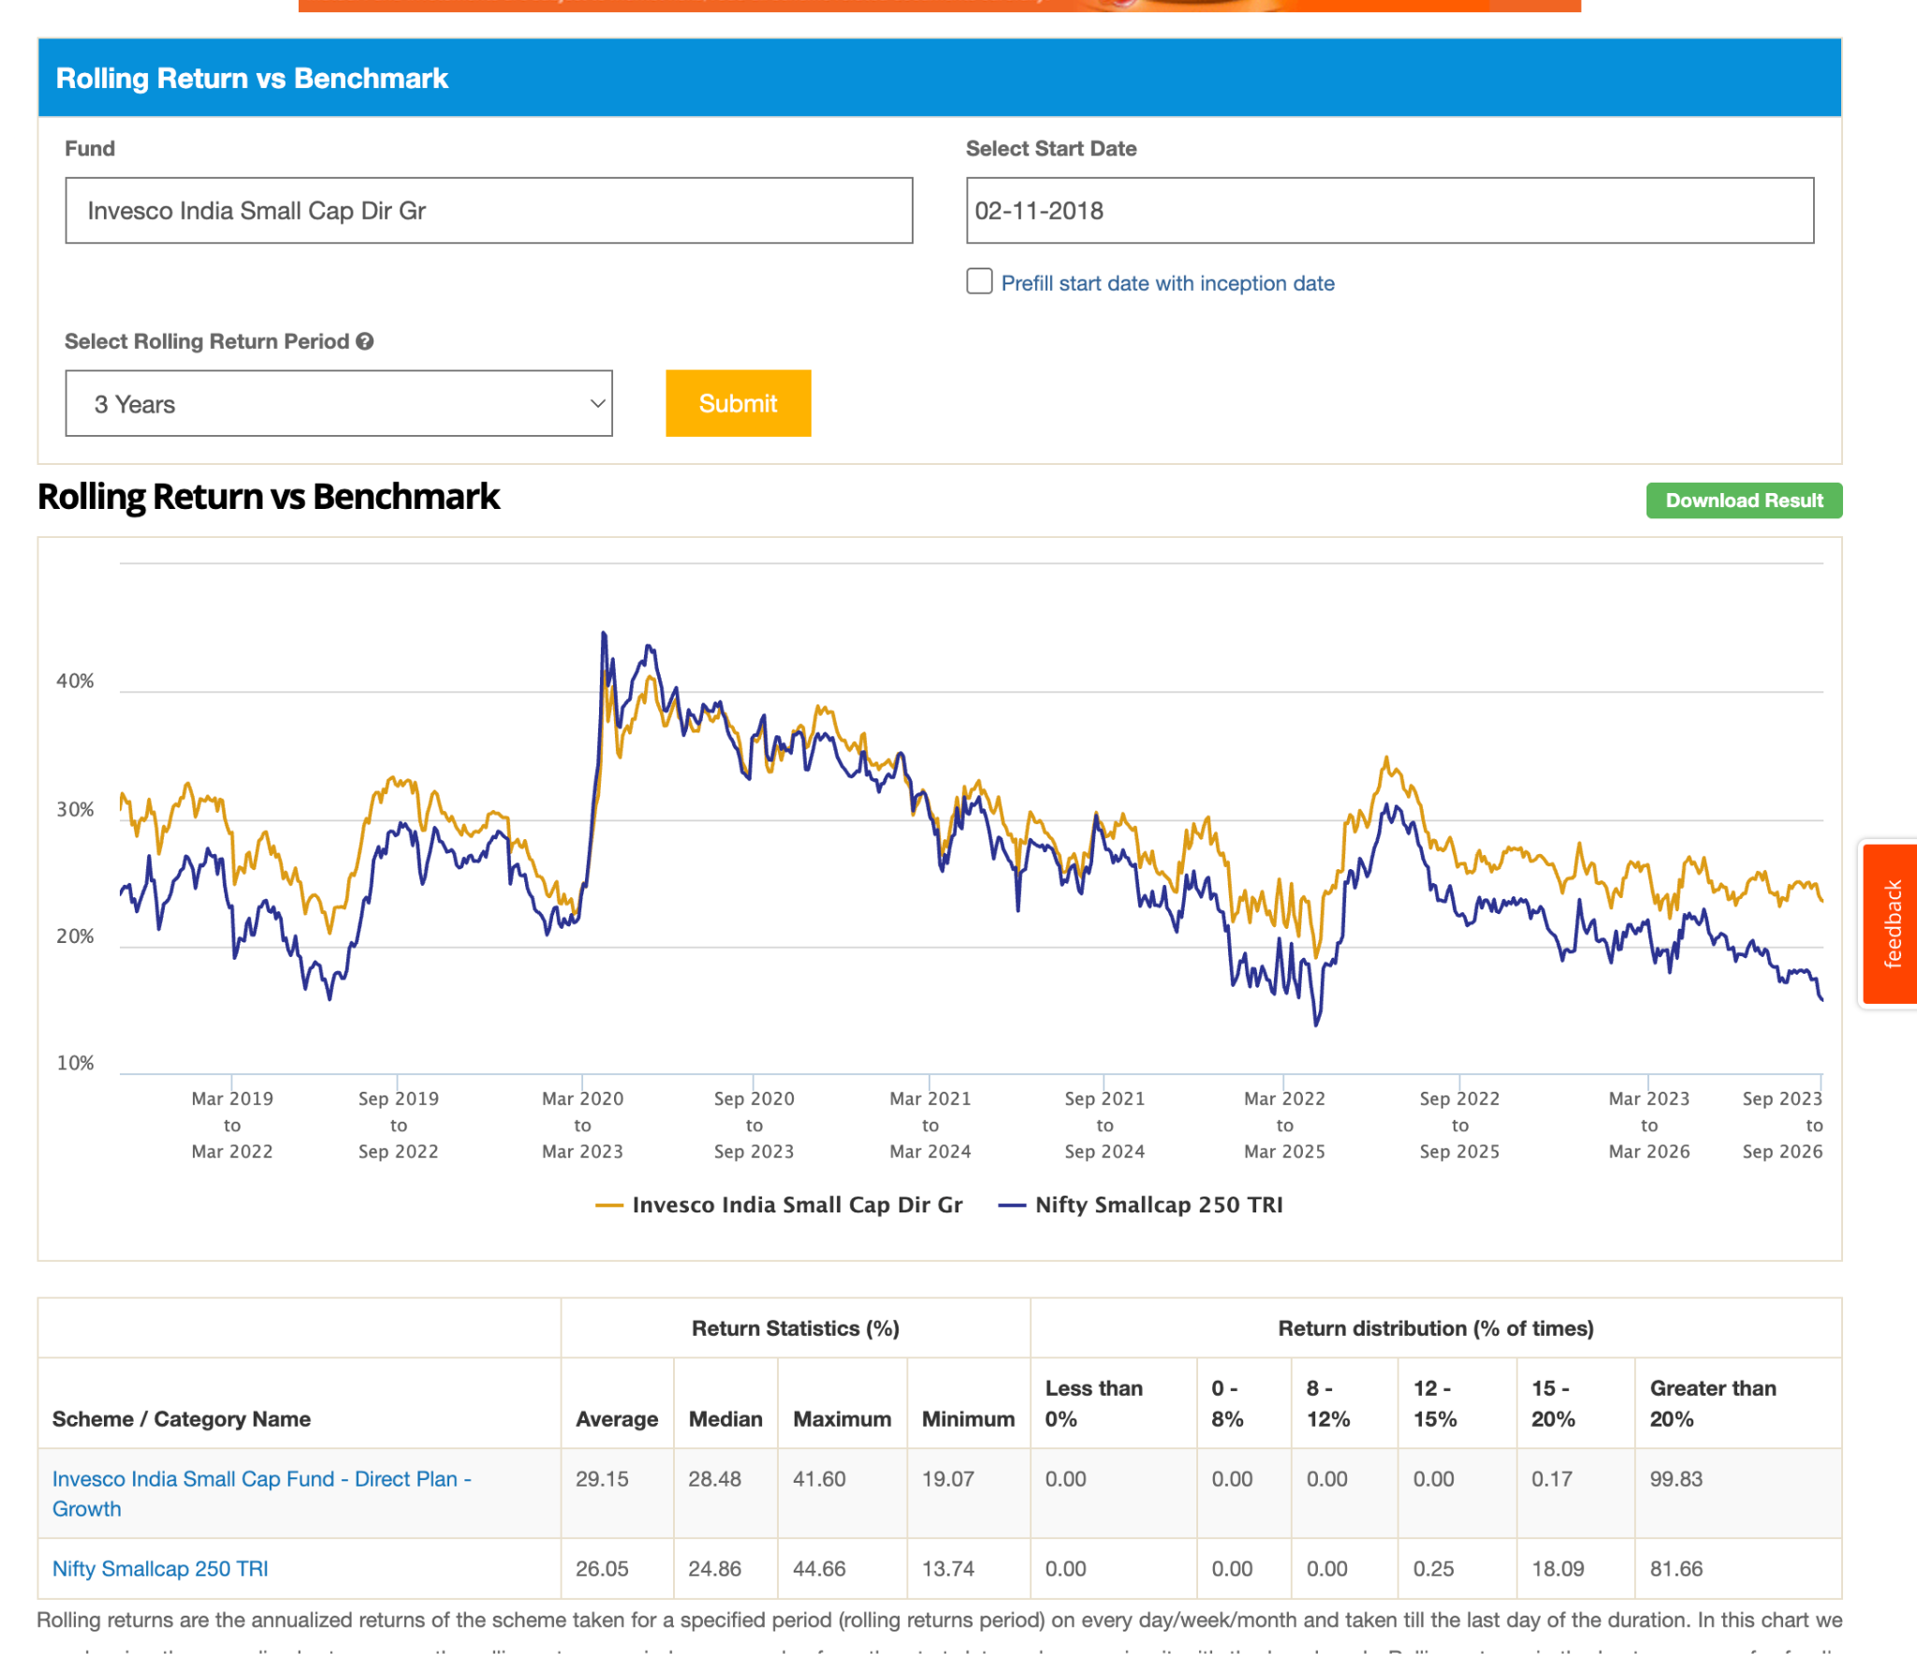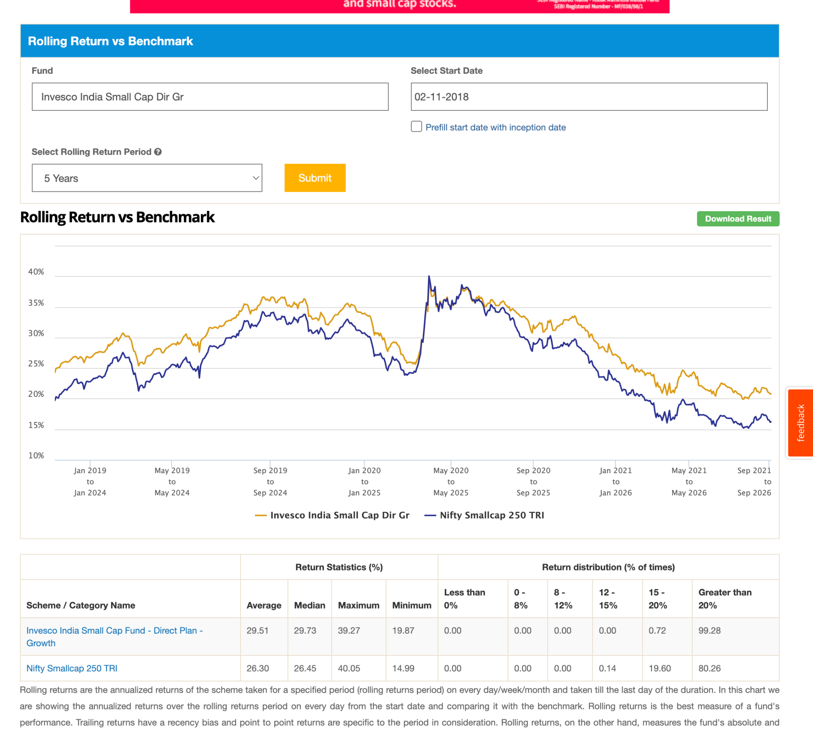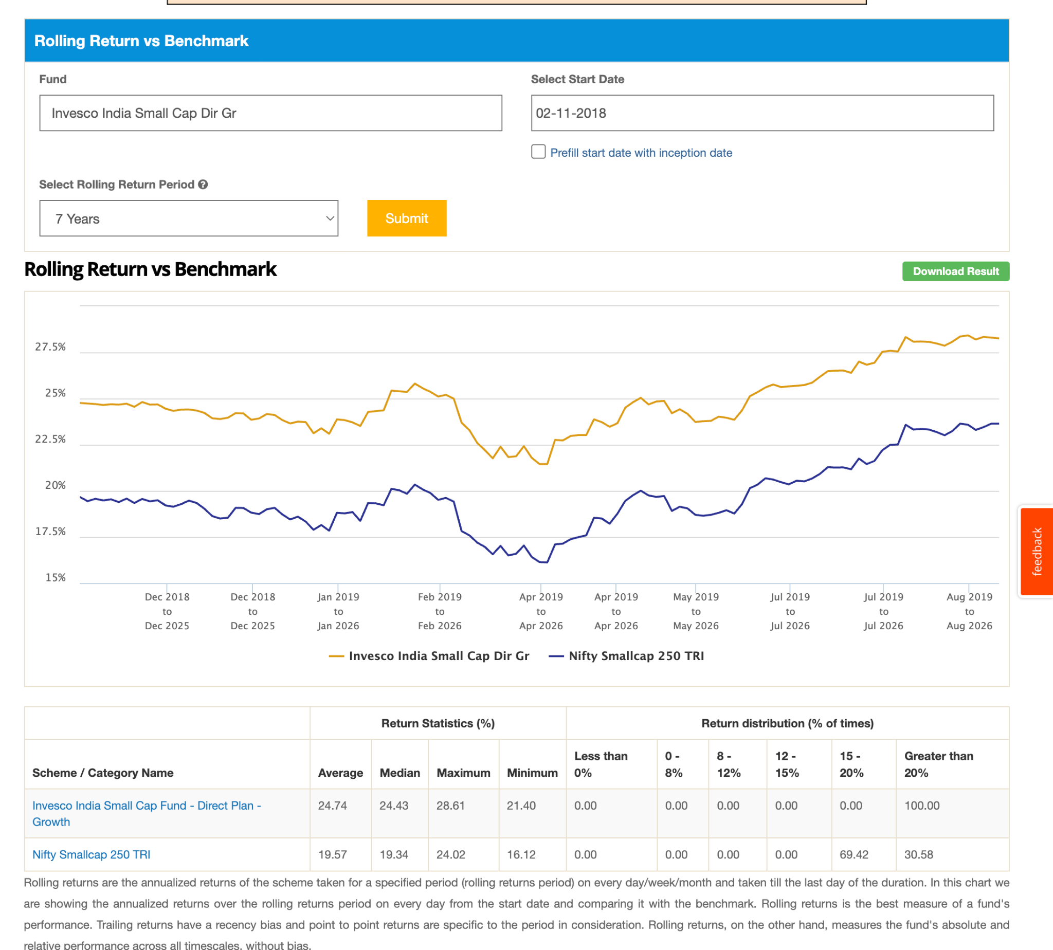

4. Mahindra Manulife: 3y old, 5k, 0.92 , not sur ehow it came int his category but in last 3 year which is his all time , good perform not below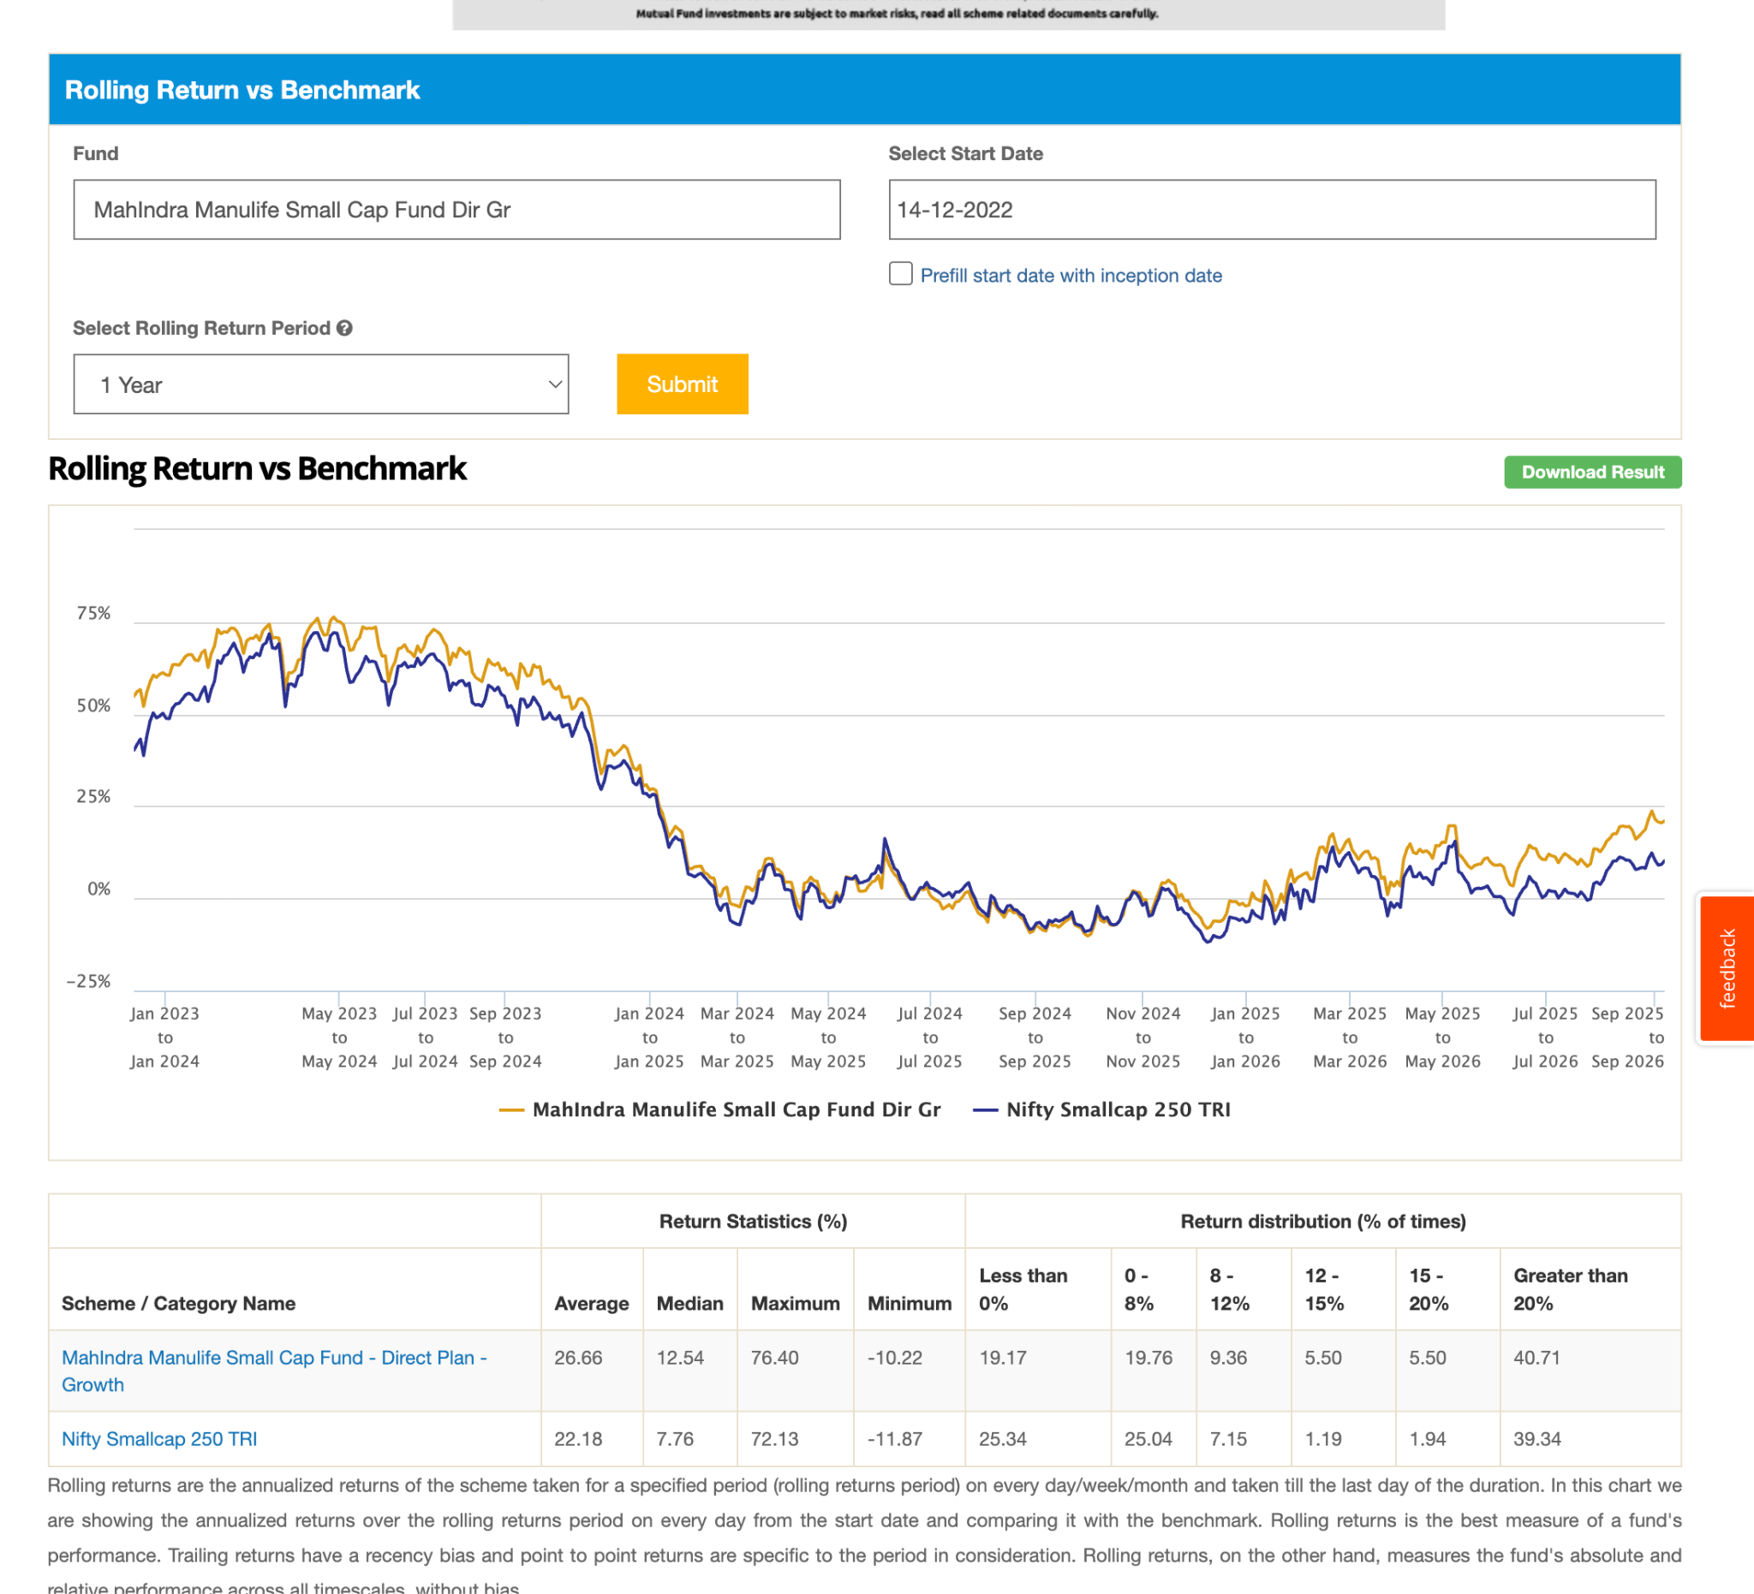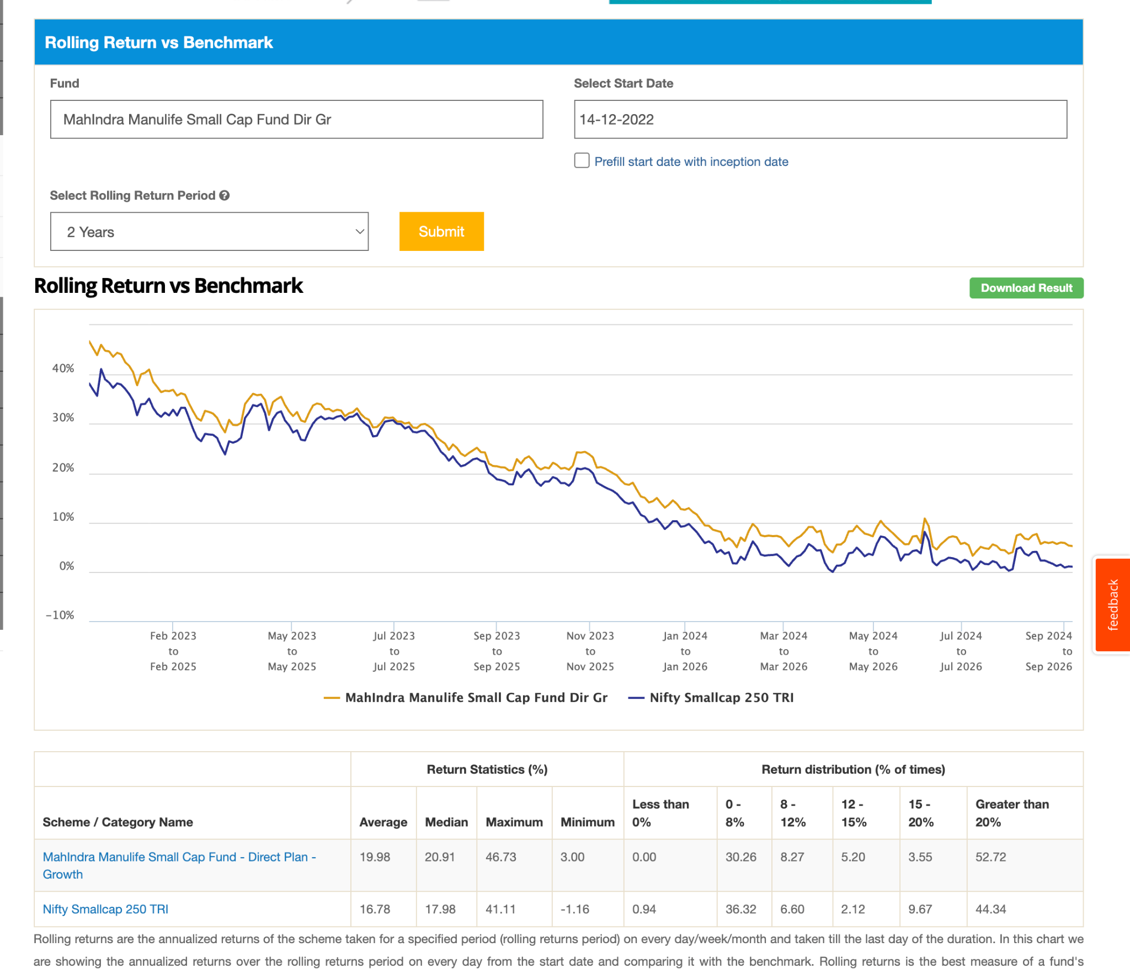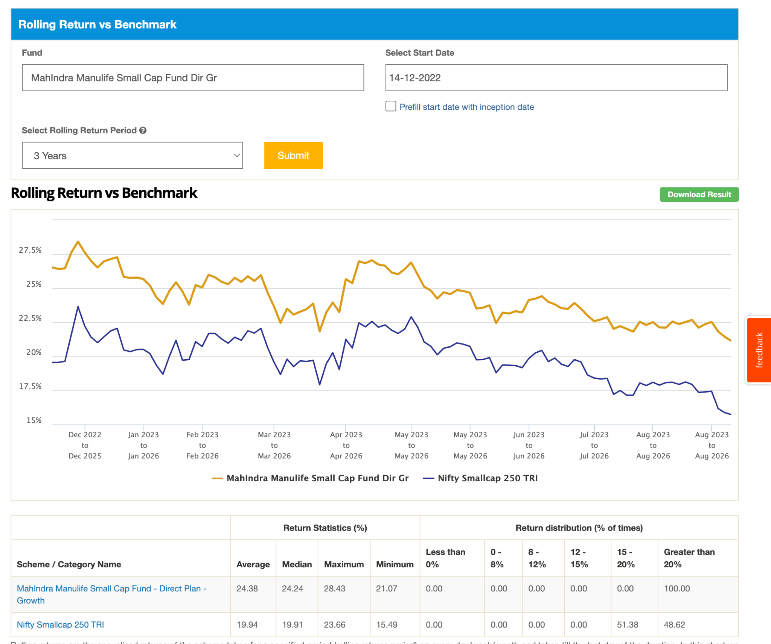
5. Nippon India: 79k 2013, 0.69 , survived cornoa handomely, last 2-3y seem started touching index. not sure about future right now looked good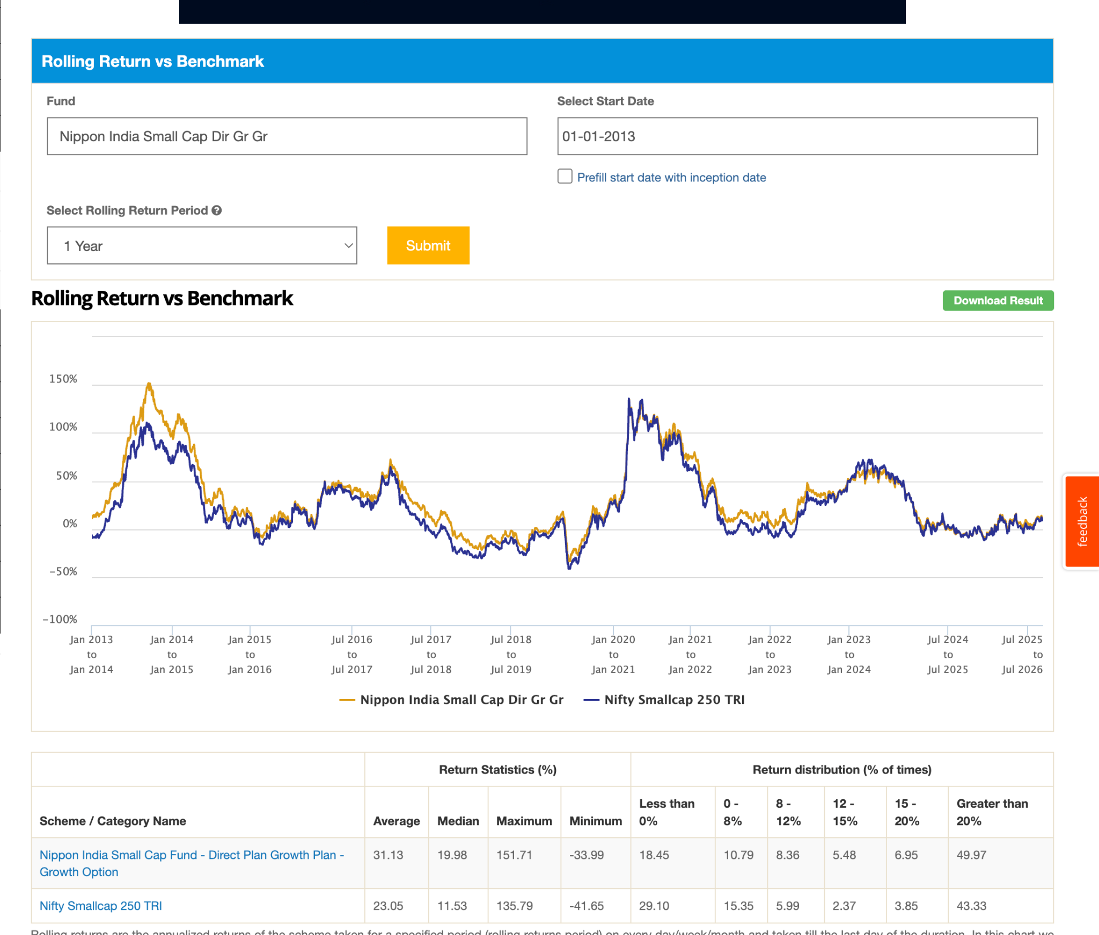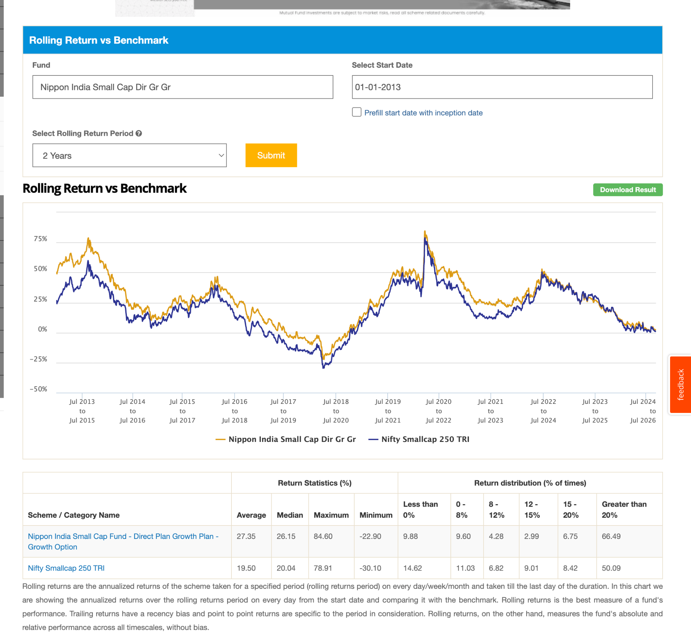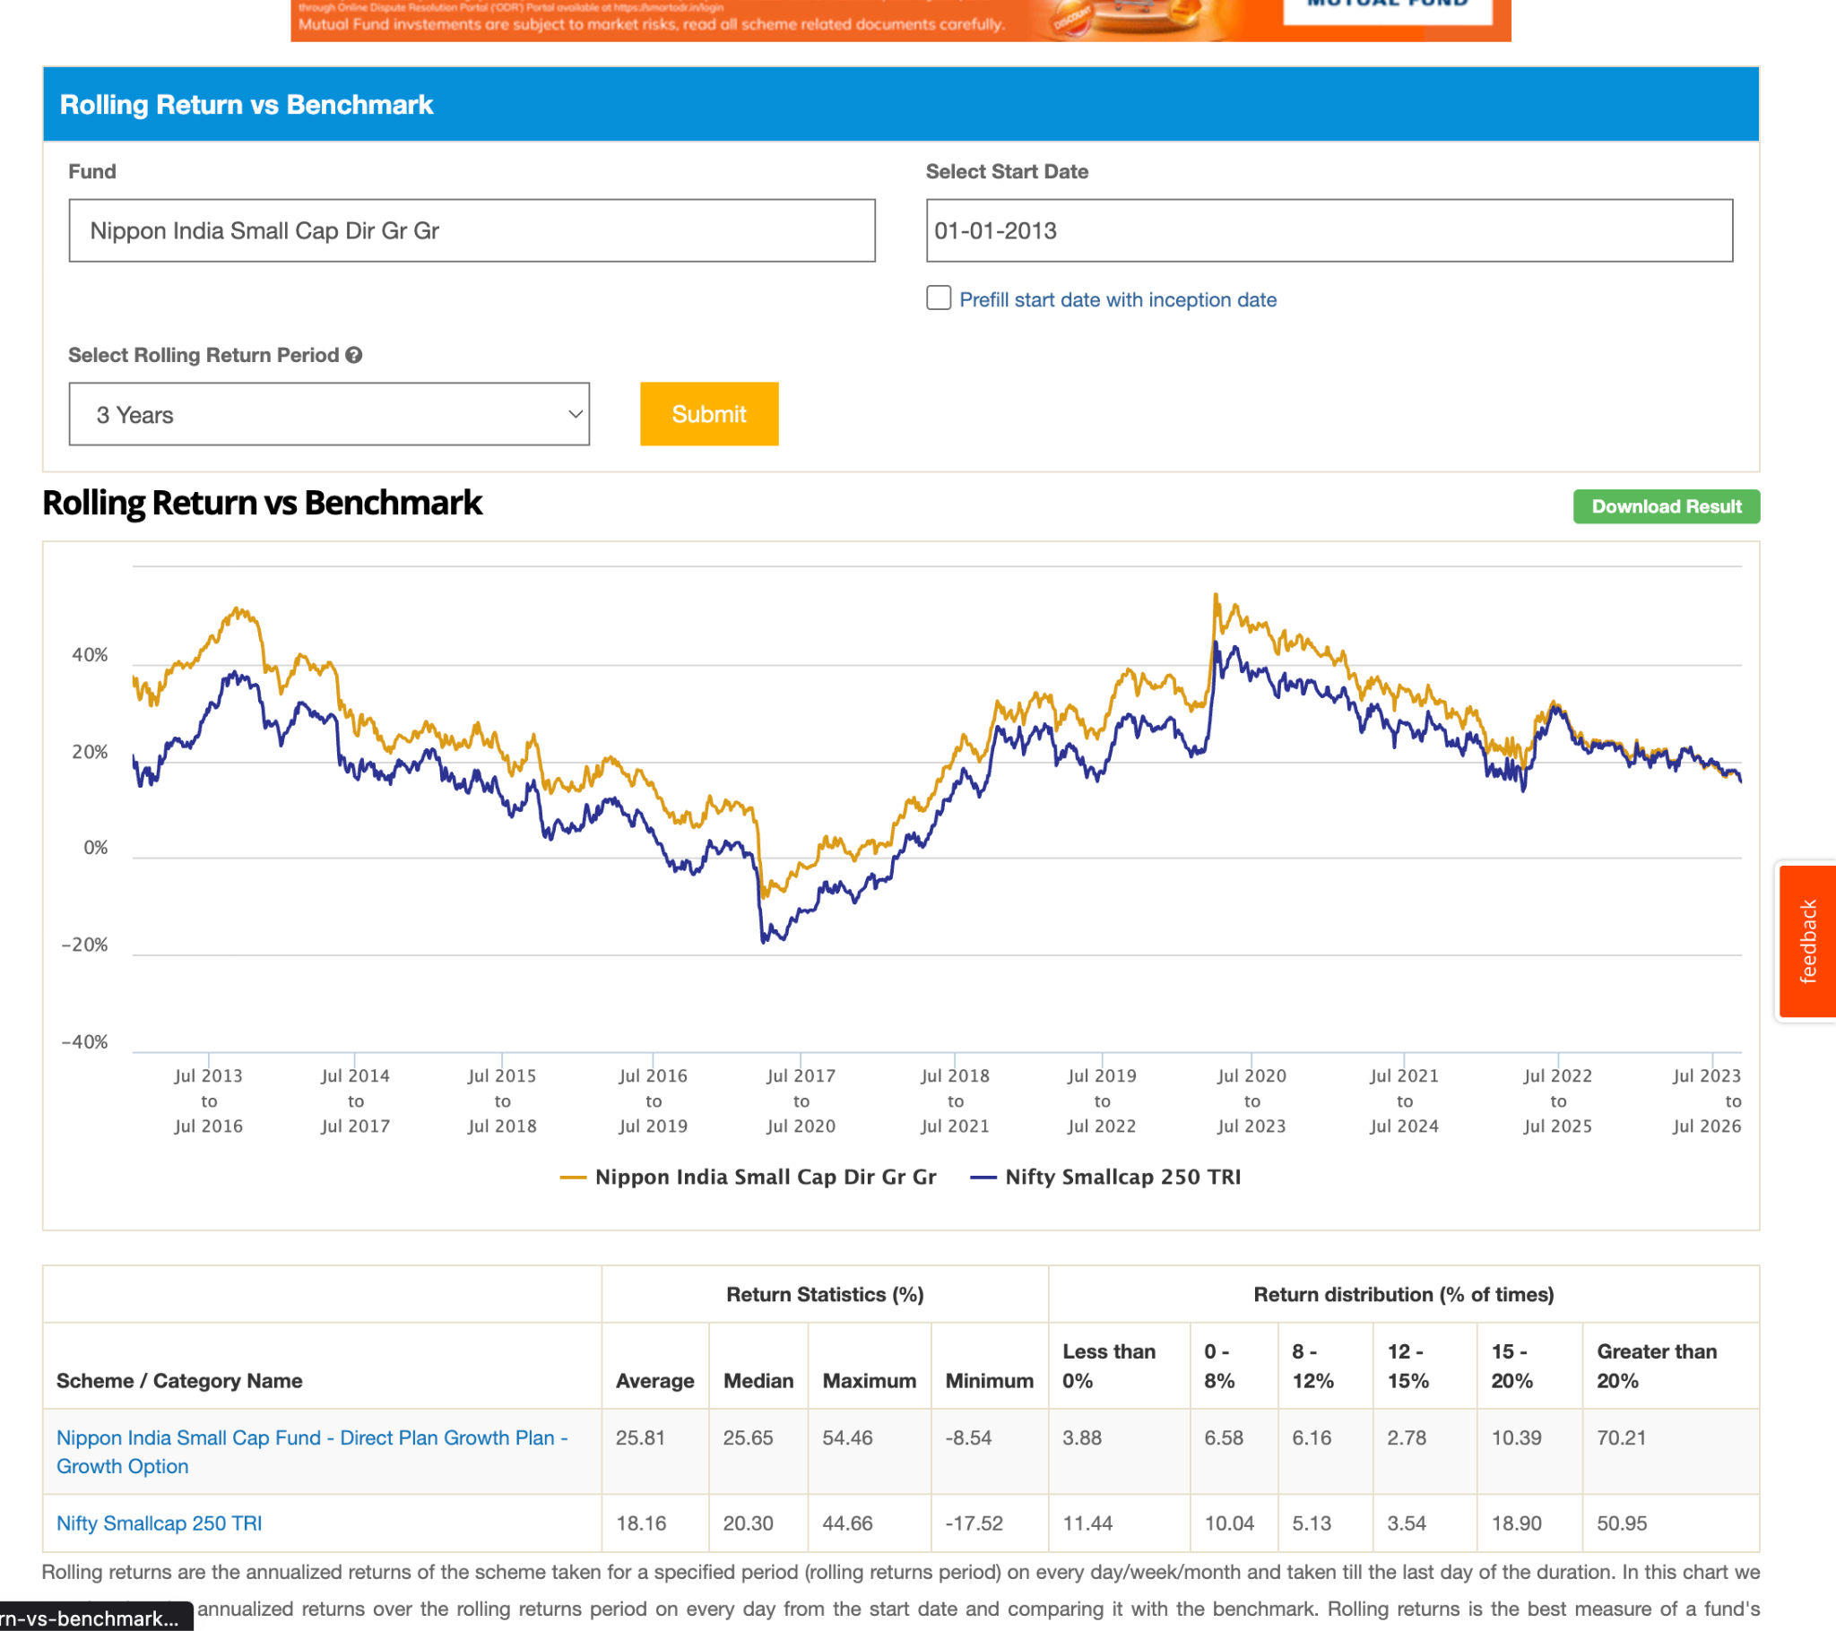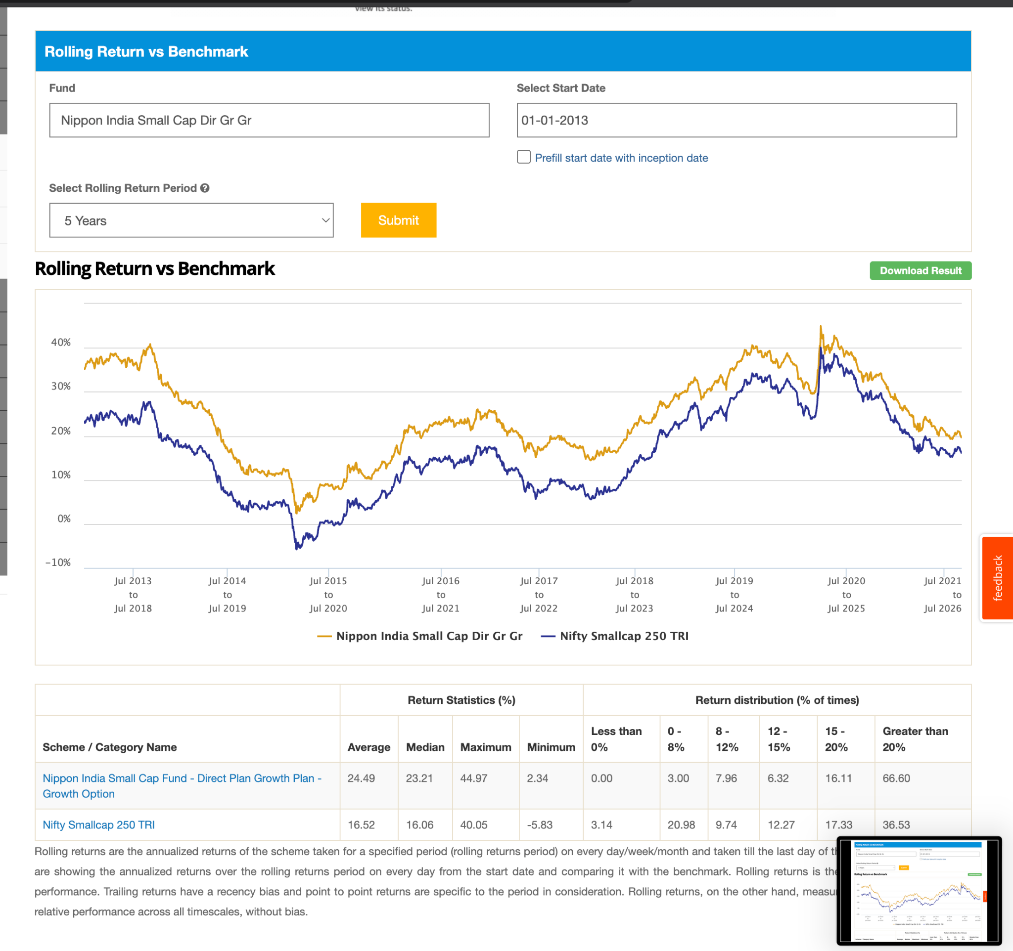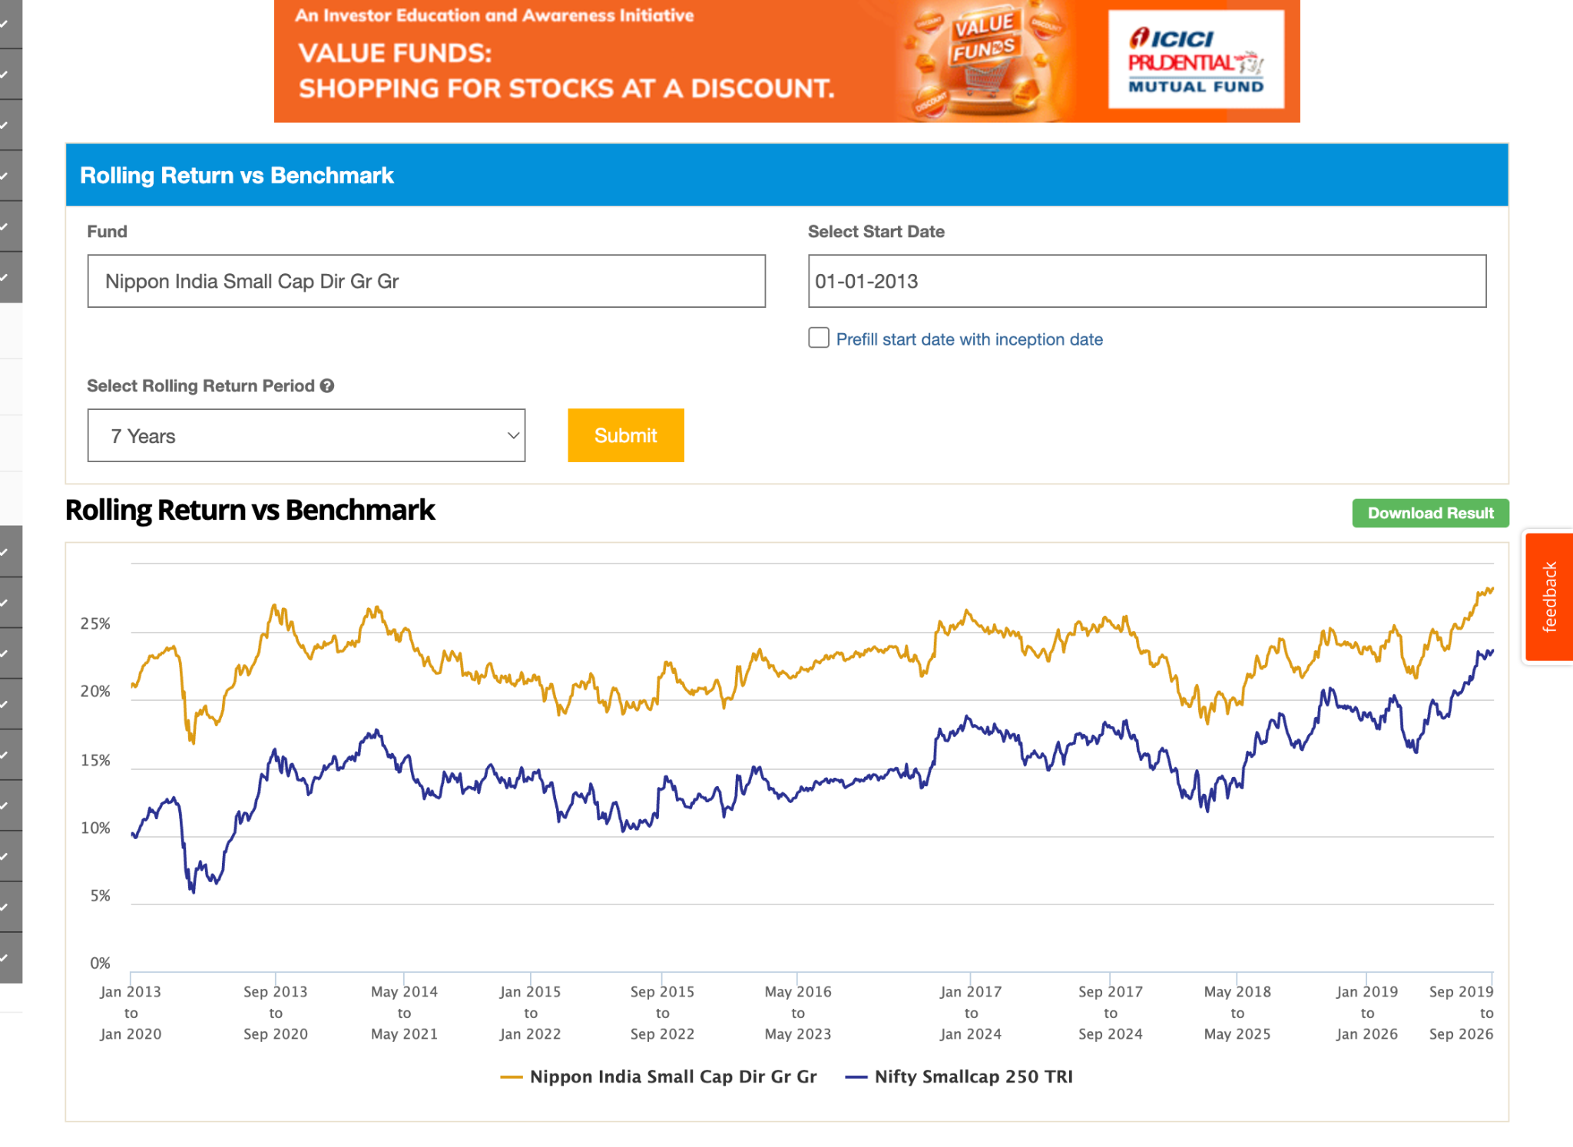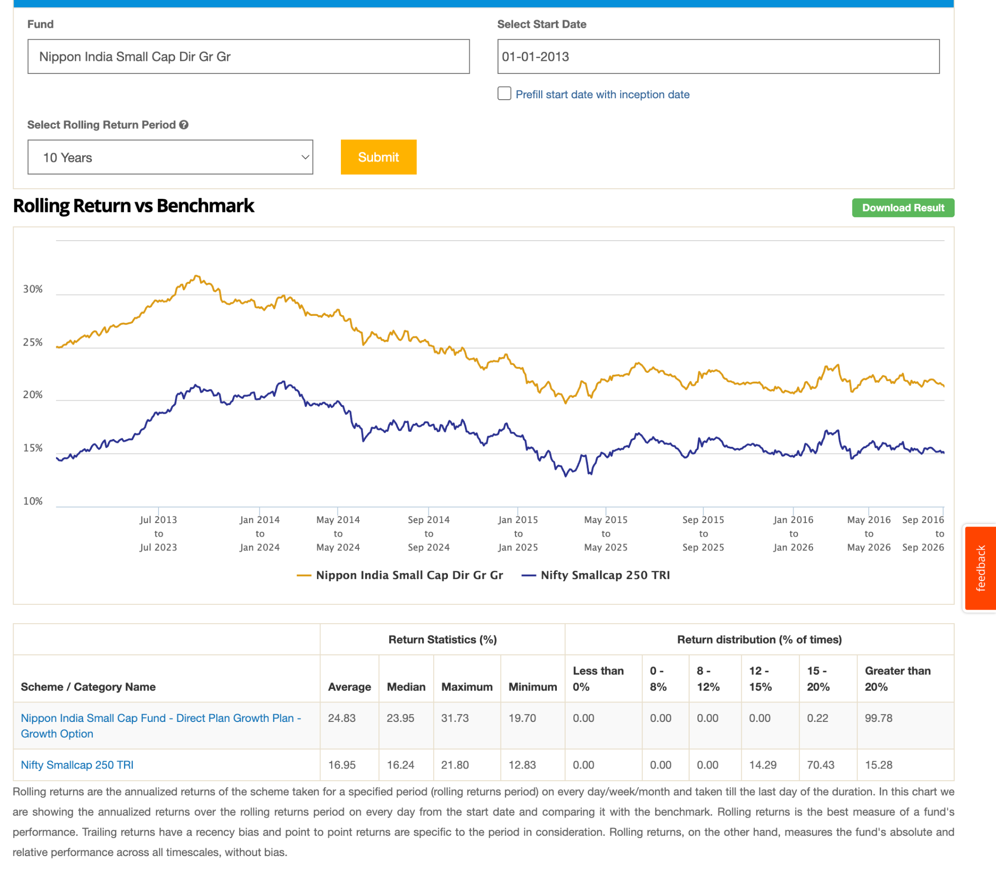

- some fund are working, great, like got hit in corana but recover quickly.

Final:
- nippon. ( no sure about large AUM )
- invesco ( last 2-3 )
- bandhan
- edeilsesis, consistent performance ( except last 3-4 )
observation
- motilal small cap -> v new
- mirae small cap -> v new
- quant
- hsbc
- dsp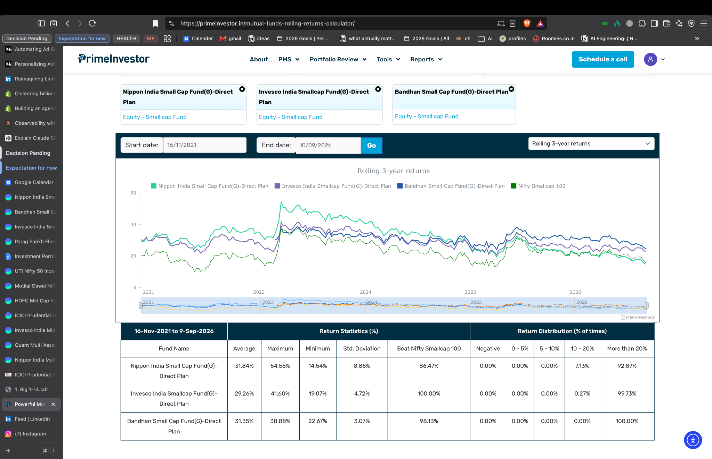
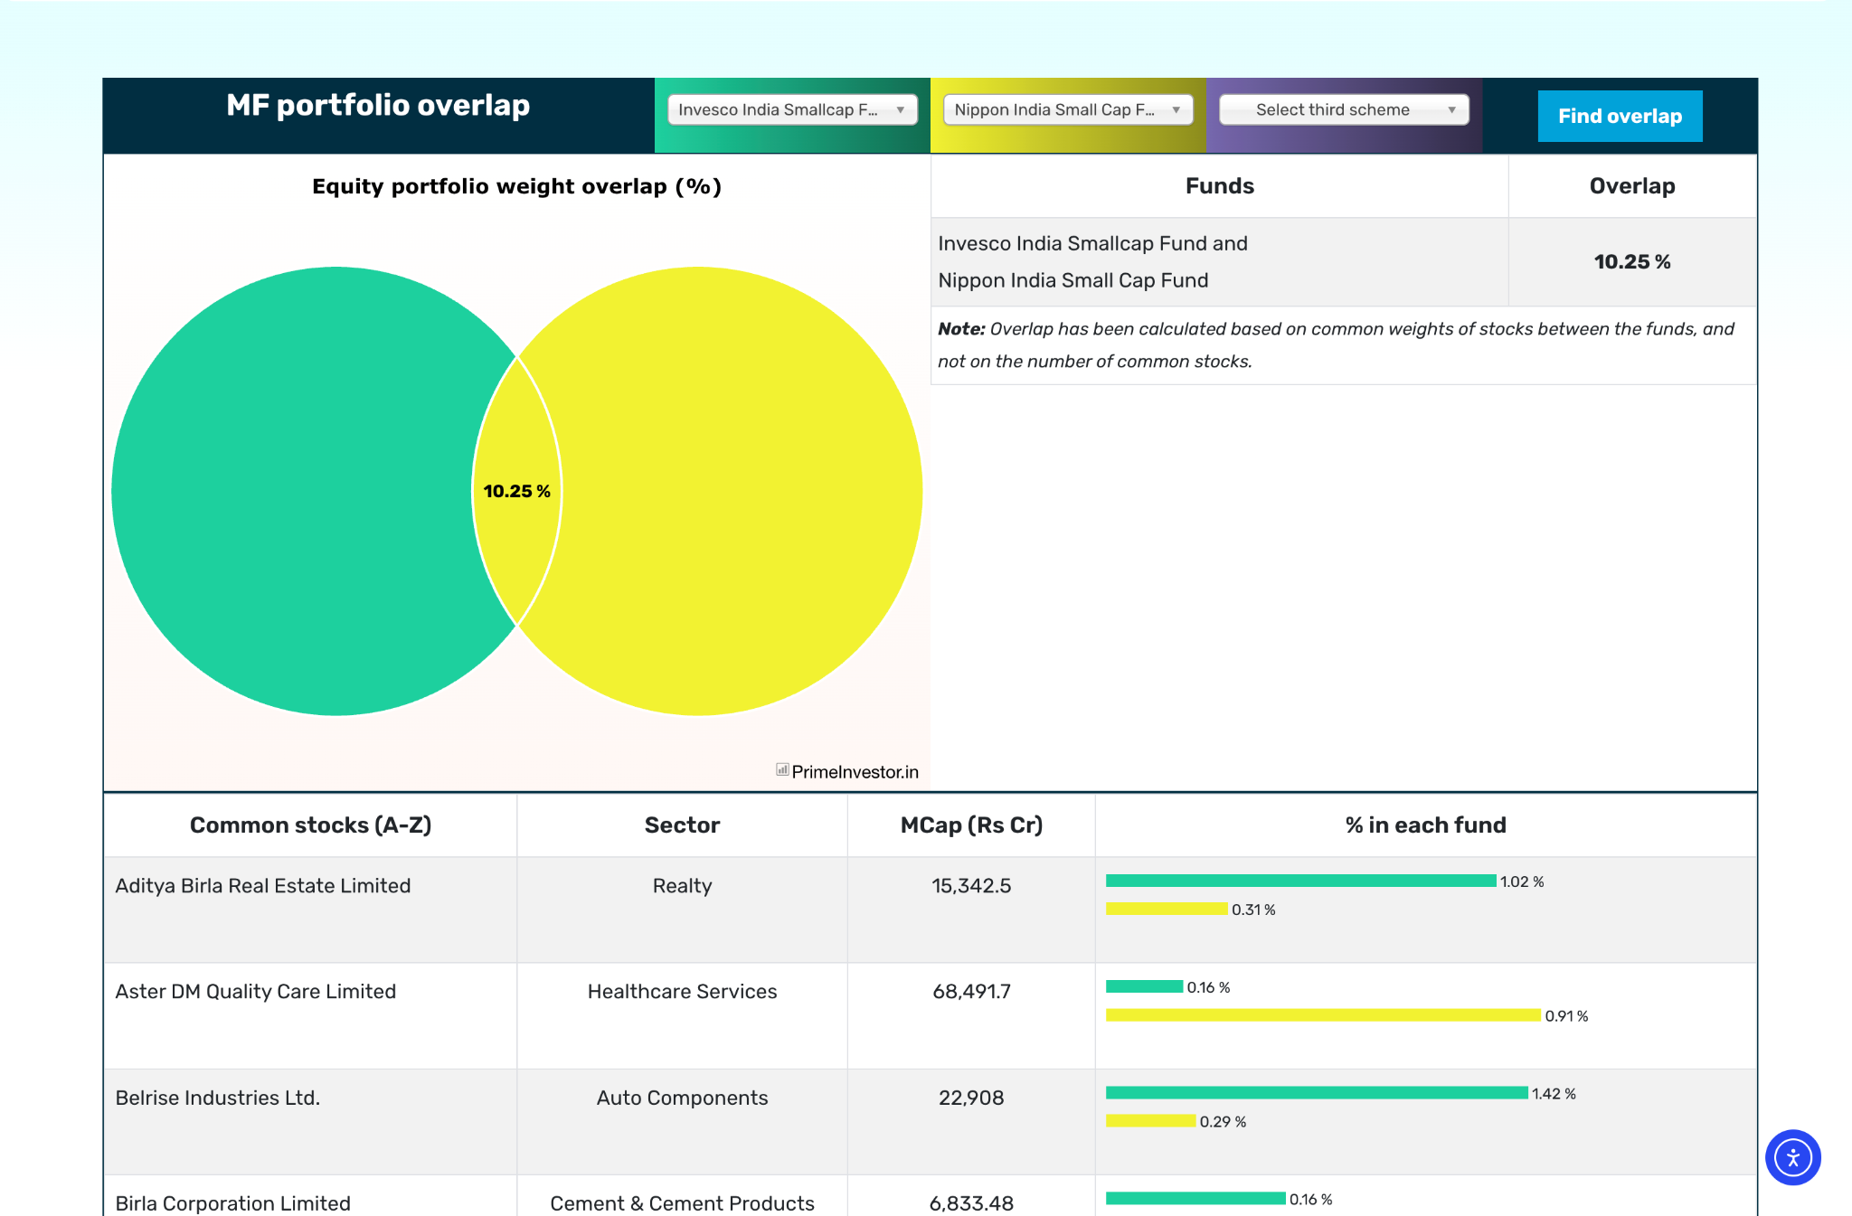
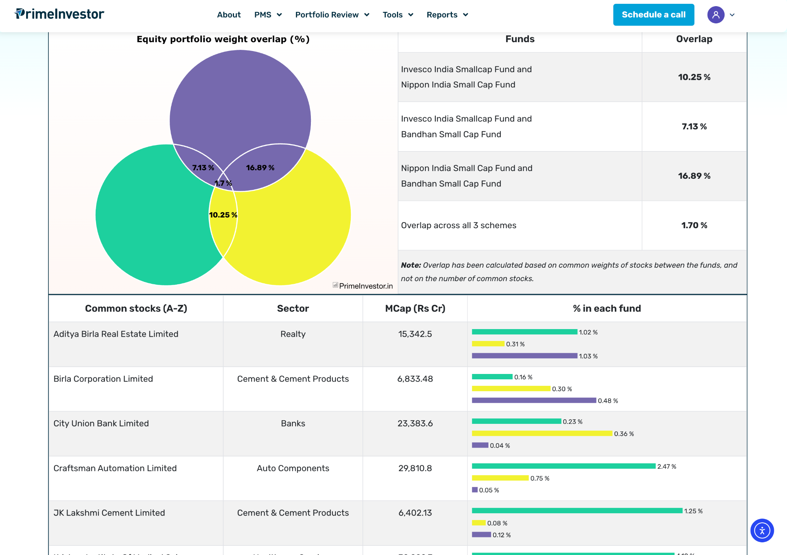

midcap150 tri 1month

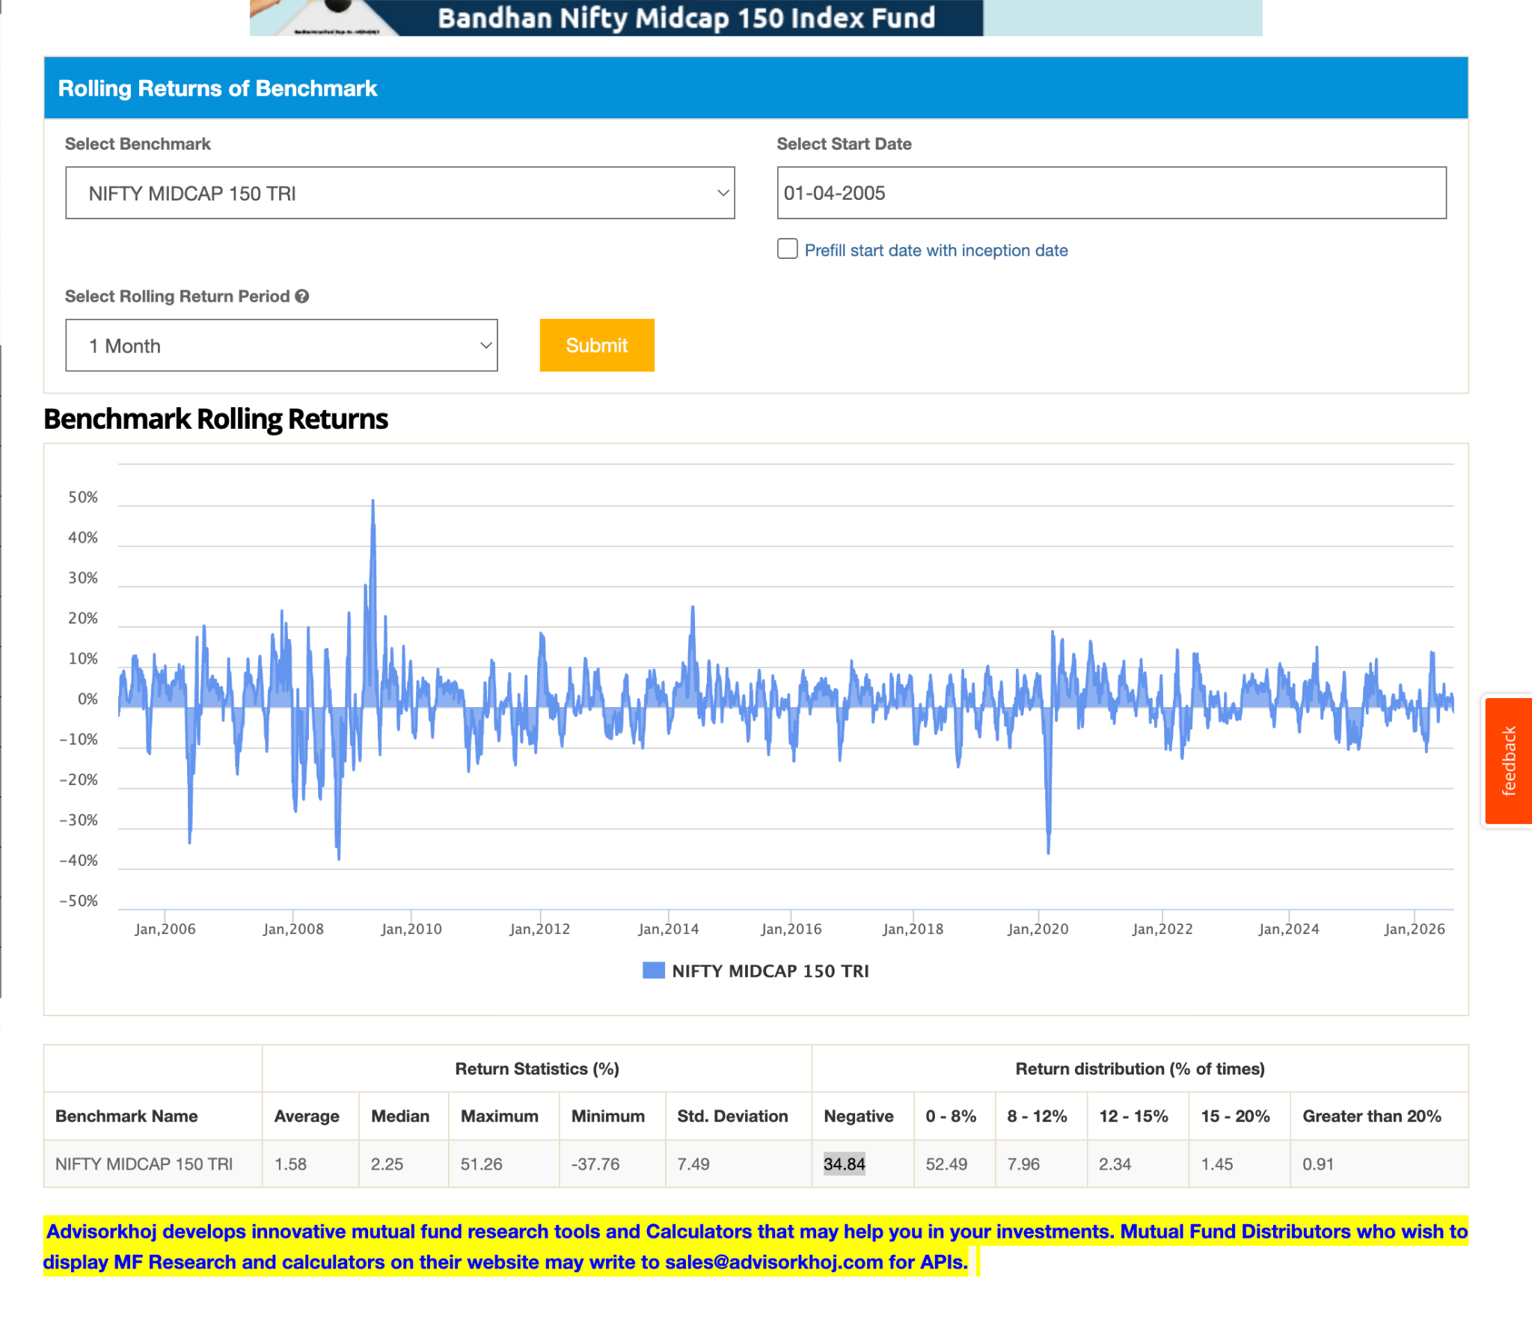
midcap 150 tri , 20y, 1 month rolling average, negative distribution via python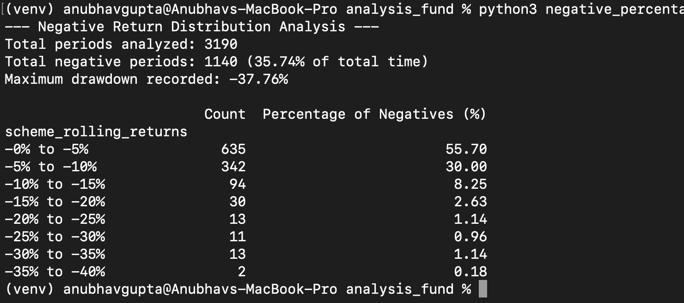
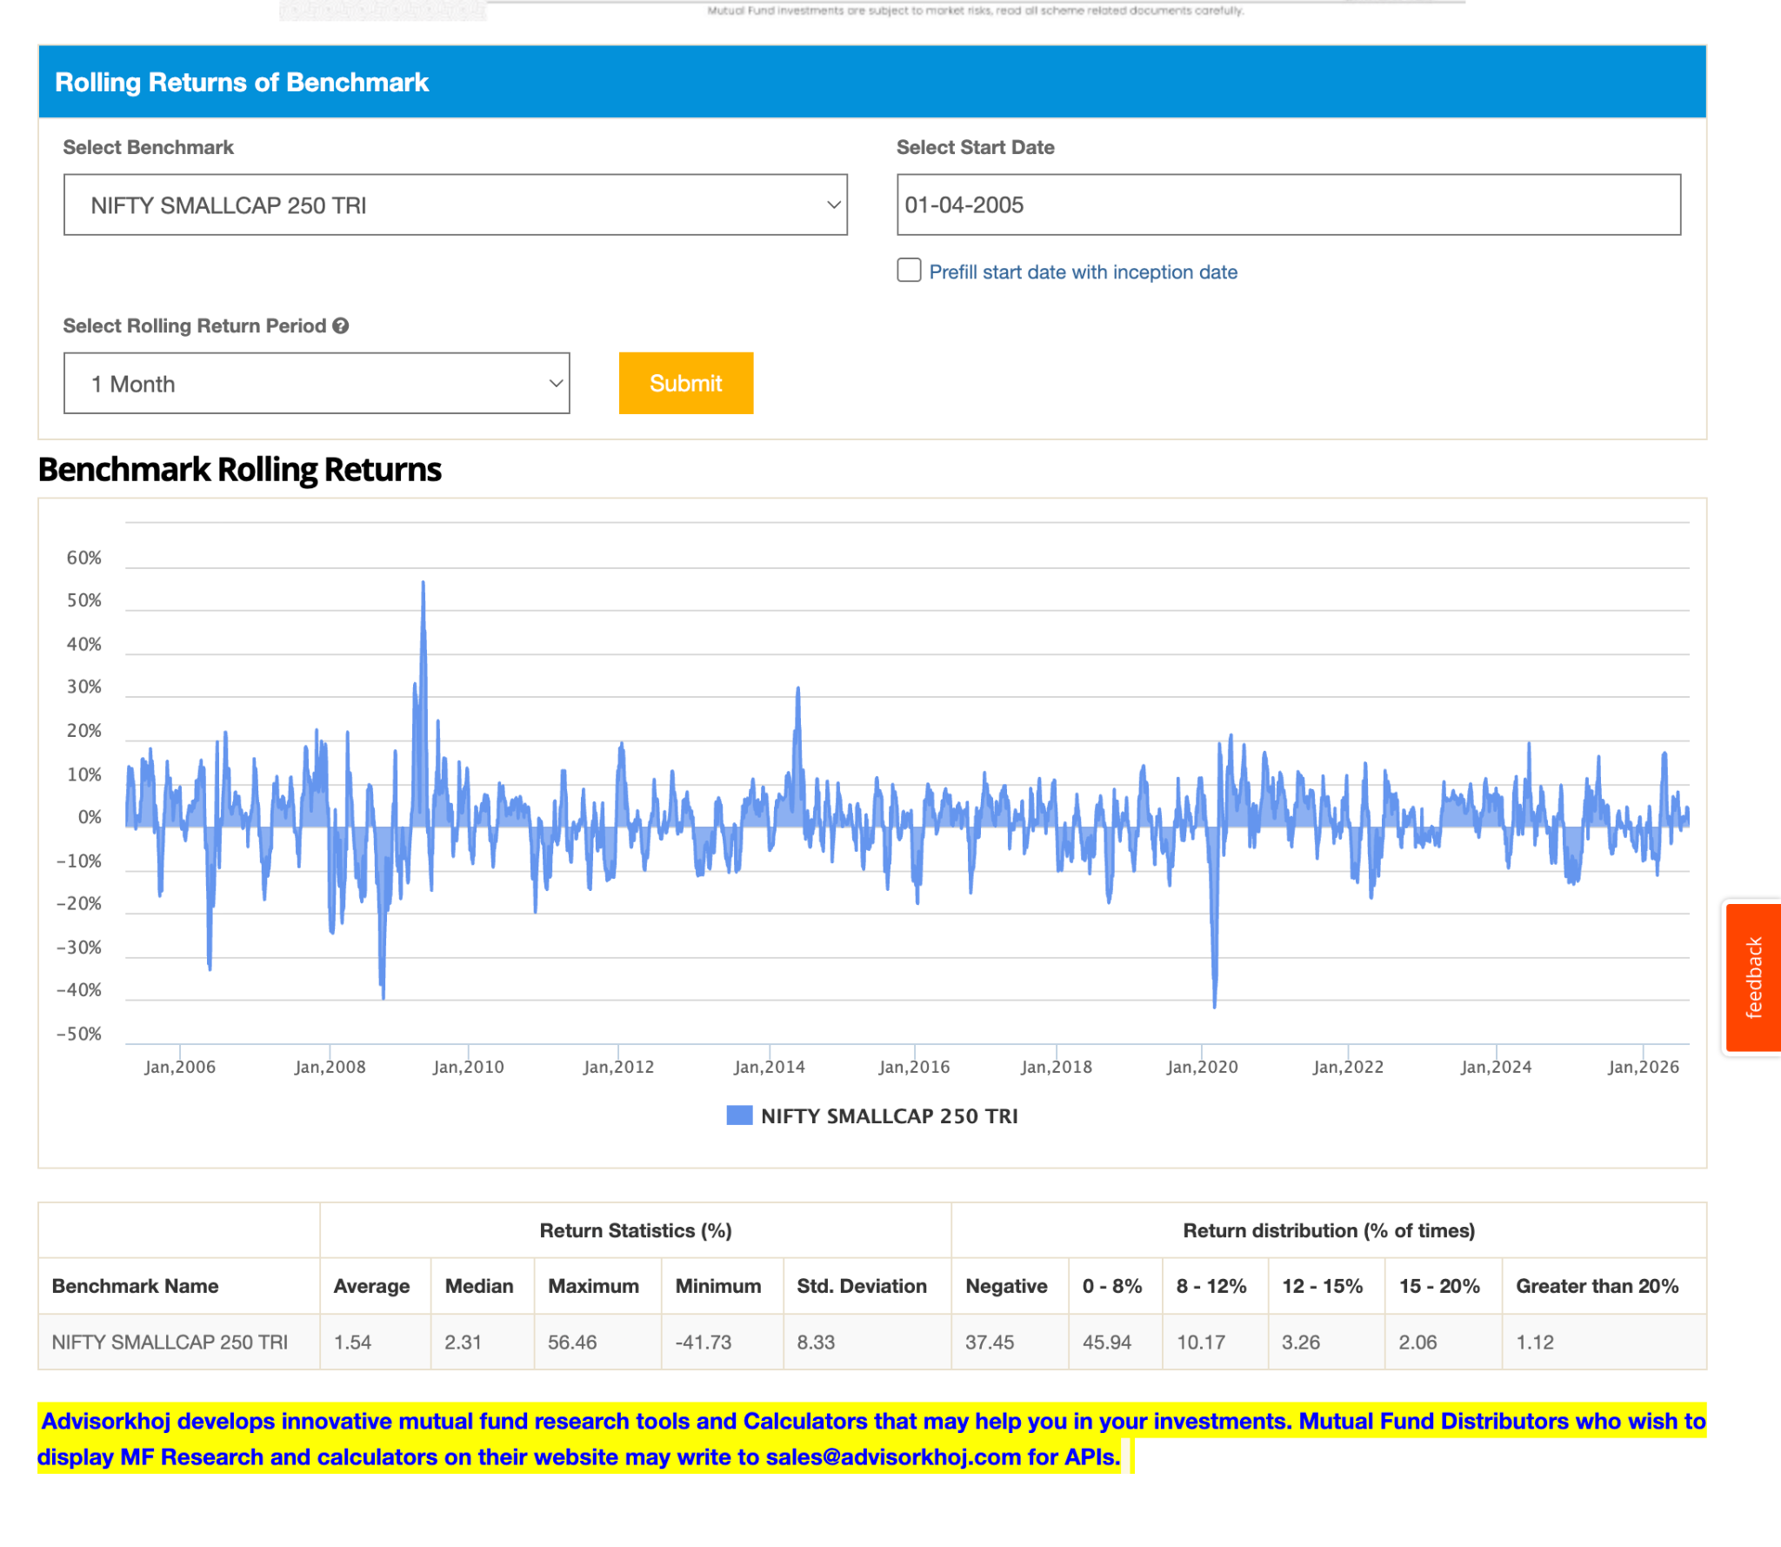
250 SMALL CAP , percentage wise negative last 20Y:
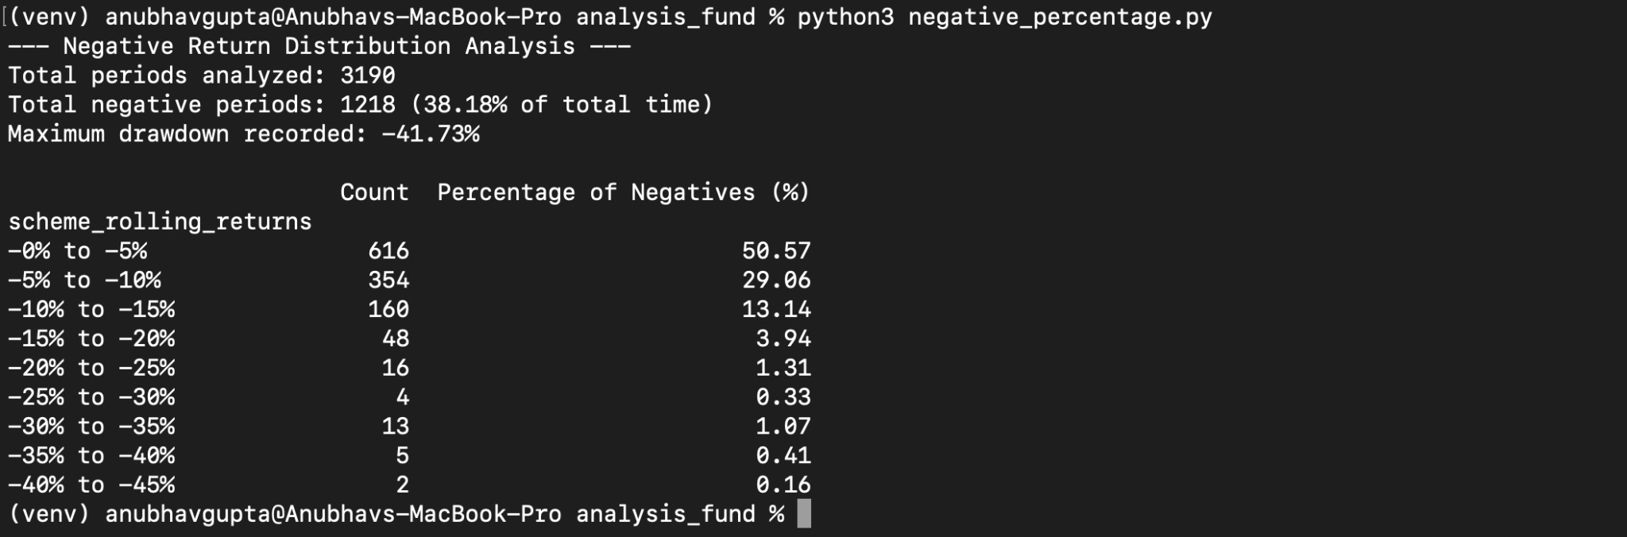
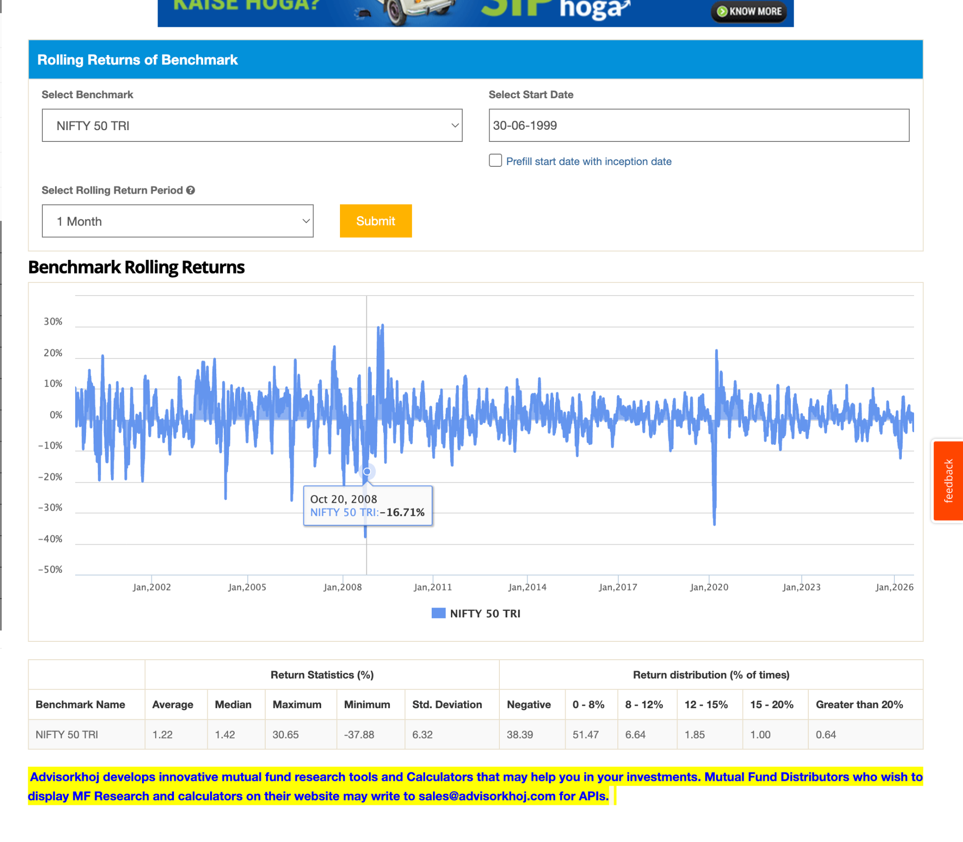

Nifty 50 tri last 20y, every month rolling average negative distribution by python script ( dumped above as json )

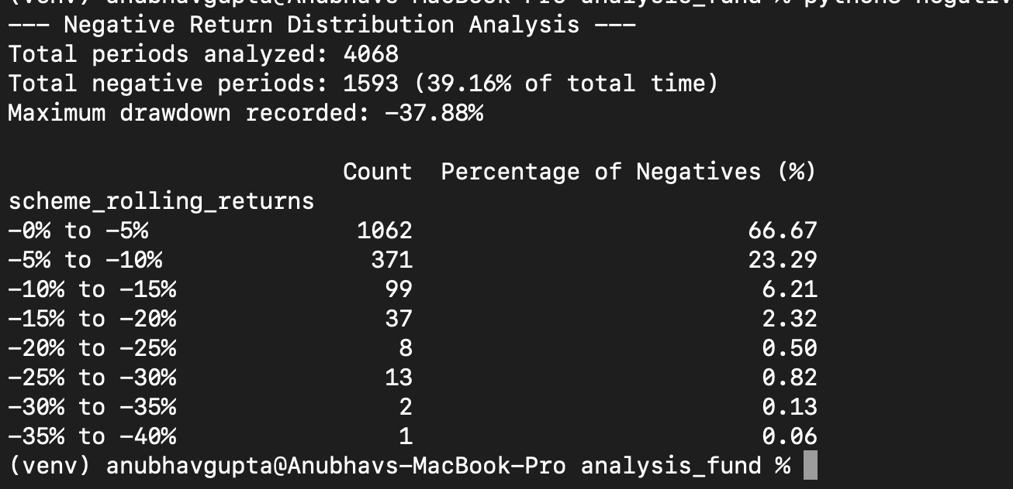
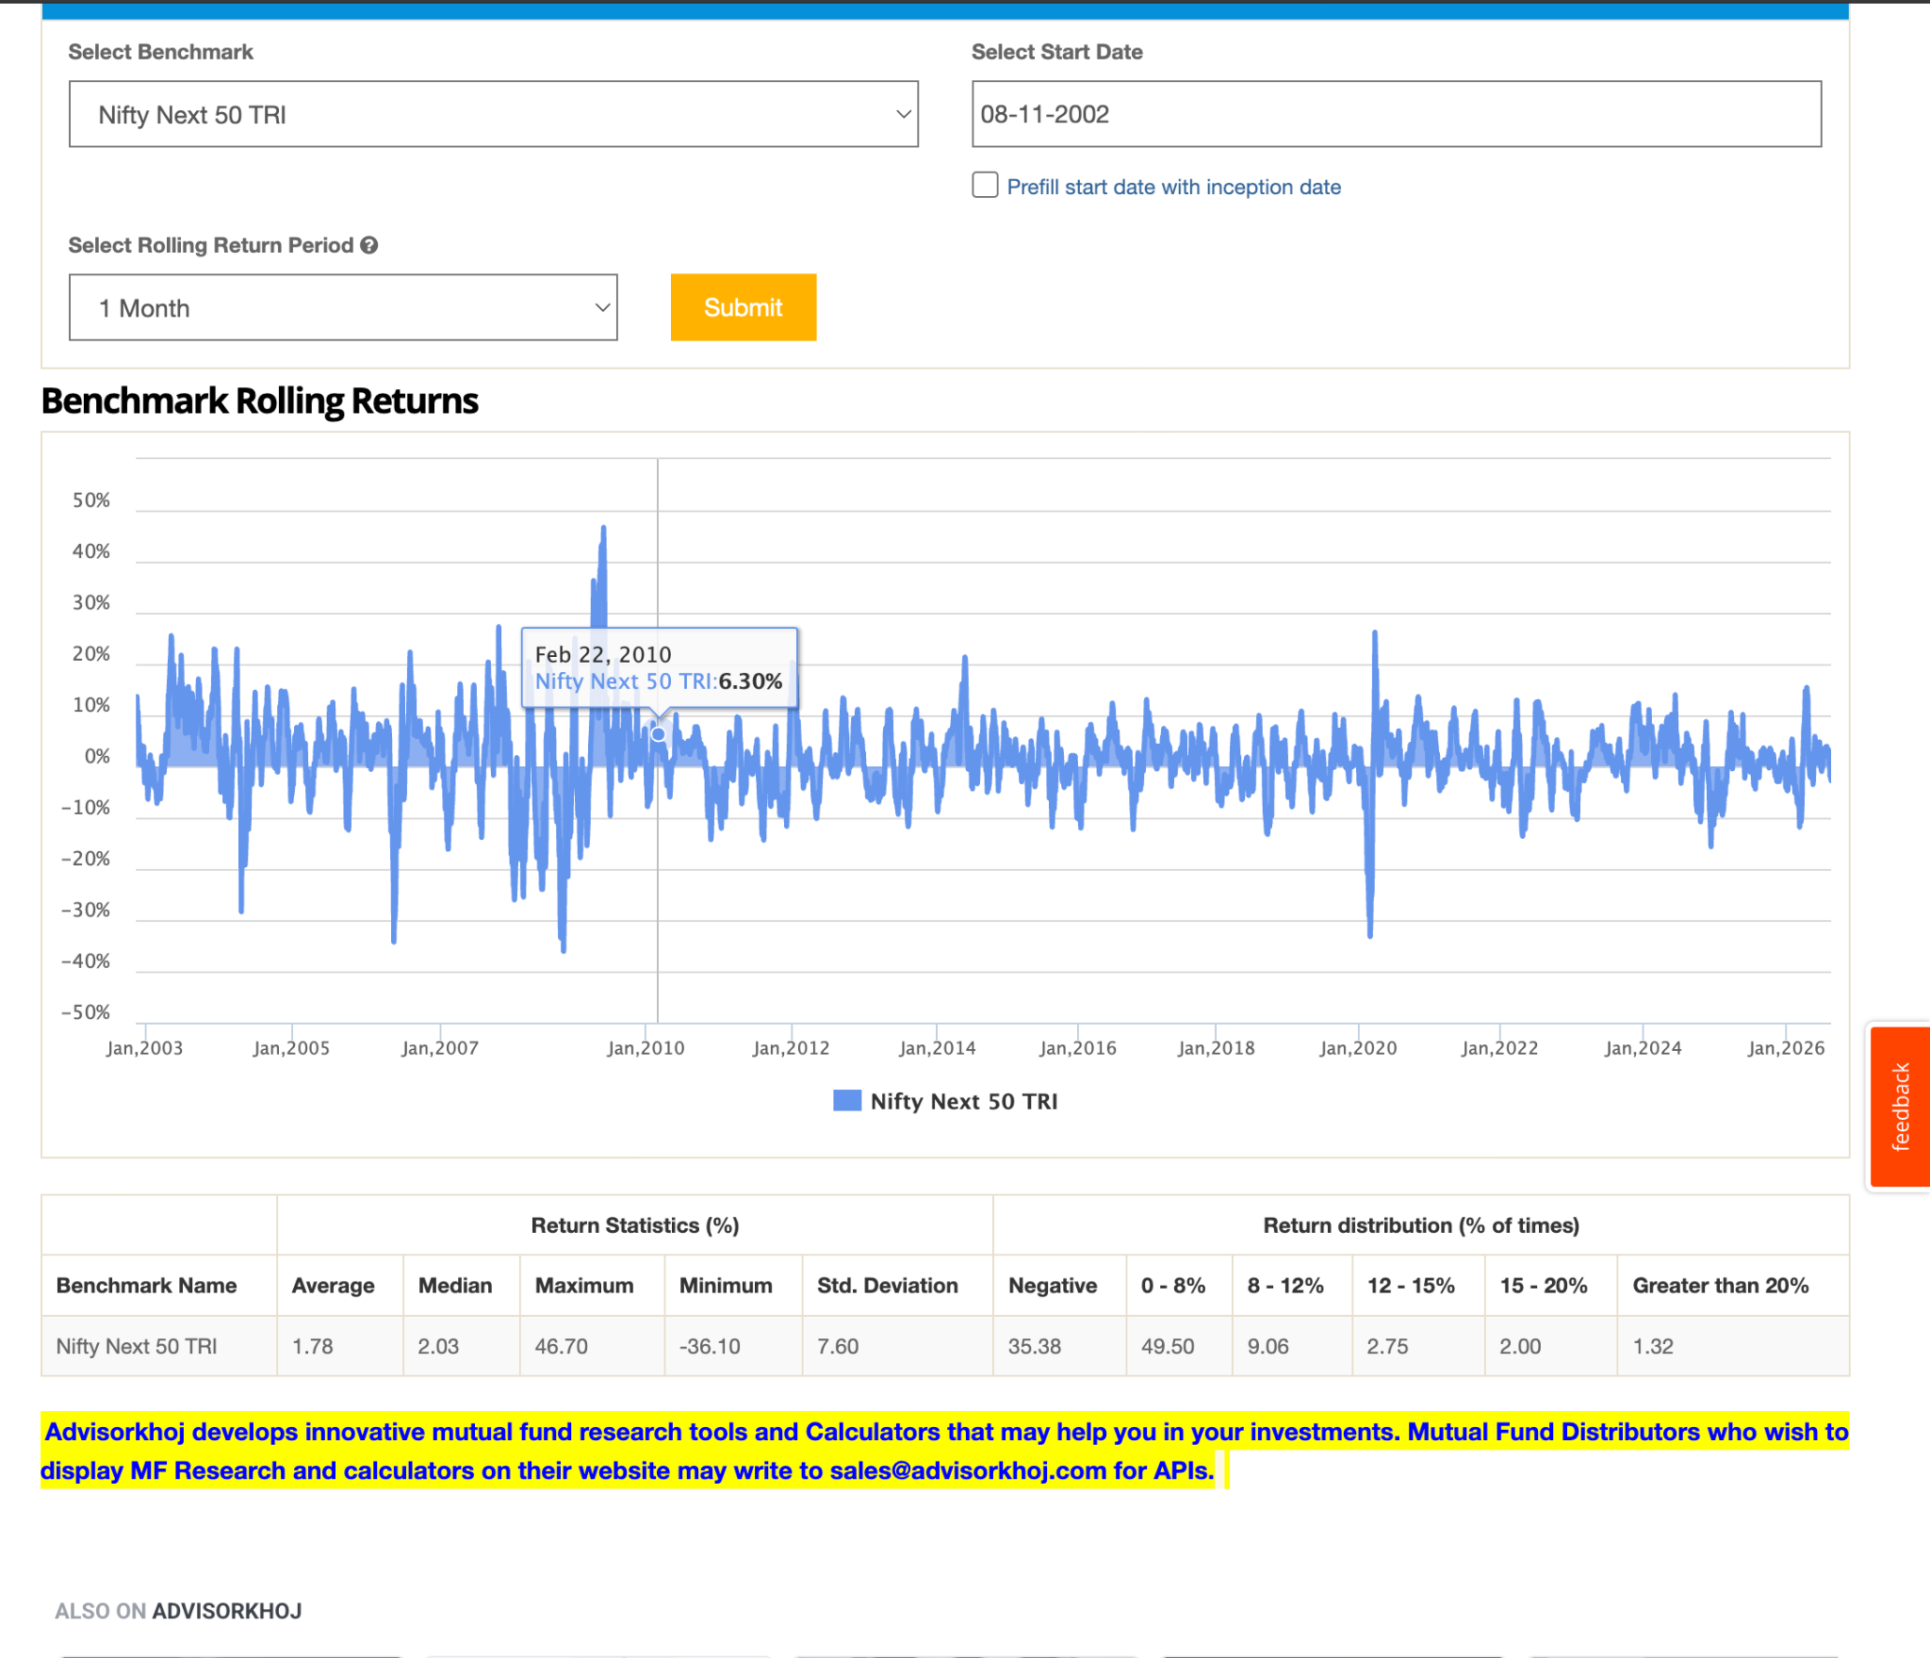
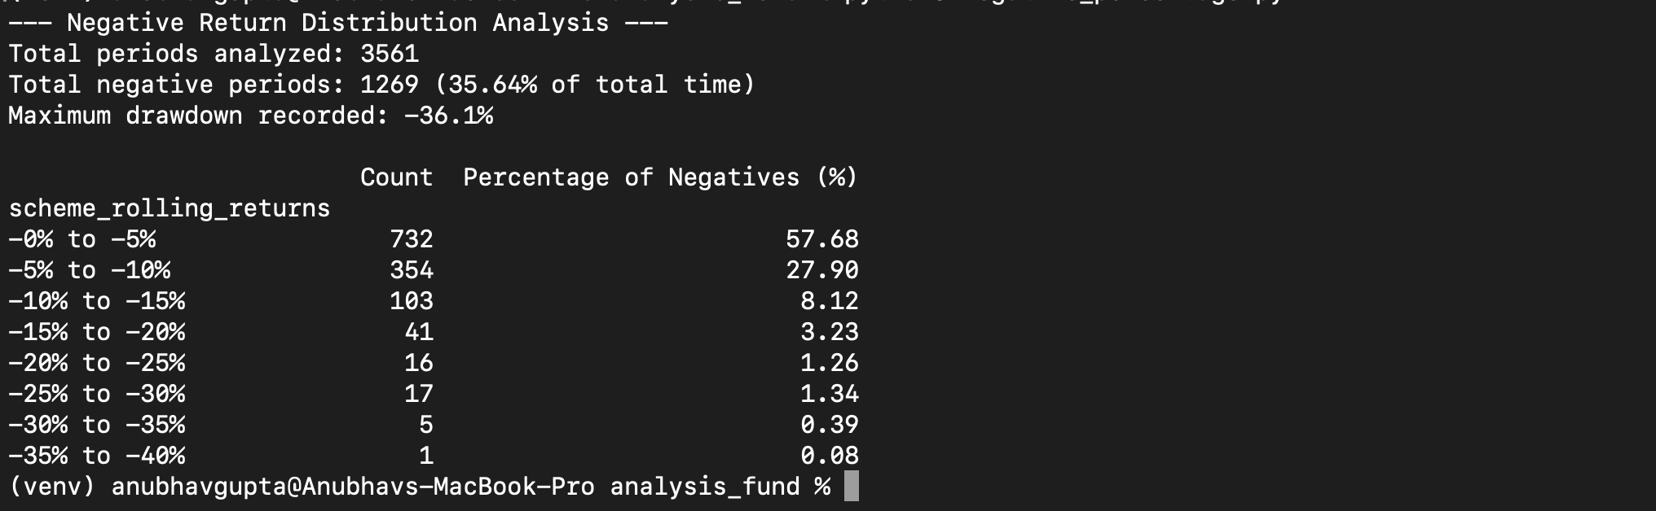
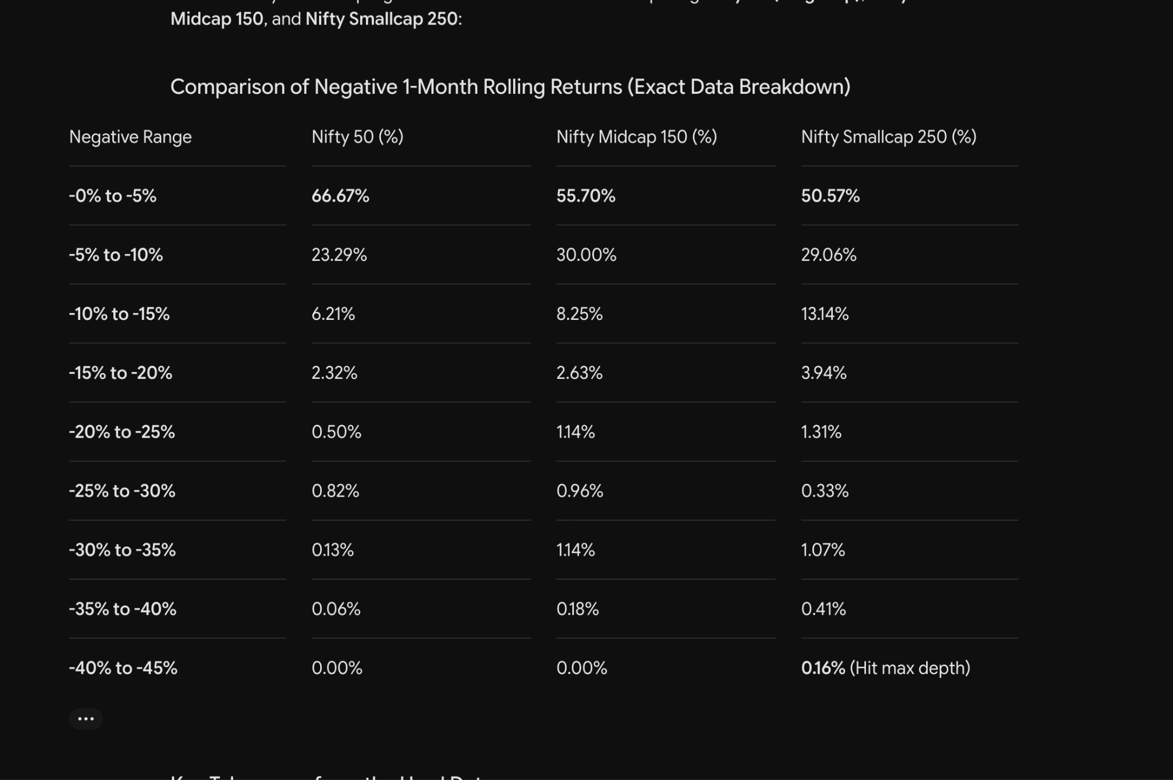

Better negative probability in lsat 20 year ( 2005 - 2026 ( 1 month ) , 2025 ( 1 year ) . with 3100 data points, mean around 50% days data poinuts.
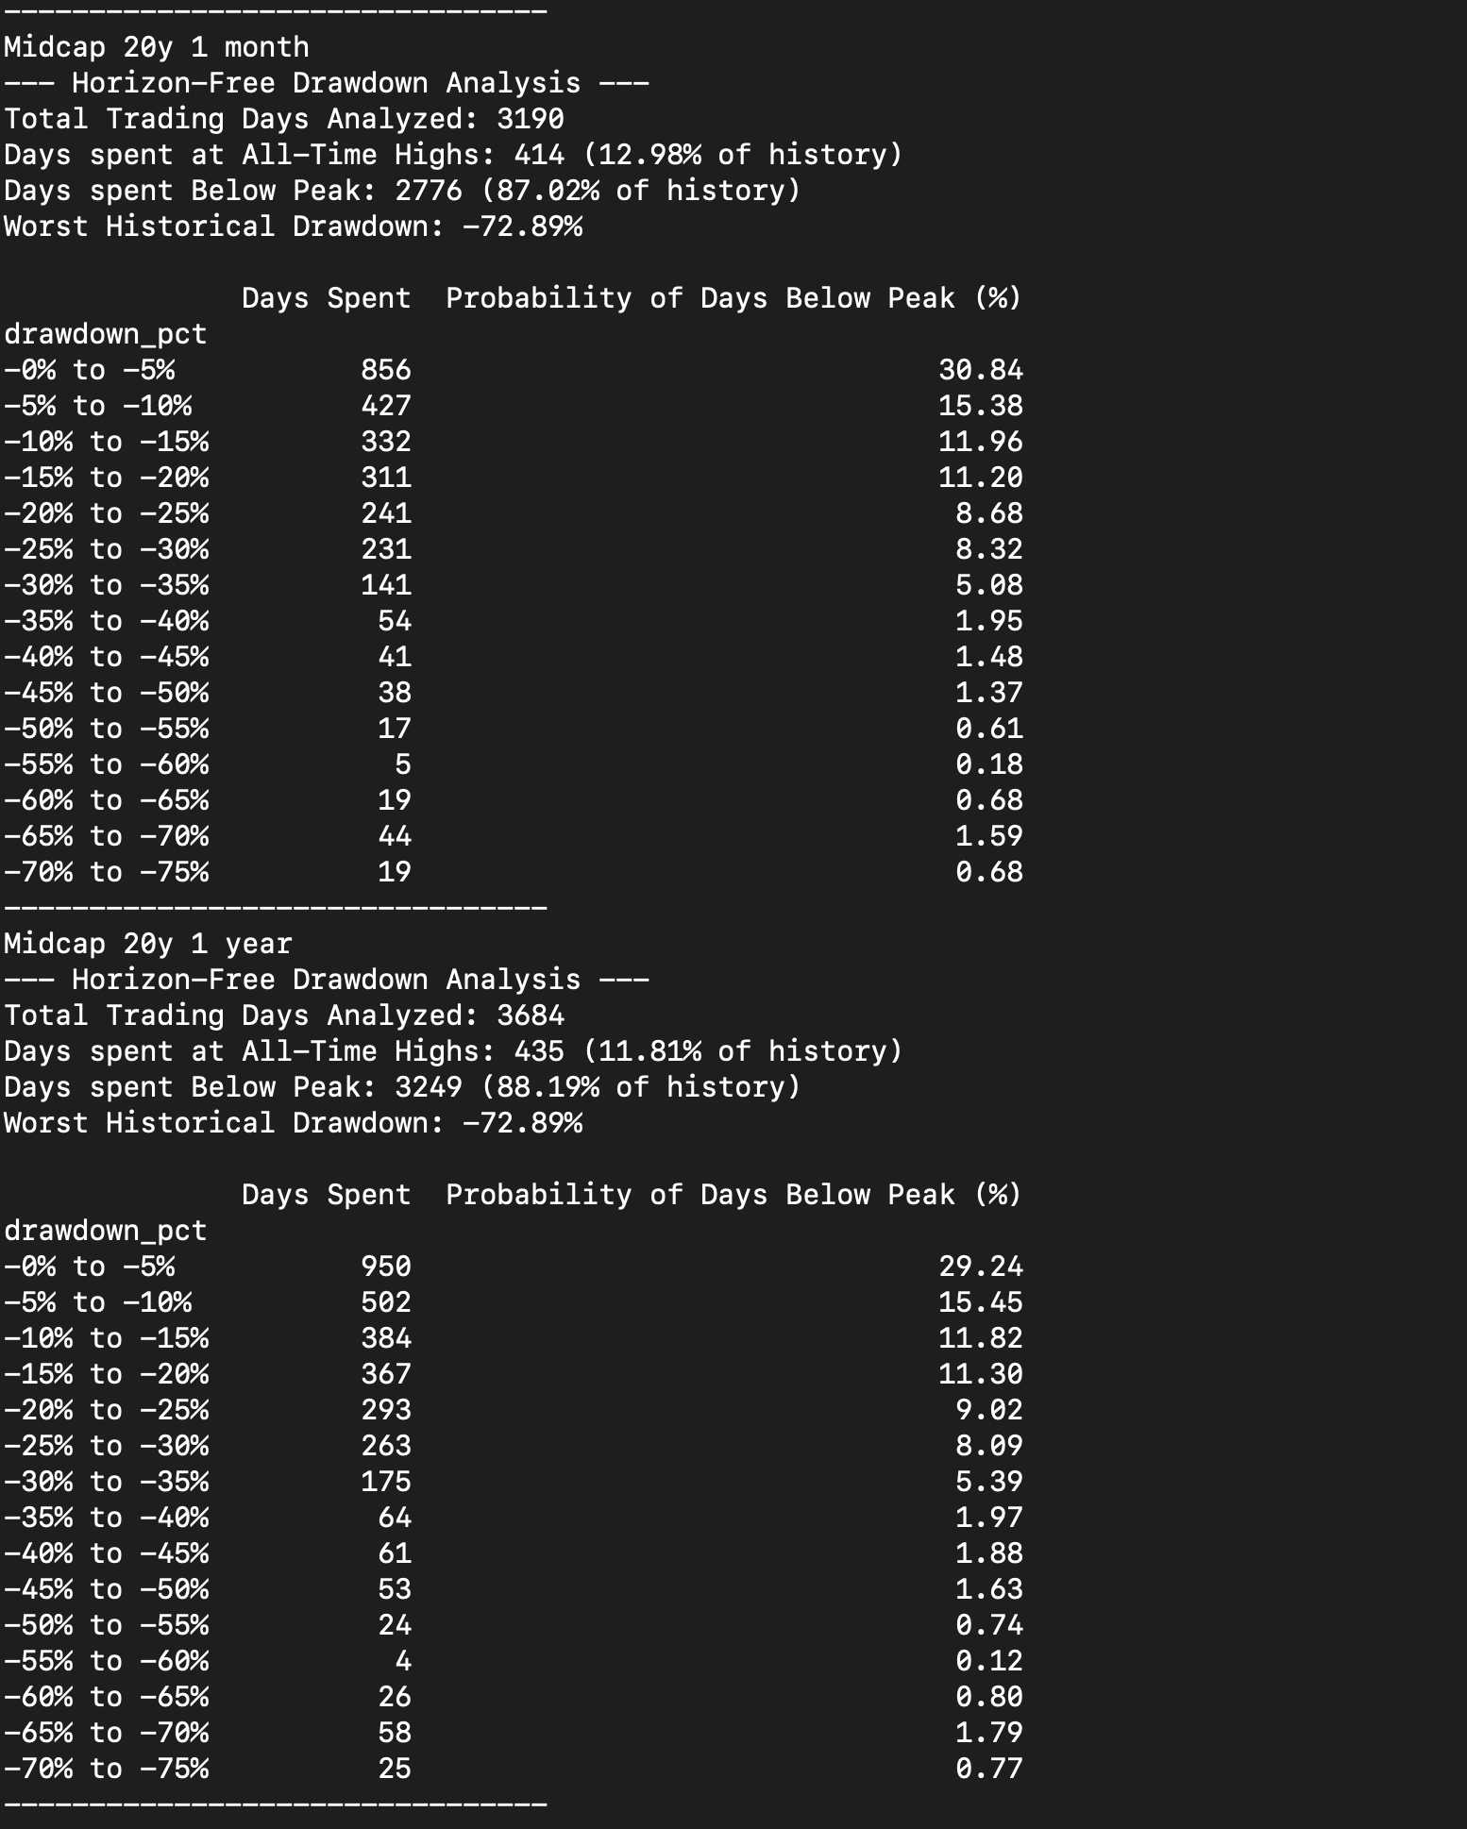
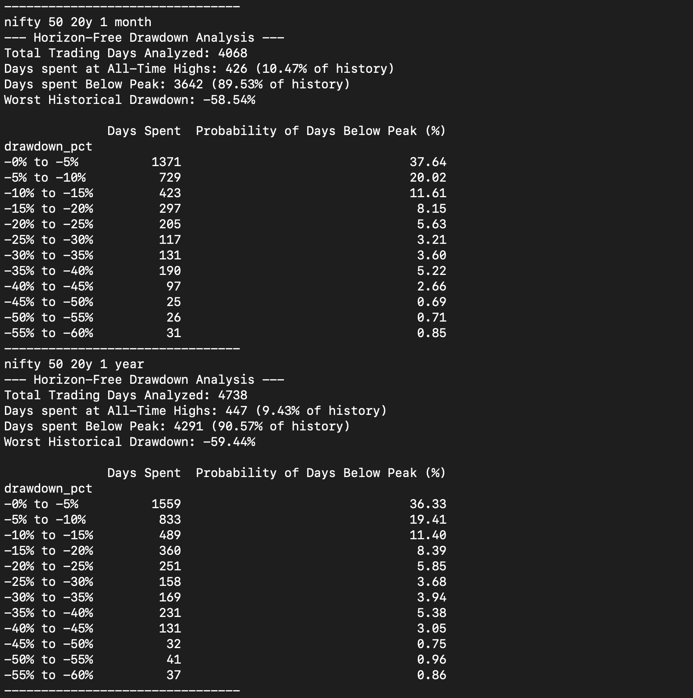
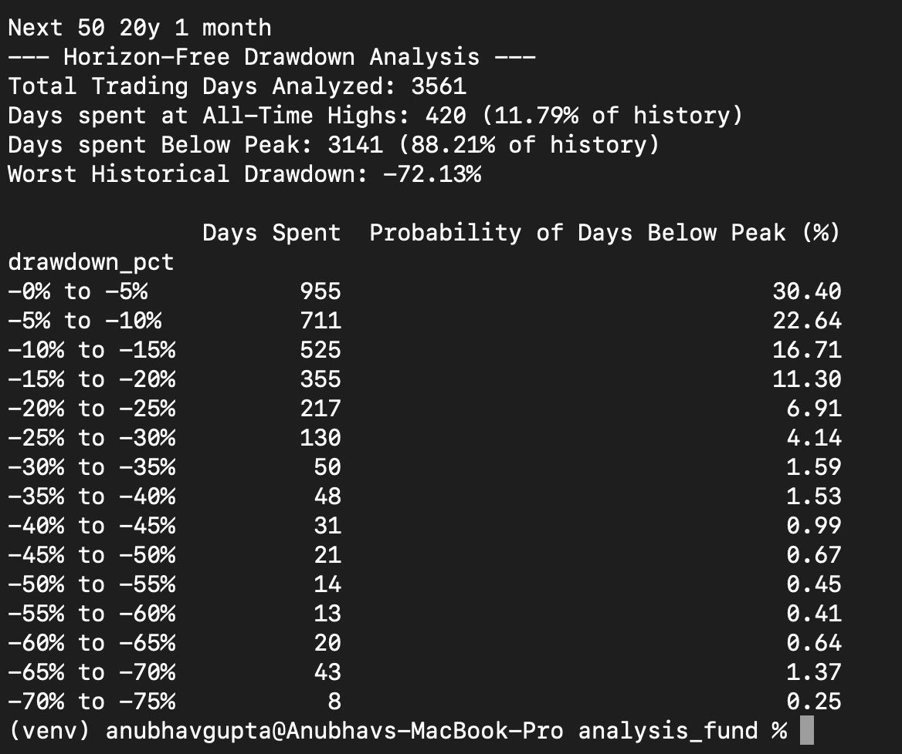

Small Cap:
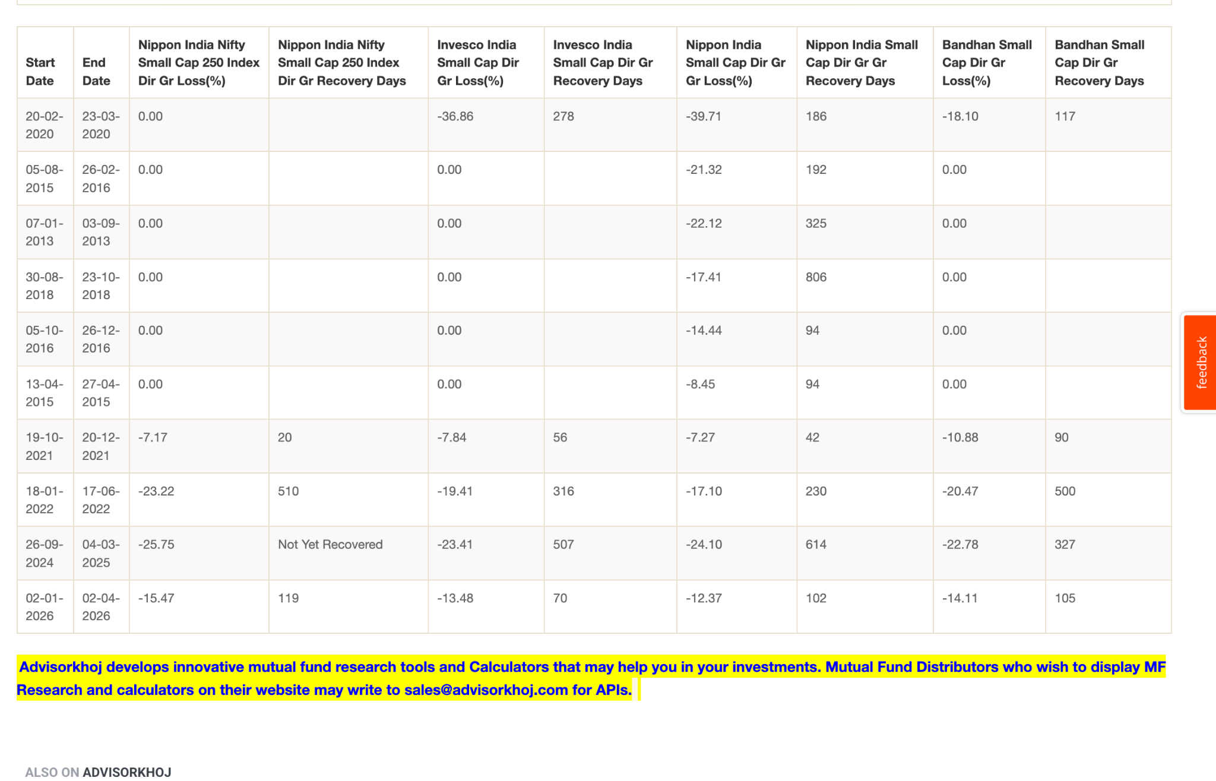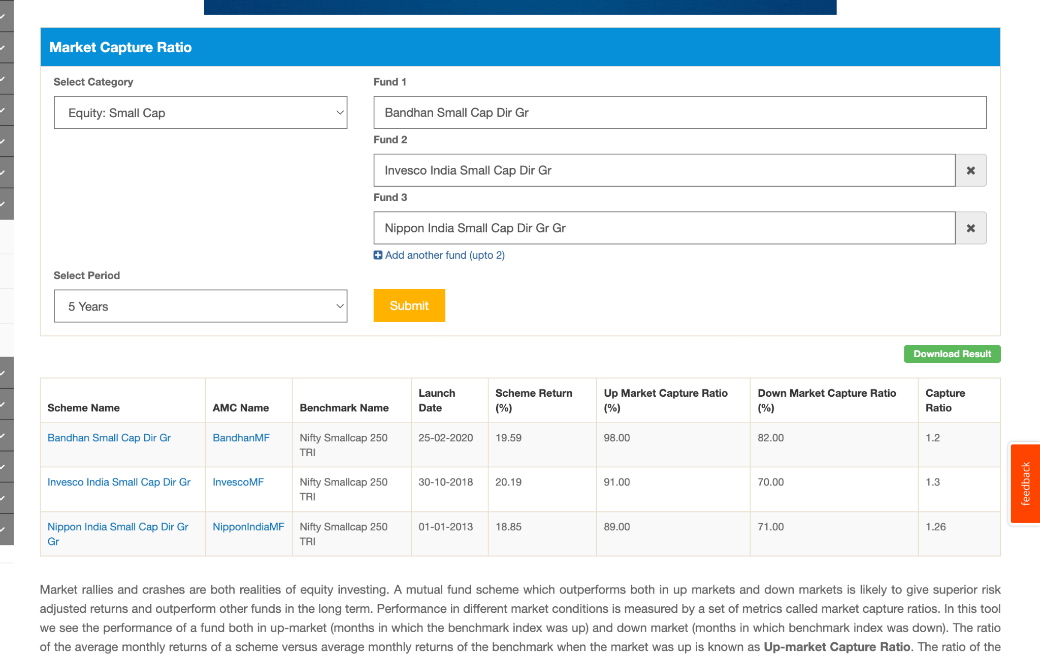
Overall decision

- Keep 10% portfolio allocation to small caps for now; may increase after gaining more experience.
- Prefer active funds over a small-cap index for now. Reason: small-cap universe is riskier, 100% equity, and a formula-based index may not work as well here.
- Small caps are very volatile and can take longer to recover. In the 2008 crash, Nifty Small-cap 250 TRI fell ~76% vs ~61% for Nifty 100.
- 2–3 small-cap funds feels like the sweet spot: not concentrated in one manager/fund, but also not over-diversified.
- Regularly compare each fund against its benchmark/index and keep observing performance.
- Important mental preparation: check how much each fund/index has fallen historically, so a future large drawdown isn't a surprise.

1. Nippon India Small Cap ( 15k )
Why I chose it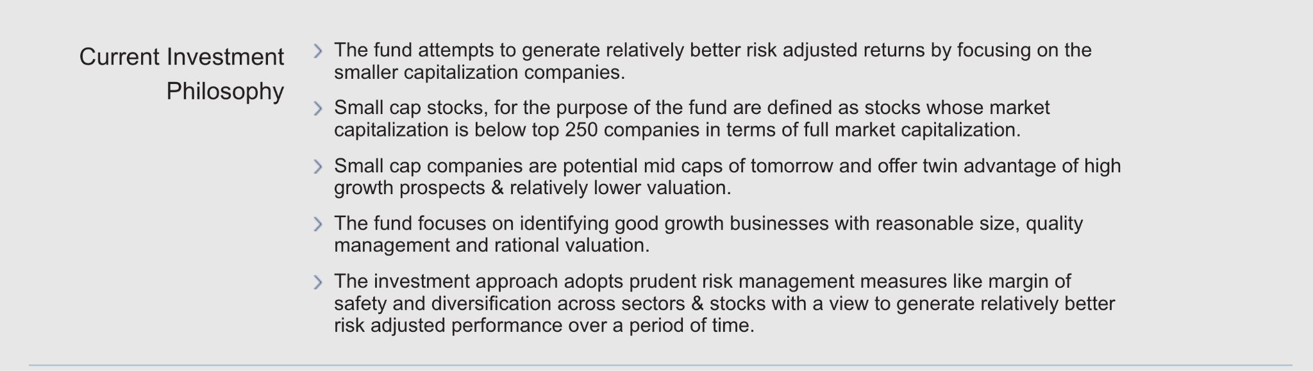
- Old fund / experienced through multiple market cycles → has seen more ups and downs than many newer small-cap funds.
- Samir Rach has been associated with the fund since 2017 (and earlier experience from 2013).
- Current philosophy: GARP.( size, quality, valuation ) + bottompu + diversified
- Large AUM → initially viewed this positively for liquidity/reliability, although I still have some concern about whether the AUM has become too large for a small-cap fund.
- Has worked well over a long period and has already demonstrated behaviour through difficult markets.
- in between allocation small 70%. 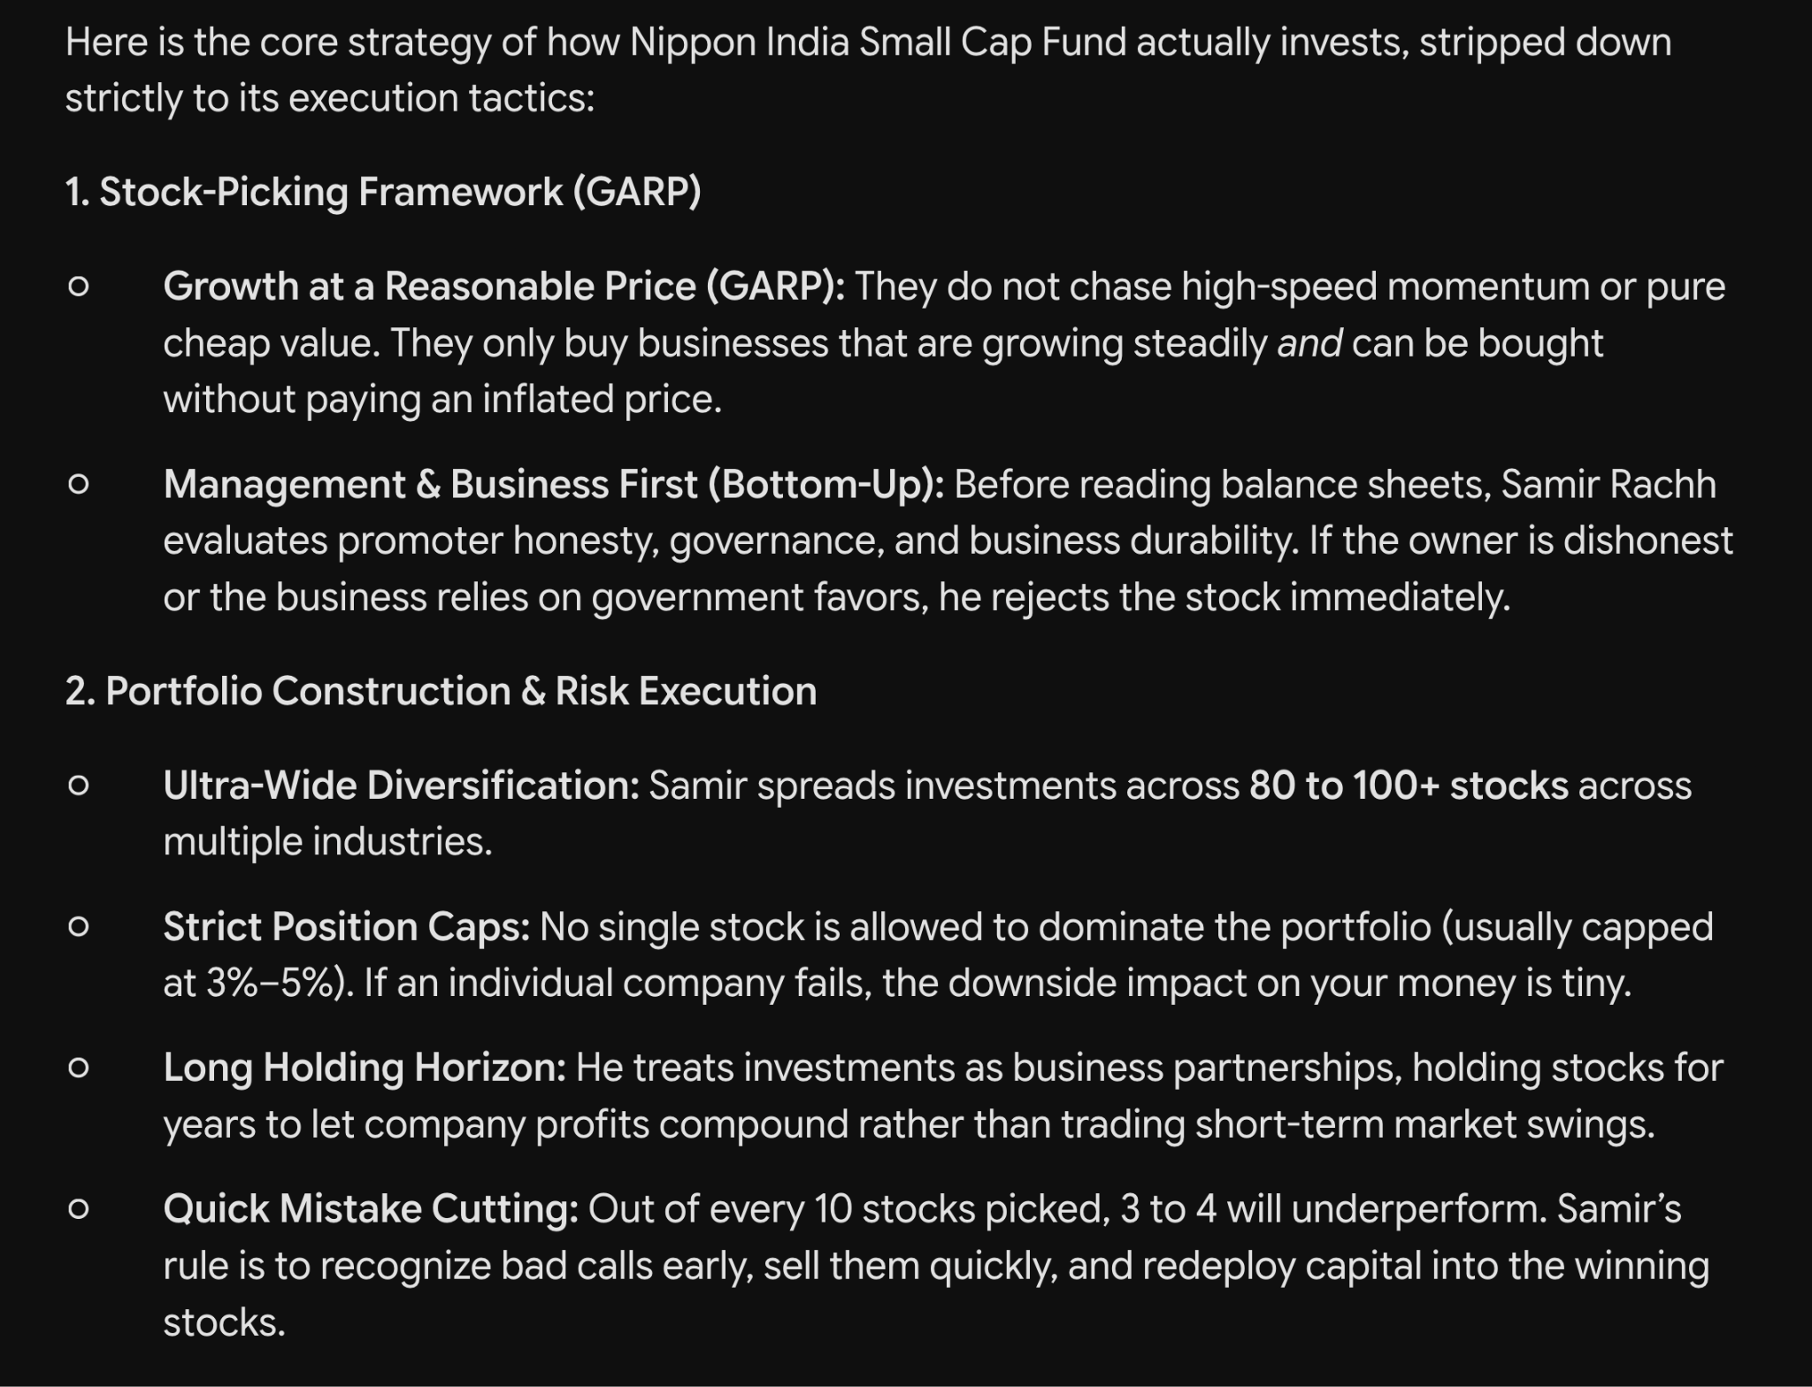
- 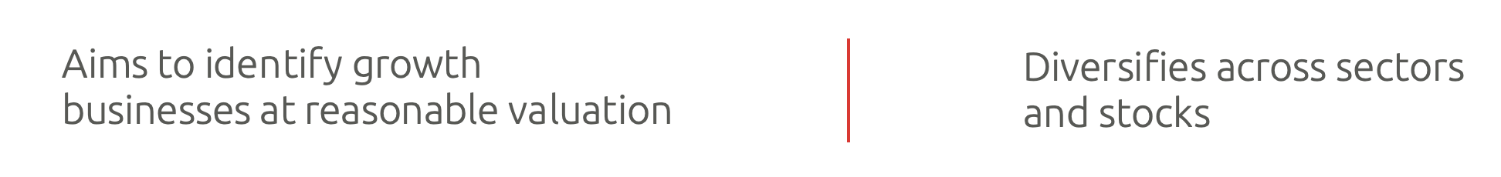
My thinking:
“If I'm going to take small-cap risk, I want at least one fund that has a long history and has already survived different market environments.”

2. Bandhan Small Cap ( 15k )
Why I chose it
- Managed by Manish Gunwani since 2023 (with relevant experience since 2020).
- Minimum 3-year horizon.
- The strategy is similar to GARP (Growth at Reasonable valuation). + bottom up. + diversified + find and invest below 500 companies also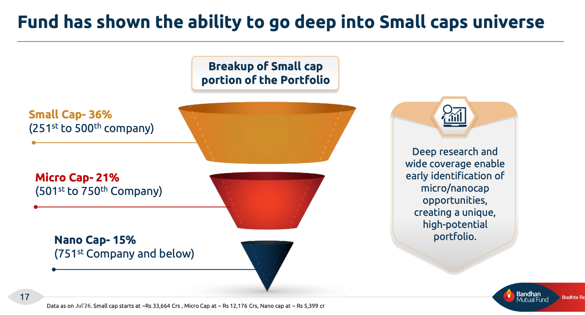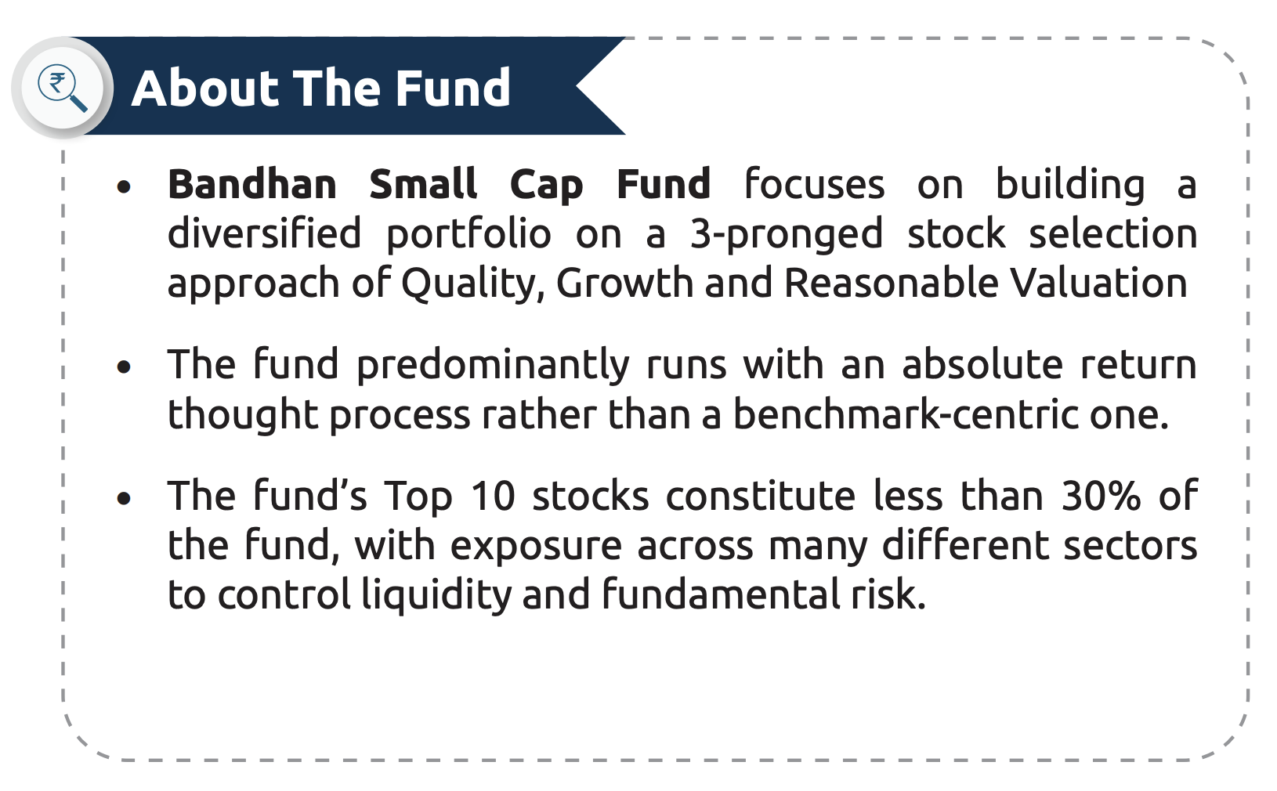
- Gives me another active manager/fund instead of putting everything into Nippon.
- Has only around 16% overlap with Nippon, so it adds some diversification rather than simply buying the same portfolio twice. Its blend also find form out fact sheet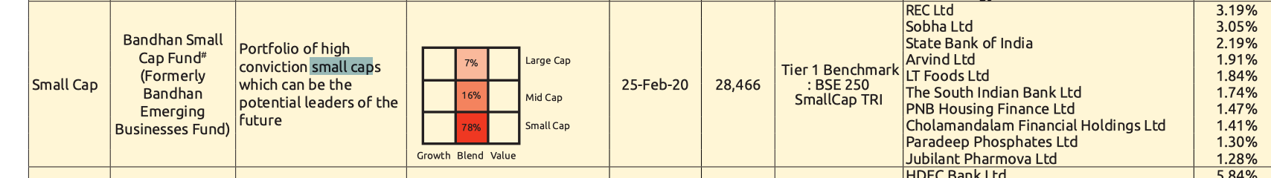
- Benchmark is BSE. why its blend. Idea is not to buy and hold for longer time. ( that why high diversified portfolio goodcash )
- maintain the high allocation of small cap 82%. 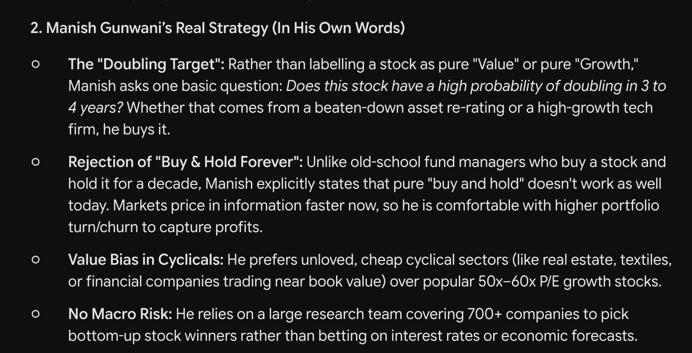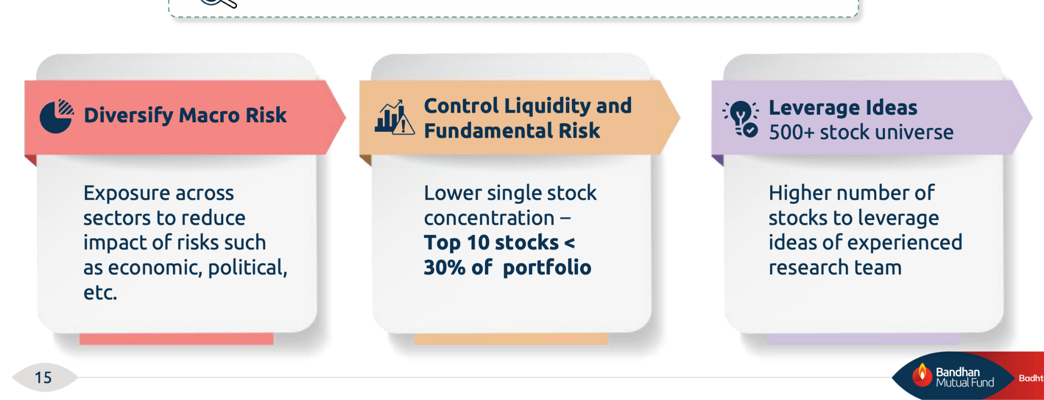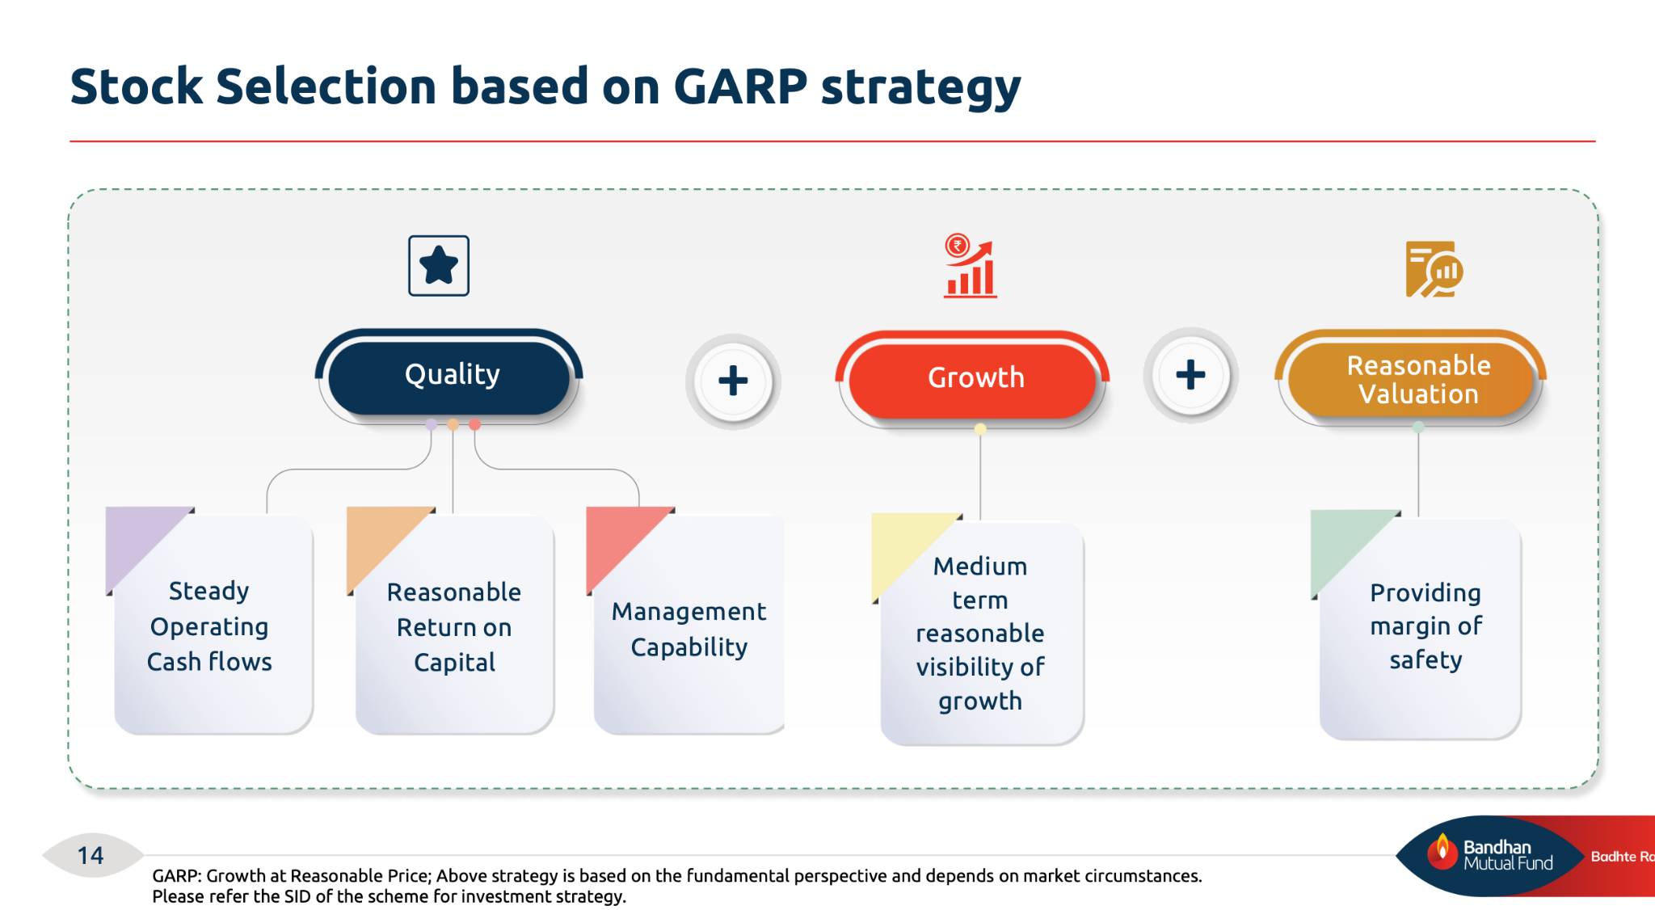
- I was initially leaning toward Nippon + Bandhan as the simpler combination.
- Recent 2-year performance wasn't impressive (~5%), but I'm not selecting it purely based on the recent return.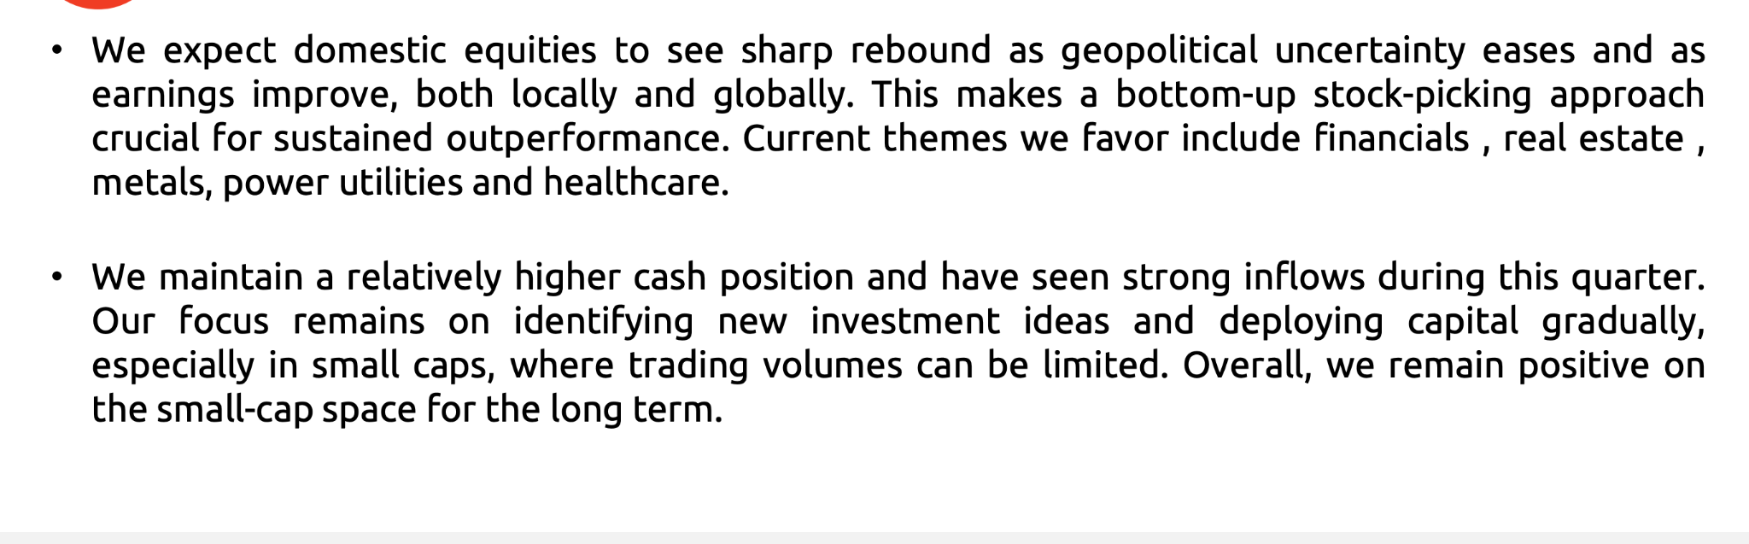
My thinking:
“I don't want my entire small-cap allocation dependent on Nippon. Bandhan gives me another active manager with relatively limited overlap.”

3. Invesco India Small Cap — Growth/style diversification bet ( 15k )
Why I chose it , ( health care heavy since other are not that much + concentration give different idea, growth +value both. good fund manager, 3 is good number to have for small call for long term. )
- Fund management associated with Taher Badshah / Aditya Khemni since around 2018.
- More growth-biased + bottom-up approach.
- Follows a largely fully invested approach (~95% equity), rather than holding significant cash. ( might have liquidity concern )
- Research/presentation was particularly useful because it gives more detail about the portfolio and investment approach.
- Portfolio appears more growth-oriented, with roughly 60% growth / 40% value in the presentation I looked at.
- Higher P/E than Nippon/Bandhan → reinforces that this is the more growth-biased bet.
- More concentrated: top 20 stocks were around 57%, compared with a much broader small-cap index universe.
- Currently its performance has improved relative to Nippon, although historically it often didn't perform as well as Nippon.
- I have a gut feeling it could fall more in the future, so I don't want to make it the largest allocation.
- The healthcare exposure is notably higher than the other funds, while Nippon also has some sector exposure that differs significantly → gives some diversification. ( + point because other are not )
- Seems more focused on long growth perspective ( by and hold )
- saver , since only 60% small cap allocation, other 30:10 to mid and large, similar to canara ( 63, 27,13 ) 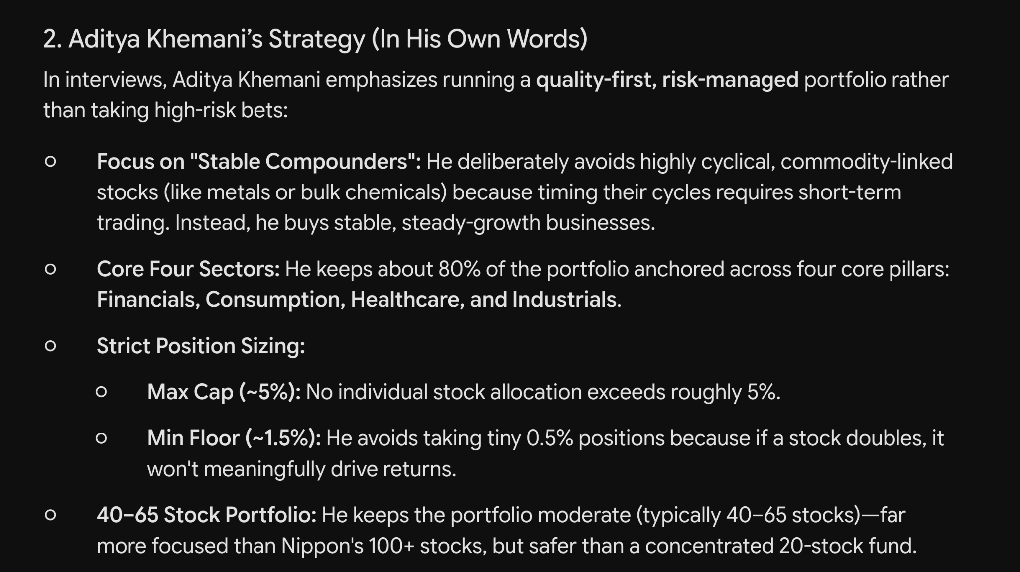
- Main reason for including it: strong fund-management/team thesis + different portfolio/style, not simply because of recent returns.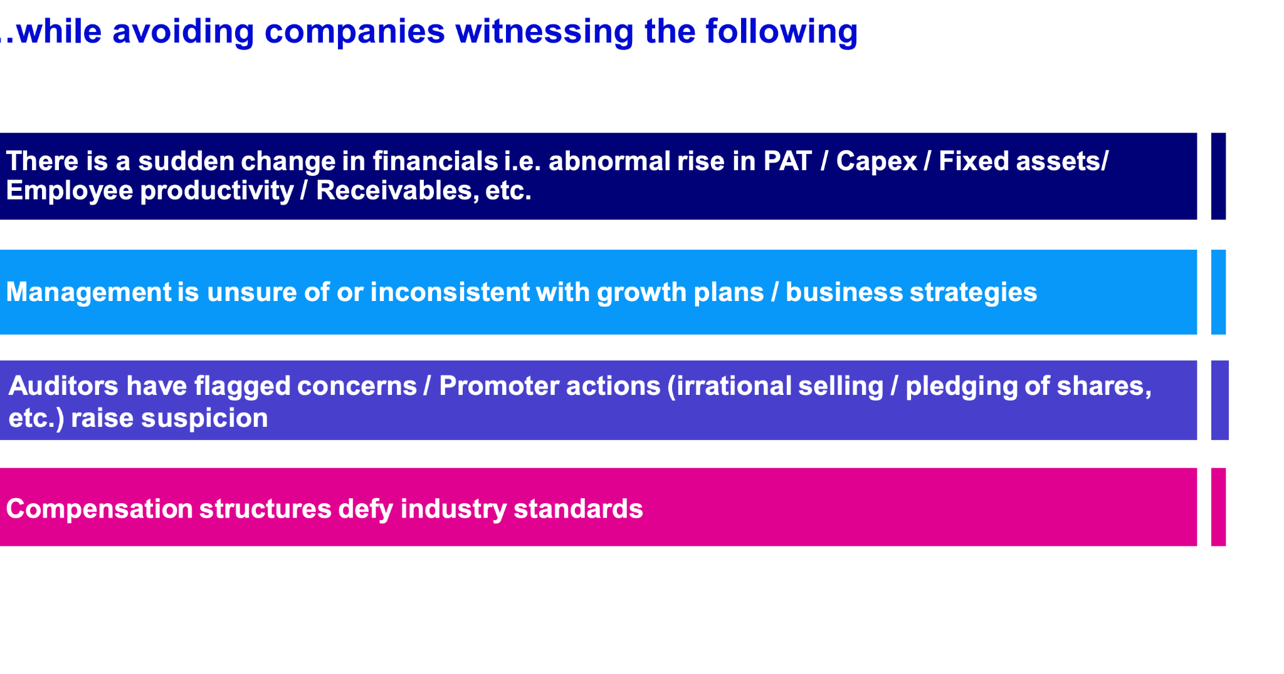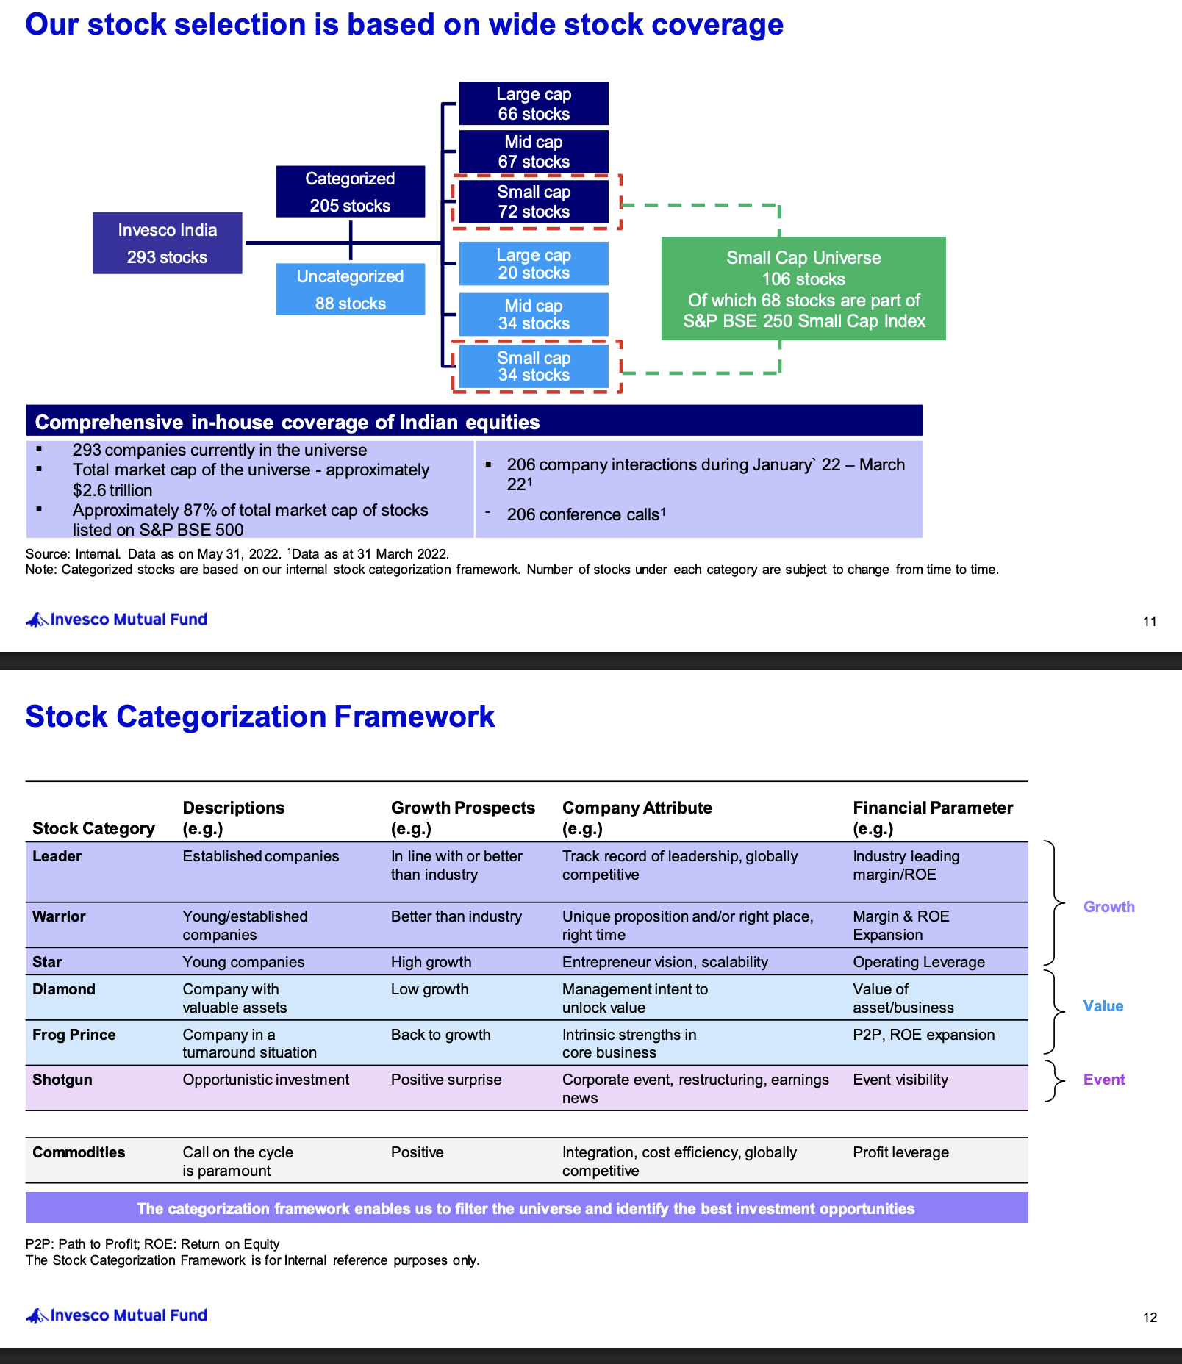
My thinking:
“This is the fund I'm least certain about, but it gives me another investment style and manager. Keep it smaller and observe.”

note , just make sur it's not only growth oriented or value. ( good diversity value, grown ,quality ( i think same as growth ), momentum etc ) since these are cyclic based . its way to have good portfolio.

large AUM impact on small cap: https://www.valueresearchonline.com/stories/228712/why-large-small-cap-funds-lose-alpha-as-aum-grows/

Midcap Cap:
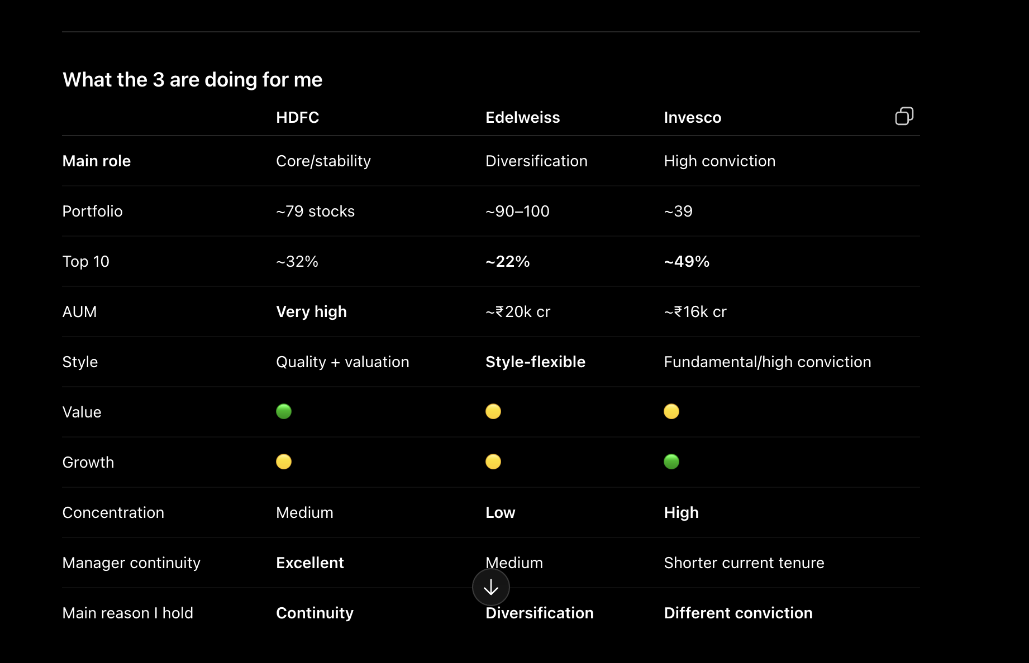

1. Edelweiss Mid Cap ( )
Why I chose it
- Old fund with ~19 years of history → started in 2007, so this is not a new/untested mid-cap fund.
- Has experienced multiple market environments, although the current manager hasn't been there for the entire history.
- Trideep Bhattacharya has managed the fund since 2021 and has substantial prior equity-investing experience; Dhruv Bhatia and Raj Koradia are also part of the current management team.
- Investment philosophy is particularly interesting because Edelweiss uses its FAIR framework and is deliberately not biased toward pure value or pure growth.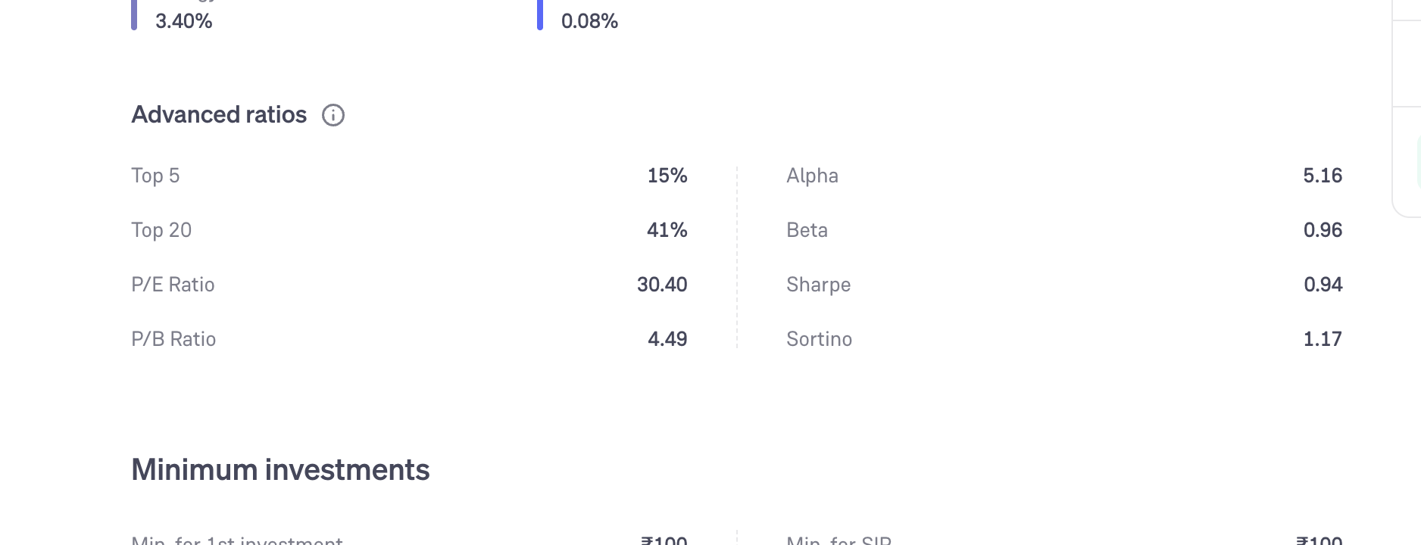
  - Our “FAIR” investment framework helps in identifying robust and clean businesses available at acceptable prices without being bias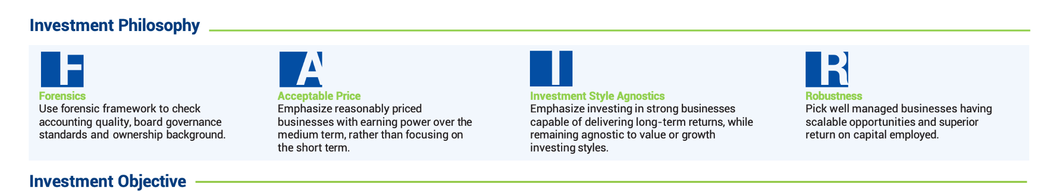ed toward either of the investing styles.
  - https://www.edelweissmf.com/Files/MF/Downloads/Product_Collateral/Presentation/Edelweiss_Mid_Cap_Fund_Presentation__August_2026_31082026180204.pdf
  - 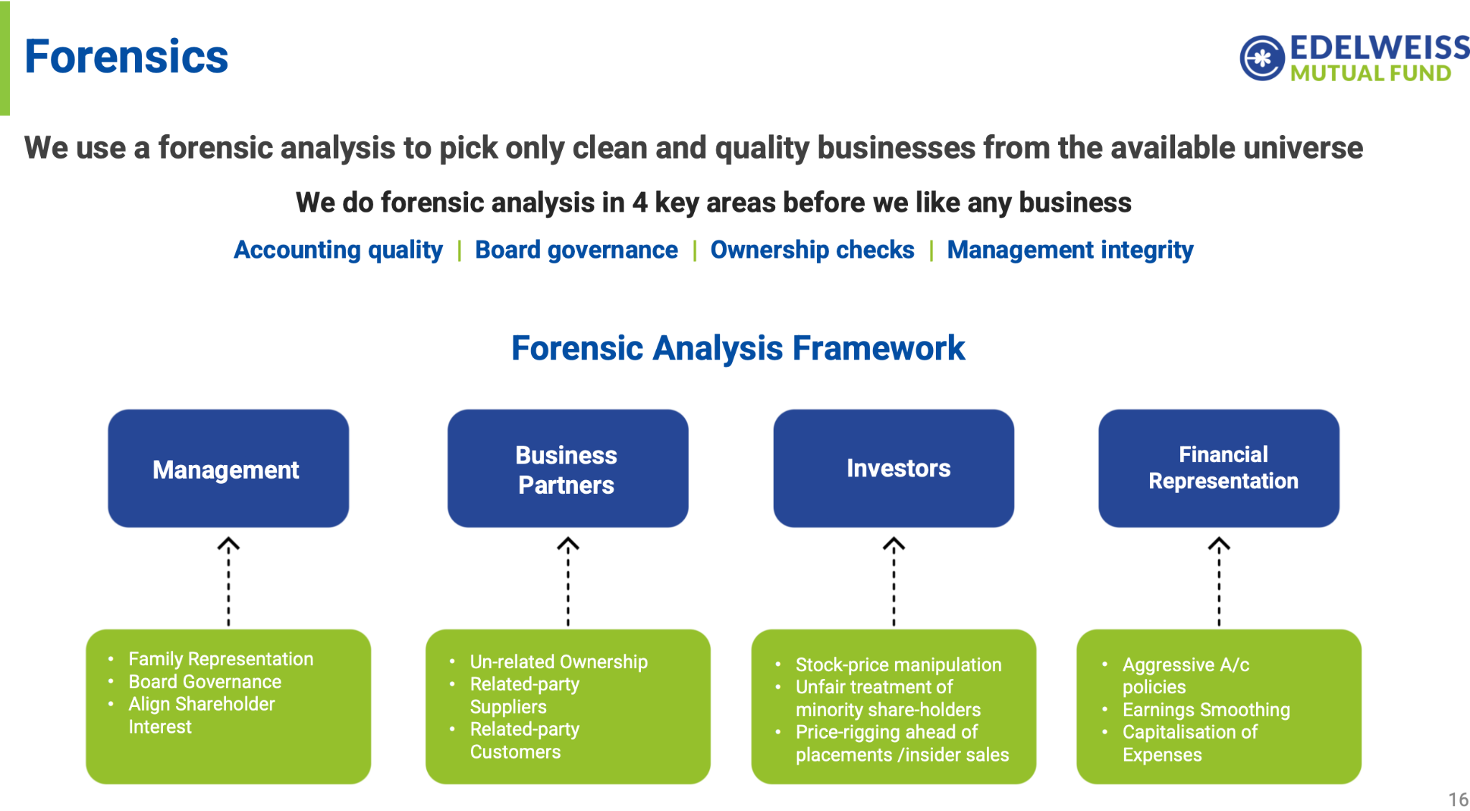
  - 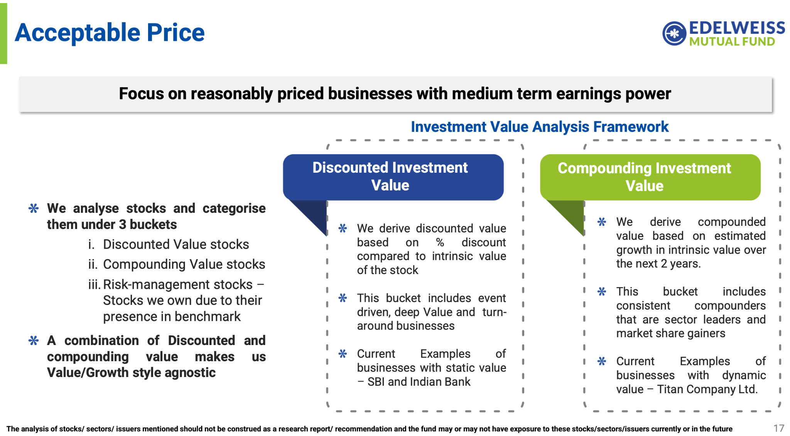
  - 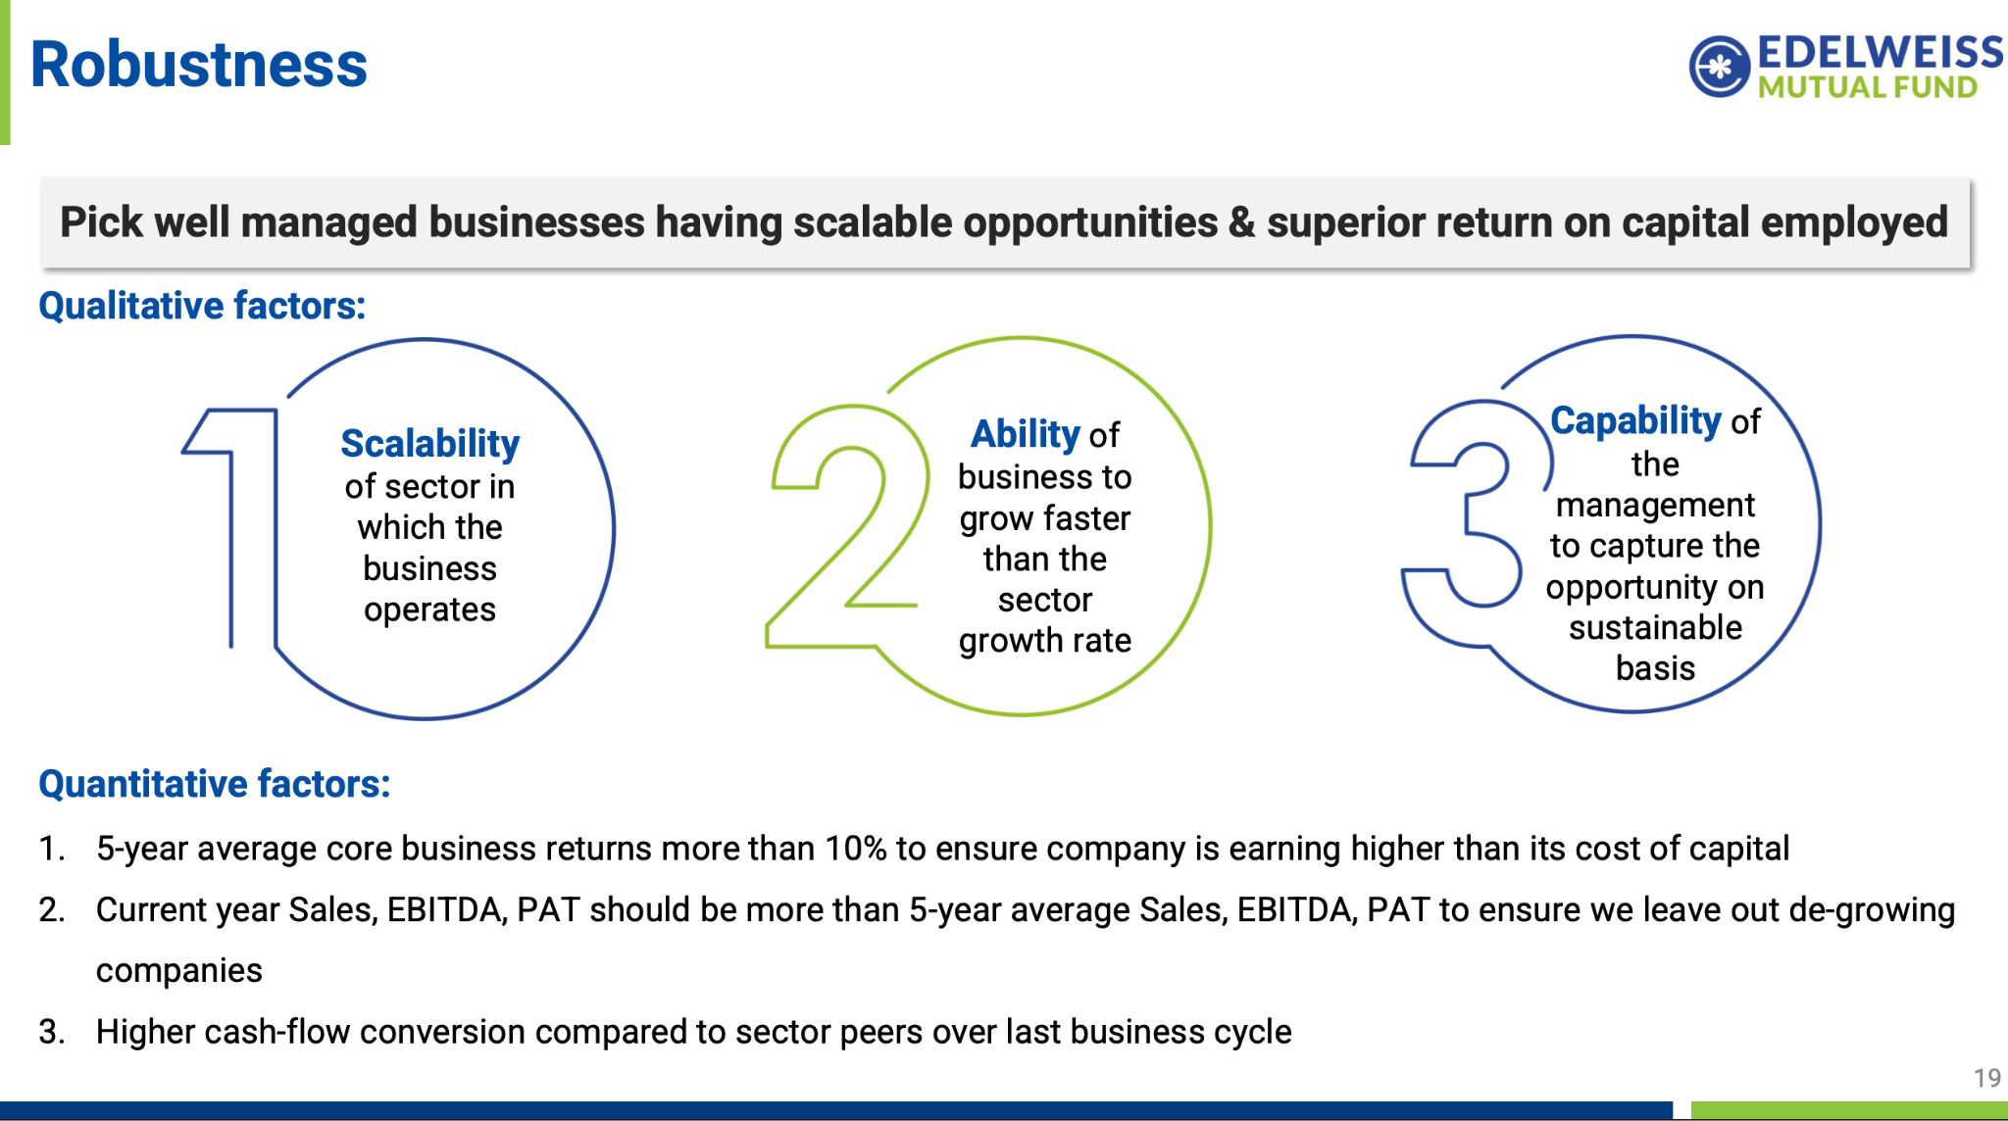
  - 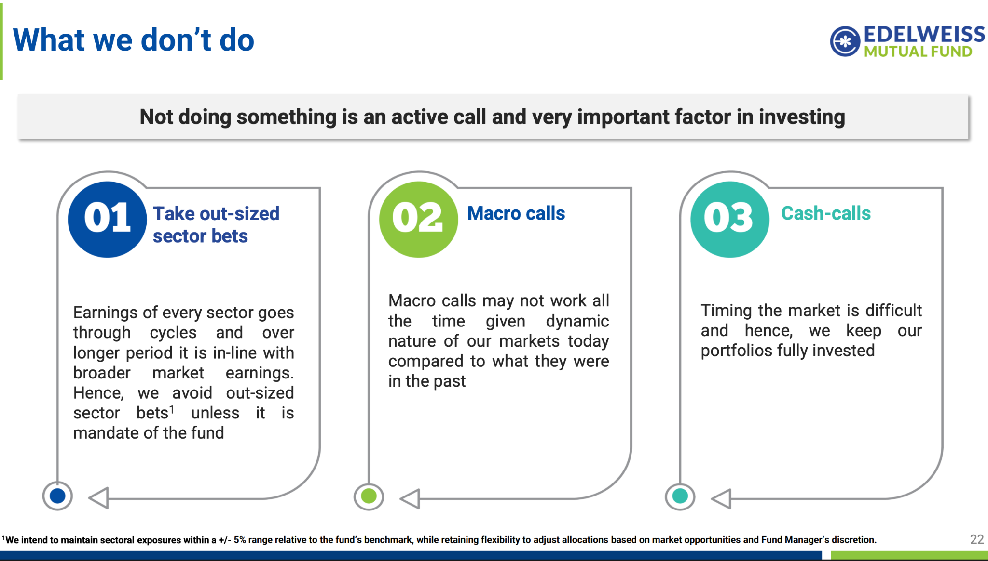
- Beat the hdfc consistency see SS above.
- Presentation well maintained and detailed ( 50+ page ), approached is defined properly. ( invesco has good ( 30 page ) , hdfc ,
- Strong fundamental/forensic approach → looks at business quality, financial robustness, governance/accounting and valuation.
- Very diversified portfolio → roughly 90–100 stocks.
- Top 10 is only around 22%, substantially lower than Invesco and lower than HDFC.
- Much smaller AUM (~₹20k crore) than HDFC → potentially easier to deploy across mid-caps without needing to become excessively large-cap oriented.
- Has produced strong long-term alpha and SIP returns, not just a recent performance spike.
- Gives me a different portfolio construction from HDFC: HDFC is diversified, but Edelweiss is even broader and less dependent on its top holdings.
- I don't consider it a pure value or pure growth fund → style-flexible fundamental investing.
- has 50% overlap with midcap index fund. 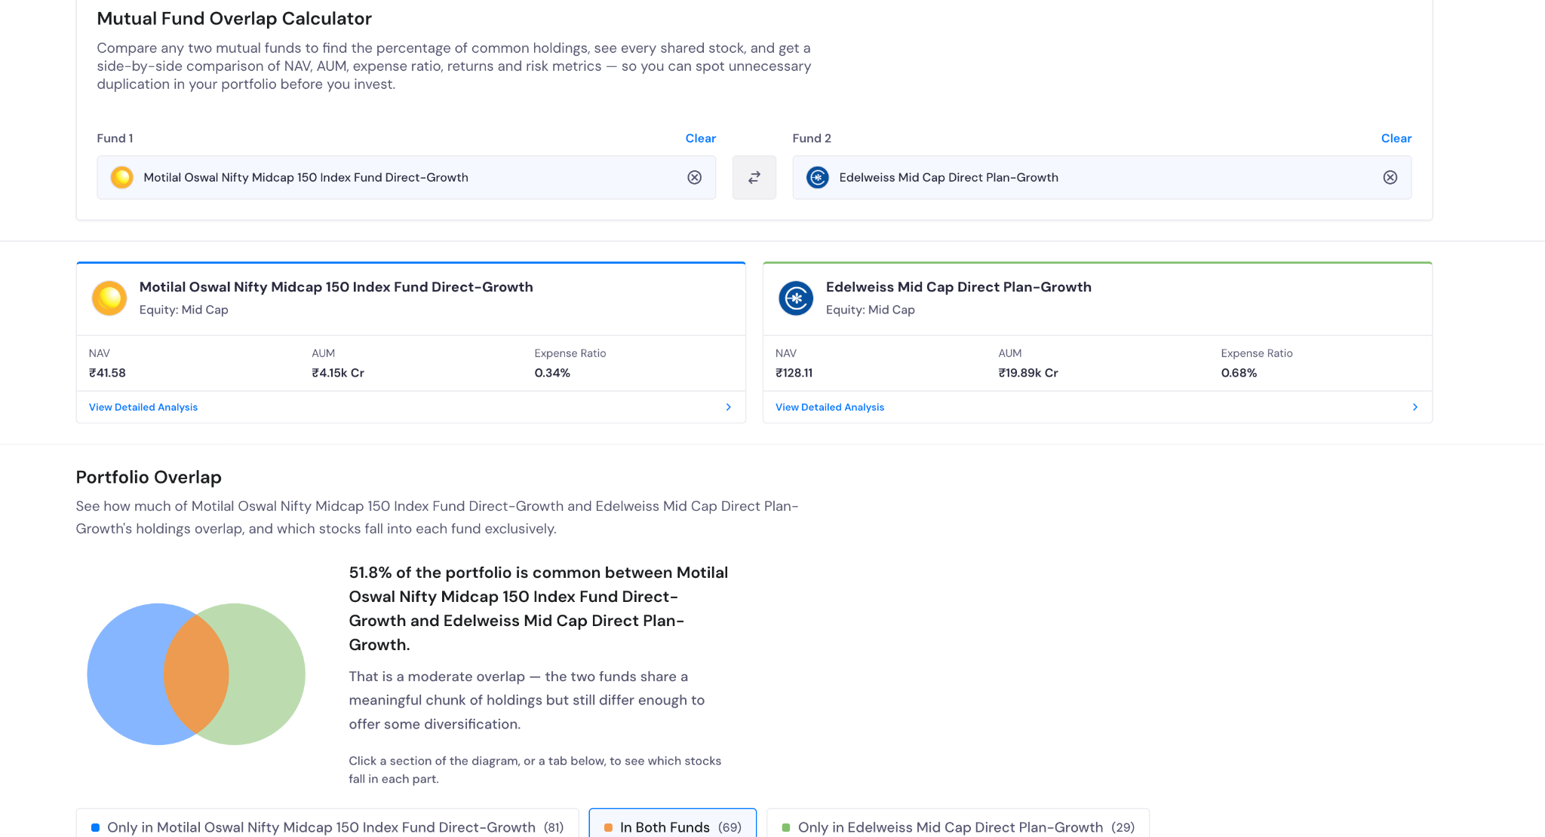
- Allocation: 15k / 45k = 33% of my mid-cap allocation.
My thinking:
“Edelweiss gives me a smaller-AUM, much broader portfolio and a style-agnostic approach.”

